Breaking Rules to Develop Antiviral Drug Candidates for Small DNA Tumor Viruses and (-)Strand RNA Viruses
James K. Bashkin
University of Missouri-Saint Louis

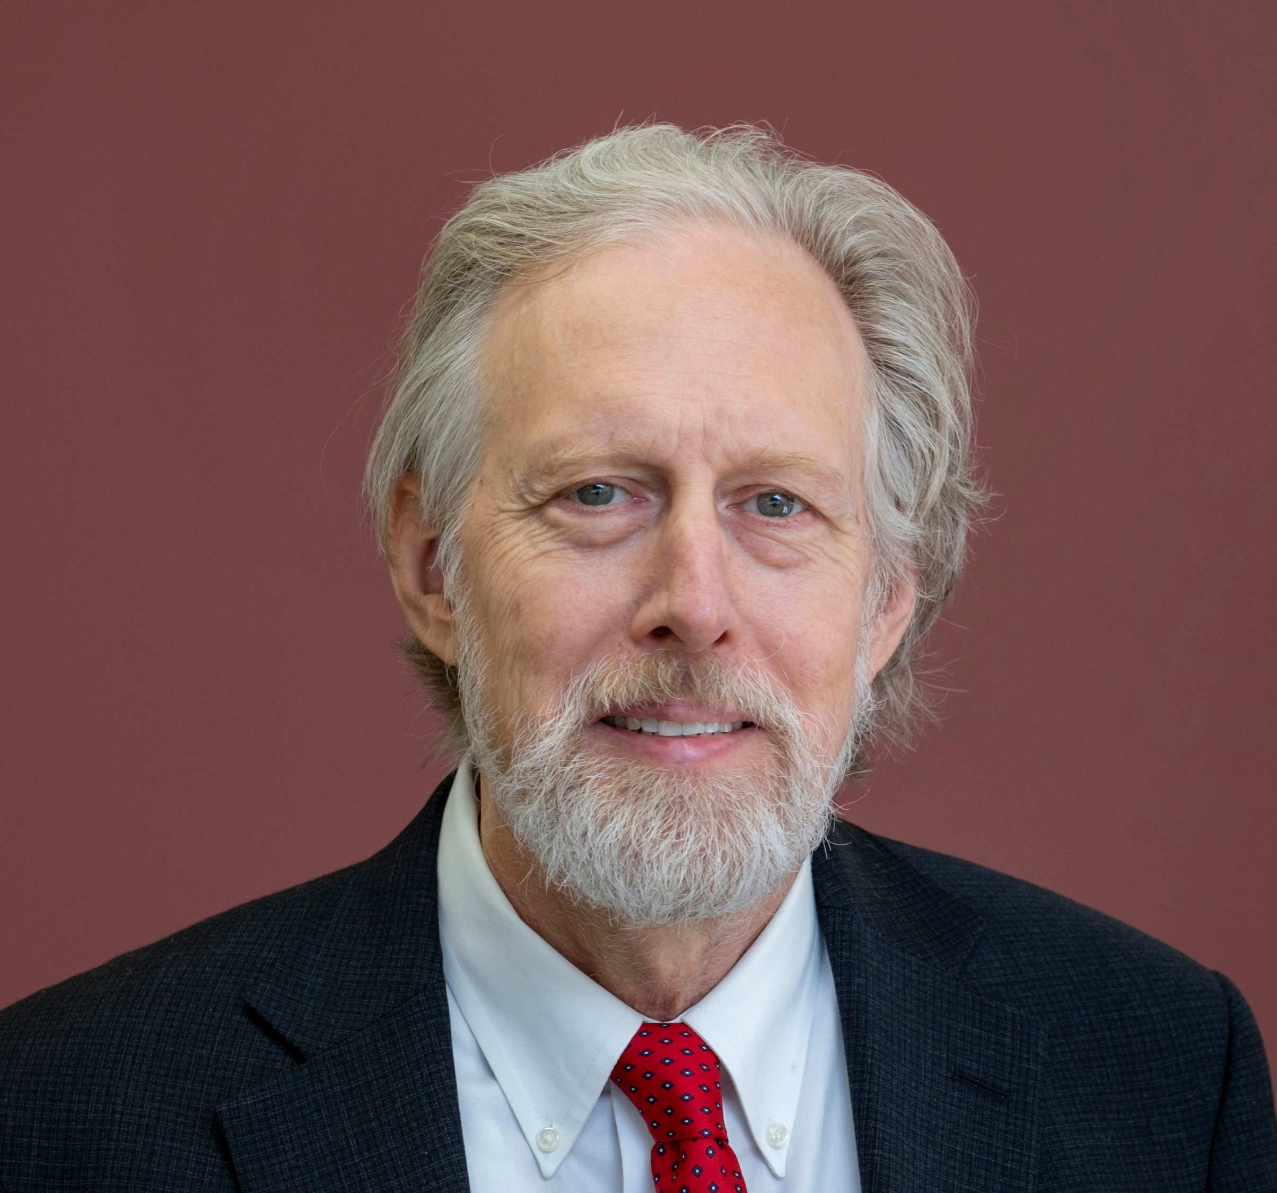Biography
James Bashkin, D.Phil. was born in Iowa City, Iowa. He started as a Biology student at the University of Arizona and graduated from the University of Calfornia-Irvine with a Chemistry degree in 1977, whereupon he enrolled in the doctoral program at the University of Oxford, U.K. In 1982, he completed his studies in organometallic chemistry under Malcolm L.H. Green and joined the lab of R. H.
Holm at Harvard University for postdoctoral and NIH postdoctoral work on bioinorganic chemistry. In 1985, he joined Monsanto Corporate research where he published a variety of papers ranging from RNA chemistry to commodity organic synthesis and received several awards for green chemistry. In 1991, he joined the faculty of Washington University in St. Louis and in 1999 he returned to Monsanto. After the transitions to Pharmacia and Pfizer, he co-founded the antiviral company NanoVir, LLC with virologist Chris Fisher and began work at the University of Missouri-St. Louis. In 2011, he was appointed full professor and in 2022 received the St. Louis Award from the local section of the American Chemical Society. He published 80 papers and has 16 issued U.S. patents.

Abstract
he current study investigates
the application of pyrrole-
imidazole polyamides to fighting viral diseases in cell and tissue culture. We first reported the use of polyamides against high-risk human papillomavirus (HPV) types 16, 18 and 31 in 2011. A previous report on repressing latency of HIV with polyamides had appeared from the Dervan group in 2004, while inhibition of Maloney murine leukemia virus integration with the same class of molecules was reported the previous year, and so-called "paradoxical effects," meaning the authors did not understand their observations, were reported in for effects of polyamides on HLTV-1 transcription by the same group in 2004. Through extensive molecular biology and biophysical studies (with Professor Cynthia M. Dupureur and group), we have explained the "paradoxical effects" and find these rule-breaking effects to be the basis

of our observed antiviral activity. We have shown the the "rules" for DNA recognition by polyamides reported so widely by Dervan et al. do not apply to longer molecules, where enthalpy plays no role in the free energy of binding, and entropy likely associated with deaggregation of polyamides is the determining factor in providing favorable, negative Gibbs free energies of binding. This deaggregation appears to be aided by increasing the positive charge on both the C- and N-termini of polyamides, resulting in improved antiviral parameters (IC₅₀ and IC₉₀) and improved thermodynamic binding parameters such as the dissociation constants. We now have IC₅₀ values as low as 8-13 nM.
Of interest to medicinal and pharmaceutical chemists, our polyamides were predicted by many to be incapable of entry into

cells. However, the opposite is usually the case, and active uptake is often the reason, though we have not identified the specific uptake mechanism yet. Uptake into some cells is extremely effective, including essentially primary keratinocytyes infected with episomal HPV. Another example is a range of blood cells: iv pharmacokinetics are hampered by the immediate uptake of compounds into blood cells, leaving none in the plasma to be measured and making bioavailability, by definition, zero, even though the blood cells transport the compounds to internal organs such as bone marrow, liver, and spleen.
Conclusion: It can be extremely important to ignore "rules" of science and medicinal chemistry and simply carry out experiments to see the results. Even highly flawed prior literature can inspire effective strategies for drug discovery.
However, novel molecular structures may require additional creativity in the formulation and drug delivery aspects of drug development. We even found activity against Vesicular Stomatitis Virus (VSV) shortly after the two most prominent groups reported poor polyamide-RNA interactions. Their data were not wrong, but they failed to account for the range of RNA structures found in RNA genomes, which go far beyond the

A-form helix of double-stranded RNA.

Importance of Research
Developing new antiviral drug candidates is of ever-increasing importance as cancer-viral links are expanded and new pathogenic viruses emerge with devastating properties.

Corresponding Author:
James K. Bashkin, Professor of Chemistry and Biochemistry, University of Missouri-St. Louis, USA. E:bashkinj@umsl.edu

About University

With more than 15,000 students, the University of Missouri–St. Louis is the St. Louis region's premier public research university. UMSL provides excellent learning experiences and leadership opportunities to a diverse student body whose influence on the region upon graduation is immense. UMSL is spread across more than
350 acres in suburban St. Louis County with a mix of modern and
historic academic buildings as well as a variety of student residence halls, condominiums and apartments. It’s the perfect setting for students to gain unique insights from outstanding faculty and work experience from internships at companies and organizations found only in this world-class metropolitan region.
While UMSL graduates can be found in all 50 states and countries around the globe, their greatest impact is felt right here in St. Louis. More than 80,000 UMSL alumni call the St. Louis region home. They drive the region’s economy and contribute mightily to its social well-being.

References

1.
Edwards, T. G.; Koeller, K. J.; Slomczynska, U.; Fok, K.; Helmus, M.; Bashkin, J. K.; Fisher, C. Antiviral Research
2. 2011, 91, 177.
Ylisastigui, L.; Coull, J. J.; Rucker, V. C.; Melander, C.; Bosch, R. J.; Brodie, S. J.;
Corey, L.; Sodora, D. L.; Dervan, P. B.; Margolis, D. M. Journal of Infectious Diseases
3. 2004, 190, 1429.
Yang, F.; Belitsky, J. M.; Villanueva, R. A.; Dervan, P. B.; Roth, M. J. Biochemistry
4. 2003, 42, 6249.
Livengood, J. A.; Fechter, E.
J.; Dervan, P. B.; Nyborg, J.
K. Frontiers in Bioscience 2004, 9, 3058.
- Edwards, T. G.; Vidmar, T. J.; Koeller, K.; Bashkin, J. K.; Fisher, C. PLOS One 2013, 8, e75406.
- Edwards, T. G.; Helmus, M. J.; Koeller, K.; Bashkin, J. K.; Fisher, C. J Virol 2013, 87, 3979.
- Koeller, K. J.; Harris, G. D.; Aston, K.; He, G.; Castaneda,
C. H.; Thornton, M. A.; Edwards, T. G.; Wang, S.; Nanjunda, R.; Wilson, W. D.; Fisher, C.; Bashkin, J. K. Med Chem (Los Angeles) 2014, 4, 338.
- Castaneda, C. H.; Scuderi, M. J.; Edwards, T. G.; G. Davis Harris, J.; He, G.; Dupureur, C. M.; Koeller, K. J.; Fisher, C.; Bashkin, J. K. MedChemComm 2016, 7, 2076.
- Dupureur, C. M.; Bashkin, J. K.; Aston, K.; Koeller, K. J.; Gaston, K. R.; He, G. Anal Biochem 2012, 423, 178.
- Song, Y.; Niederschulte, J.; Bales, K. N.; Bashkin, J. K.; Dupureur, C. M. Biochimie 2019, 157, 149.
- Niederschulte, J.; Song, Y.; Park, A. H.; Bashkin, J. K.; Dupureur, C. M. Biochimie 2021, 185, 146.
- Niederschulte, J.; Song, Y.; Bashkin, J. K.; Dupureur, C. M. Biochimie 2022, 199, 123.

NOTE: This is a sample proceedings abs4tr.act template. The content will be changed while publishing respective abstract in supporting journal website.

