Physical activity as an exogenous risk factor for amyotrophic lateral sclerosis (ALS): An updated review of the evidence
Laura Chapman*
University of Sheffield, Sheffield, UK

Abstract
Statement of the problem: Amyotrophic lateral sclerosis (ALS) is a rapidly progressive and fatal disease the aetiology of which has been long debated. The only established epidemiological risk factors for ALS are male sex and increasing age. The role of physical activity (PA) has been debated for many years. Over the last decade multiple publications have been released attempting to delineate the architecture of ALS. These have not yet established further risk factors, often due to low powered studies, lack of focus on at risk-genotypes and varying methodology. The identification of a specific genetic-environmental interaction could play an important role in preventive and personalised medicine.
Methodology & theoretical orientation: We have conducted a review of all the studies published between 2009 and December 2021. The free text search terms were ((motor neuron disease) OR (MND) OR (Amyotrophic Lateral Sclerosis) OR (ALS)) AND ((Exercise) or (Physical Activity) or (PA) or (sport)). We identified common themes, for example soccer, head injury and the physiological mechanisms that differ in ALS patients. We have analysed the relevant, available studies (n=81), highlighting the underlying reasons for any reported discrepancies.
Findings: Overall, we have found that the more highly powered studies using validated questionnaires, linked strenuous, anaerobic physical activity as a risk factor for people with an at-risk ALS genotype.

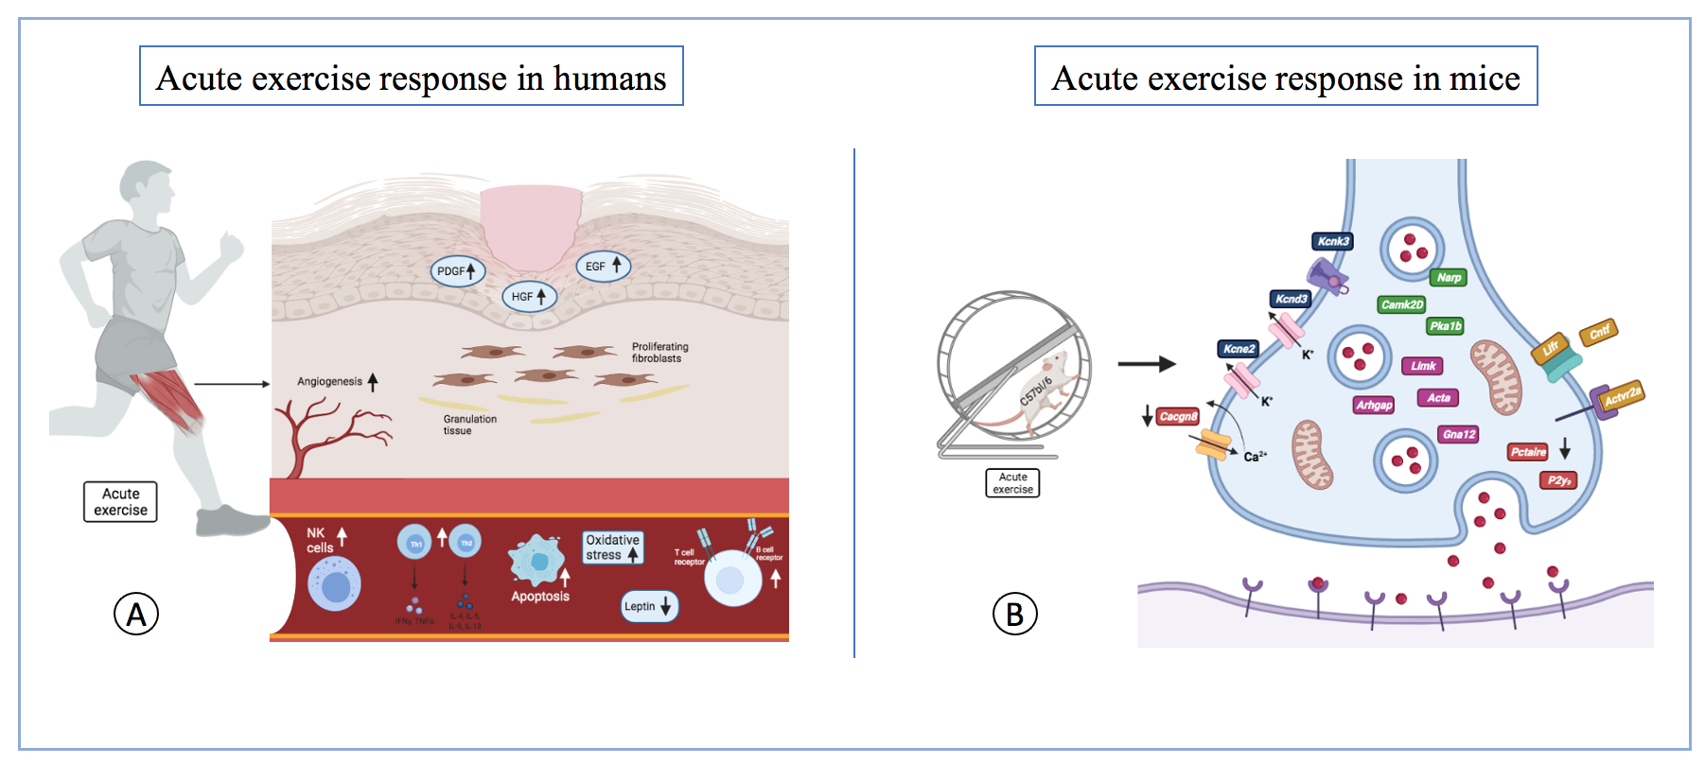
Figure 1(A). The impact of acute exercise on the body. It induces an inflammatory response (increasing natural killer ((NK)) cells, Th1 and Th2 activation, B cell receptors, T cell receptors). It increased oxidative stress, apoptosis and upregulated angiogenesis and wound healing pathways (platelet-derived growth factor ((PDGF)), hepatocyte growth factor ((HGF)) and epidermal growth factor ((EGF)) signalling and also dysregulated metabolic pathways, decreasing leptin.
Figure 1(B). The important gene expression changes in the motor neurons from mice following regular daily exercise for 6 weeks. Neurotrophic factors and receptors in yellow (Cntf, Lifr, Actvr2a) are increased. Genes involved in signalling in green (Pka1b, Narp, CamkIId) are also increased. Genes involved in ion channels in dark blue (Kcnd3, Kcne2, Kcnk3) are increased and (Cacng8) is decreased. Genes involved in cytoskeleton reorganisation (Arhgap, Gna12, Limk, Acta) are increased, these are involved in neurite outgrowth and (P2Y9, Pctaore) involved in neurite retraction are decreased.

Conclusion: In the future, large scale studies focusing on specific at-risk genotypes and PA should be conducted to confirm this finding. This will strengthen the evidence already surrounding strenuous physical activity as an environmental risk factor for ALS and allow advice to be given to the at-risk family members of patients with these subtypes of ALS. Increasing our understanding of the pathophysiology of ALS will allow for the possibility of developing preventative therapeutic approaches.
References
- Julian TH, et al. Physical exercise is a risk factor for amyotrophic lateral sclerosis: Convergent evidence from Mendelian randomisation, transcriptomics and risk genotypes. EBioMedicine. 2021;68: 103397.
- Raymond J, et al. History of vigorous leisure-time physical activity and early onset amyotrophic lateral sclerosis (ALS), data from the national ALS registry: 2010–2018. Amyotrophic Lateral Sclerosis and Frontotemporal Degeneration. 2021; 7–8: 535–44.
- Westeneng H-J, et al. Associations between lifestyle and amyotrophic lateral sclerosis stratified by C9orf72 genotype: a longitudinal, population-based, case-control study. The Lancet Neurology. 2021;5: 373–84.
- Daneshvar DH, et al. Incidence of and Mortality from Amyotrophic Lateral Sclerosis in National Football League Athletes. JAMA Network Open. 2021;12.
- Gamez J, Carmona F. Confirmation of early non-bulbar onset of amyotrophic lateral sclerosis in Spanish league soccer players. Journal of the Neurological Sciences. 2021;21.
Biography
Laura Chapman is an academic foundation doctor at the beginning of her exciting career in research. She has a passion for neuromuscular disorders and wishes to pursue this further. She has had many years of research experience already for being of a young age. She has completed a degree in Human Physiology at the University of Leeds and a Post Graduate Diploma in Clinical Research at the University of Sheffield, UK, as well as her Master and Bachler’s of Medicine and Surgery at the University of Leeds, UK.

