Esthetics and cosmetics in prosthodontics
Eman Helal
MSc, PhD prosthodontics, National Research Centre

Abstract

Our everyday lives are full of esthetic experiences. Uncountable decisions depend on the esthetic appeal of the available options. The Oxford English Dictionary (OED) defines ‘esthetic’ as “concerned with beauty or the appreciation of beauty”, Dental esthetics is the application of the principles of esthetics to the natural or artificial teeth and restorations .Nowadays, owing to patients’ increasing esthetic demands and expectations, the natural appearance of the prosthesis has become an important outcome measure for defining the success of restoration therapy.

The difference between Cosmetic and Esthetic prosthodontics is that Cosmetic prosthodontics implies treatment that is done strictly for visual appearance that may not be considered essential such as Veneers, Cosmetic crowns as well as teeth whitening .On the other hand, Esthetic prosthodontics uses an approach that helps to solve more complicated problems such as missing teeth or missing part of maxillary or mandibular jaws that both fixes the problem from a functional standpoint, but also helps the patient to look and feel better it also requires harmony and balance. In other words, esthetic prosthodontics is a more broad approach than cosmetic prosthodontics.

The demand for cosmetic dental prosthetics has grown considerably during the last few years. Rush-to-market products, media-driven ideas, as well as dentists keen to please, have formed a challenge for the dentist to calculate benefits /risks ratio for every single treatment modality. For this reason this presentation investigated the traditional and recent techniques and materials in different branches of prosthodontics that helps to give the patient the most esthetically satisfying dental experience.

Image
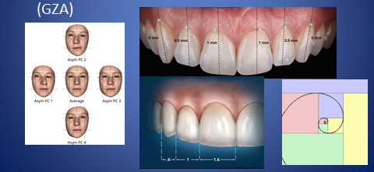

Recent publications:
1-Prosthetic and biological complications of implant-retained fixed versus removable telescopic overdentures: randomized controlled clinical trial. .
2- Comparative study of maxillary denture-base retention between CAD/CAM (3D printed) and conventional fabrication techniques: a randomized clinical study.

Shady M. EL Naggar, Eman Helal, Mai F.F. Khalil, Ahmed M. Esmat El-Sisy, Ayman Gouda Journal of The Arab Society for Medical Research 2022, 17:46–51

3-Precision and accuracy of digital smile analysis in removable complete denture .
Shady M. EL Naggar, Eman Helal, Mai F.F. Khalil, Ahmed M.Esmat .
Journal of The Arab Society for Medical Research 2022, 17:52–58

4-Amount of Bone Loss and Digital Occlusal Analysis of Different Attachment Designs in Bilateral Distal Extension Partial Denture Cases.
Eman Helal, Ahmed M. Esmat and Sherihan M. Eissa.
International Journal of Advanced Research 2020;8(12): (431-438).

5-Probing depth and patient satisfaction with mandibular overdentures retained by four versus two mini-implants: randomized controlled clinical study
May Mahmoud Hassan, Ayman Gouda and Eman Helal.
Egyptian Dental Journal, Vol. 67, 3447:3456, October, 2021 .

6-peri-implant marginal bone loss and oral health-related quality of life in patients treated by mini-implant-retained mandibular overdentures with different occlusal schemes (lingualized, monoplane and bilateral balanced): a randomized clinical trial.

Iman Adel El-Asfahani and Eman Helal.
Egyptian Dental Journal, Vol. 68, 923:936, January, 2022
7-Influence of denture adhesives on oral health quality of life, occlusion and disocclusion times of digitally fabricated and designed removable complete dentures (clinical cross over study)
Eman Helal, Ahmed M.Esmat, Ayman F. Elawady and Maie F. F. Khalil .
International Journal of Advanced Research 2022: 10(06), 696-706.

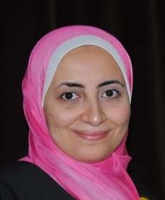

Biography (150 word limit)
Eman Helal has her expertise in prosthodontics she earned her Master and PhD of prosthodontics (2012-2017),she taught removable prosthodontics in different universities in Egypt and United Arab Emirates,she published over fifteen papers in local and international journals.
Email: emangamalrashed@gmail.com

Notes/Comments:

Presenting author details
Full name: Eman Gamal Helal
Contact number:01005127947
Category: (Oral presentation)

