Music Therapy and Aromatherapy on Dental Anxiety and Fear: A Randomized Control Trial
Natthatida Janthasila, MPH, Sirindhorn College of Public Health, Thailand
Orawan Keeratisiroj, PhD, Naresuan University, Thailand

Abstract

Introduction: Dental anxiety and fear in children are one of the major public health concerns. Music therapy and aromatherapy are practical dental treatments. It is effective, cost-effective, and appropriate for pediatric patients who may have anxiety and fear.

Objectives: The aim of this randomized control trial with a 2 x 2 factorial design was to determine the effectiveness of music therapy, combined with aromatherapy, in reducing the anxiety and fear of dental services in young children.

Methods: A total of 128 school-age children aged 10-12 years, studying in grades 4-6 in Thailand were randomly allocated into 4 groups: a control group with 32 volunteers, an experimental group that received music therapy, with 33 volunteers, an aromatherapy experimental group with 31 volunteers, and 32 volunteers in an experimental group with music therapy combined with aromatherapy.

Results: The results found that within-group comparisons before and after the experiment revealed the outcomes with a statistically significant change at the 0.05 level of each group, as follows: the control group had increased heart rate, the music therapy group had dental anxiety and fear and systolic blood pressure decreased, the aromatherapy experimental group had increased oxygen saturation, and the experimental group receiving music therapy combined with aromatherapy had dental anxiety and fear with decreased heart rate, systolic and diastolic blood pressure, and increased oxygen saturation values. In addition, it was found that music therapy combined with aromatherapy had a co-influence on dental anxiety and fear (F = 22.22, P < 0.001) and oxygen saturation (F = 17.40, P < 0.001), and the two main treatments also significantly influenced these outcomes at the 0.05 level.

Conclusion: The results showed that the use of music therapy in combination with aromatherapy reduced school-age children's anxiety and fear of dental services better than a single treatment.

Image

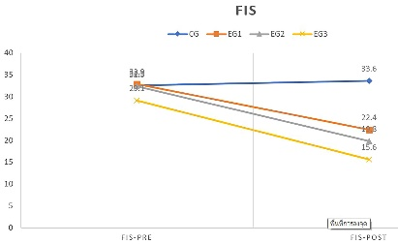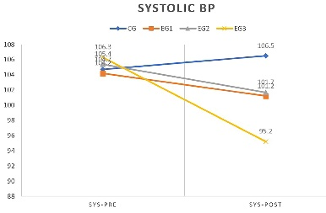
Figure 1. Estimated Marginal Means of Change in Dental Anxiety and Fear and Systolic Blood Pressure
Recent Publications
- James J, Retnakumari N, Vadakkepurayil K, Thekkeveetil AK, Tom A. (2021). Effectiveness of aromatherapy and music distraction in managing pediatric dental anxiety: a comparative study. International journal of clinical pediatric dentistry 14:249-253.
- Kakkar M, Wahi A, Thakkar R, Vohra I, Shukla AK. (2016). Prevalence of dental anxiety in 10-14 years old children and its implications. Journal of dental anesthesia and pain medicine 16:199-202.
- Pradopo S, Sinaredi BR, Januarisca BV. (2017). Pandan Leaves (Pandanus Amaryllifolius) aromatherapy and relaxation music to reduce dental anxiety of pediatric patients. Journal of International Dental and Medical Research 10:933-937.
- Son HK, So WY, Kim M. (2019). Effects of aromatherapy combined with music therapy on anxiety, stress, and fundamental nursing skills in nursing students: a randomized controlled trial. International journal of environmental research and public health 16:4185.
- Zamanifar S, Bagheri-Saveh MI, Nezakati A, Mohammadi R, Seidi J. (2020). The effect of music therapy and aromatherapy with chamomile-lavender essential oil on the anxiety of clinical nurses: A randomized and double-blind clinical trial. Journal of medicine and life 13:87-93.

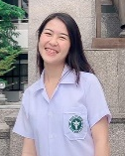 Biography Biography 
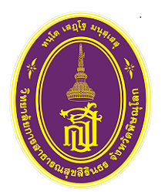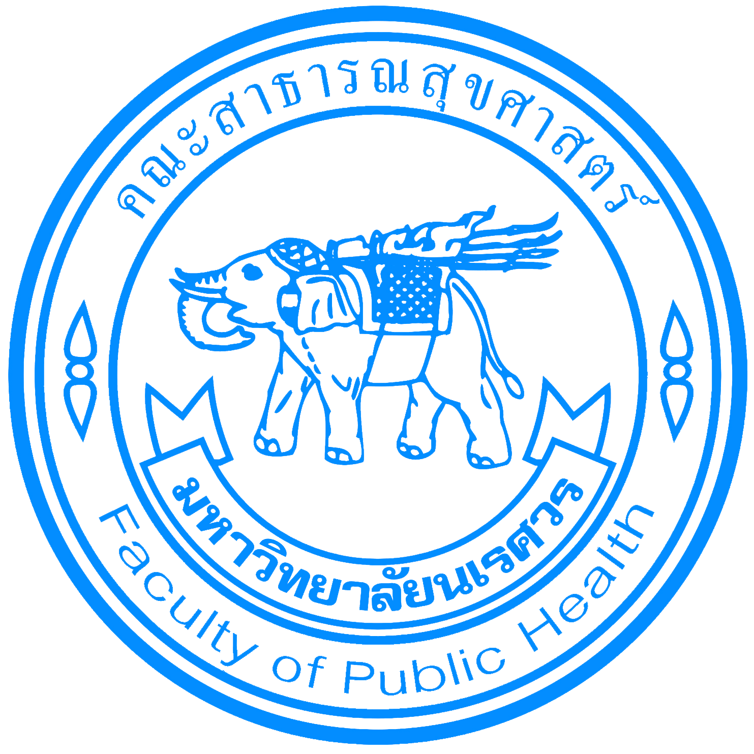

Orawan Keeratisiroj has her expertise in clinical epidemiology and biostatistics. She is interested in research on musculoskeletal pain, children with cerebral palsy, physical disability and the elderly. She supervises graduate students of the Faculty of Public Health, Naresuan University.
Email: orawansa@nu.ac.th
Natthatida Janthasila has her expertise in dental public health. She graduated with a bachelor's degree Dental Public Health at Sirindhorn College of Public Health and Master of Public Health Program, Faculty of Public Health, Naresuan University, Phitsanulok,Thailand
Email: natthatidaj63@nu.ac.th

Presenting author details
Full name: Natthatida Janthasila
Contact number:+66 85-535-4959
Twitter account: @OKeeratisiroj
Linked In account: Orawan Keeratisiroj
Session name/ number: Dental Nursing and Public Health Dentistry
Category: (Oral presentation)

