Entrepreneurship Opportunities in Agriculture
Dr. Parveen Kumar

Agriculture sector today is being threatened by low profitability and the lack of interest of the younger generation towards this noble profession. This is because the cost of cultivation has increased so much that the net income of the farming community goes on declining in the successive years. Another important factor is the predominance of marginal and small farmers in the agriculture. In India, small and marginal holdings (below two hectares) constitute 86.21% of the total land holdings (Ag. Census, 2011). Unfortunately, we have been focusing on production side to meet the growing requirements of a burgeoning population. The commercial aspect of this sector was ignored. This resulted in lack of employment generation and a sort of disguised employment in the agriculture sector. Now, it has been realized that agriculture development has to include generation of employment opportunities and generation of income. The country at present is witnessing a ‘demographic dividend’; a term used for the economic growth potential that can result from shifts in a population’s age structure mainly when the share of working age population is larger than the non working age. The economic survey 2018-19 pointed out that India’s demographic dividend will be at its peak by the year 2041 when the share of working people is expected to reach 59 per cent of the total population. The country is expected to add another 183 million people to the working age group 15-64 years in between 2020 to 2050. This demographic dividend can become a liability in the absence of enough jobs and the required skilled work force. Education and Skill are the biggest enablers for reaping this dividend, but it is also true that in this age of digitization and automation, generating adequate jobs for all is also not a simple task. Another unfortunate thing is the poor record of the country when it comes to the number of skilled persons. All across the globe, the proportion of formally skilled workers as a percentage of total workforce stands at 24 per cent in China, 52 percent in USA, 68 per cent in United Kingdom and 80 percent in Japan as against only 3 percent in India.
Agri-preneurship refers to the entrepreneurship opportunities in agriculture sector. Dollinger (2003) stated that entrepreneurship in agriculture is the creation of innovative economic organization for the purpose of growth or gain under conditions of risk and uncertainty in agriculture. This sector provides various entrepreneurship opportunities to the unemployed youths to skill themselves and generates enough employment opportunities not only for themselves but also for others too. Entrepreneurship is also reported to be a feasible approach for upward mobility as a 1% increase in entrepreneurial activities decreases the poverty rate by 2%. The government of India through its various policies and programmes has already come up with an enabling ecosystem for entrepreneurship development in agriculture and allied sectors by creating awareness, developing skills in various fields, providing financial assistance, exposures and necessary hands holding for those desirous of setting their own entrepreneurial ventures. Agri-preneurship has emerged as a tool for economic development of India in the new millennium.
Recent Publications (minimum 5)
- Demographic Dividend-United Nation Population Fund Harper Cited at: www.unfpa.org>demographicdividend. Accessed on Oct.04, 2022
- Rajesh Shukla, Megha, S. P. Geetha R. (2019) Explained: Gap between Skill India goals and current status, Financial Express. March 19
- Demographic dividend may turn into liability in absence of enough jobs, skilled workforce: A Report (2022). The Free Press, April 03.
- Varun B Krishnan (2018). What the agriculture census shows about land holdings in India. The Hindu, Oct. 03.

5. Dollinger, M. J. (2003). Entrepreneurship:
Strategies and Resources. 3rd Edition. Prentice
Hall, US.

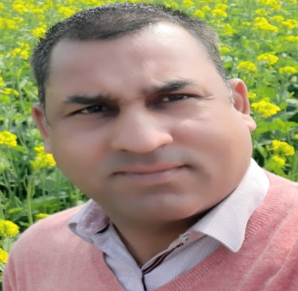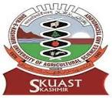

Dr. Parveen Kumar is a Doctorate in Ag. Extension and presently working as an Assistant Professor in the Directorate of Extension, Sher-e-Kashmir University of Agricultural Sciences and Technology of Kashmir, Shalimar, Srinagar. With an experience of about 10 years in different capacities, Dr. Kumar has a considerable experience in research, teaching and extension. He has authored a no. of books. He is an editorial member of various journals and has been a part of National Organizing Committee of various national and international conferences.
Email: pkumar6674@gmail.com

Notes/Comments:

Presenting author details
Full name: Dr. Parveen Kumar
Contact number: 7298360187
Twitter account:
Linked In account:
Session name/ number:
Category: (Oral presentation/ Poster presentation): Oral.

