STRESS AND COPING STYLES OF WOMEN ENTREPRENEURS IN A DEVELOPING NATION
Dr.R.Subashini PhD, Vellore Institute of Technology (VIT), Velllore, TamilNadu, India | rsubashini@vit.ac.in

Abstract
Statement of the Problem: The development of any country is regulated by the human resource, physical resource and monetary resources. The development of the economy is highly sparked by the means of enterprising spirit. The entrepreneurs are considered as the asset to the nation. Entrepreneurs are responsible for not only to earn money but also to generate more job opportunities for others and for contributing towards the development of nation. In developing country like India, the entrepreneurial world is predominantly meant for men. But now this picture is changing. Recently the trend is emphasizing that women can also contribute to the development of economy.
Main Objective: To identify the various stress faced by the women entrepreneurs and the coping styles they follow in their entrepreneurial activities.
Methodology & Theoretical contribution:
After in-depth interviews and focus group discussions, a well-designed questionnaire known as Entrepreneurial Role Stress Scale was used. This scale was developed by Pareek (2002). This scale measures the independent variable of this study, using 35 items. The first dependent variable in this study is Coping Style. The overall Coping style is measured using the revised questionnaire having 26 items developed by Carver, (1997).
Findings and Conclusion:
In this study it is found that the women entrepreneurs who are associated in the work meaningfully and with good quality, are facing more stress and they are using perfect coping strategy to overcome it. But at the same time there are some women entrepreneurs who don’t have awareness on the coping strategies and thereby face more stress and feel alone and isolated many times in their career. The best way to develop and encourage more women entrepreneurs’ in our society is to educate and communicate them through need based awareness programs regarding various sources of stress and coping strategies.

Conceptual Framework

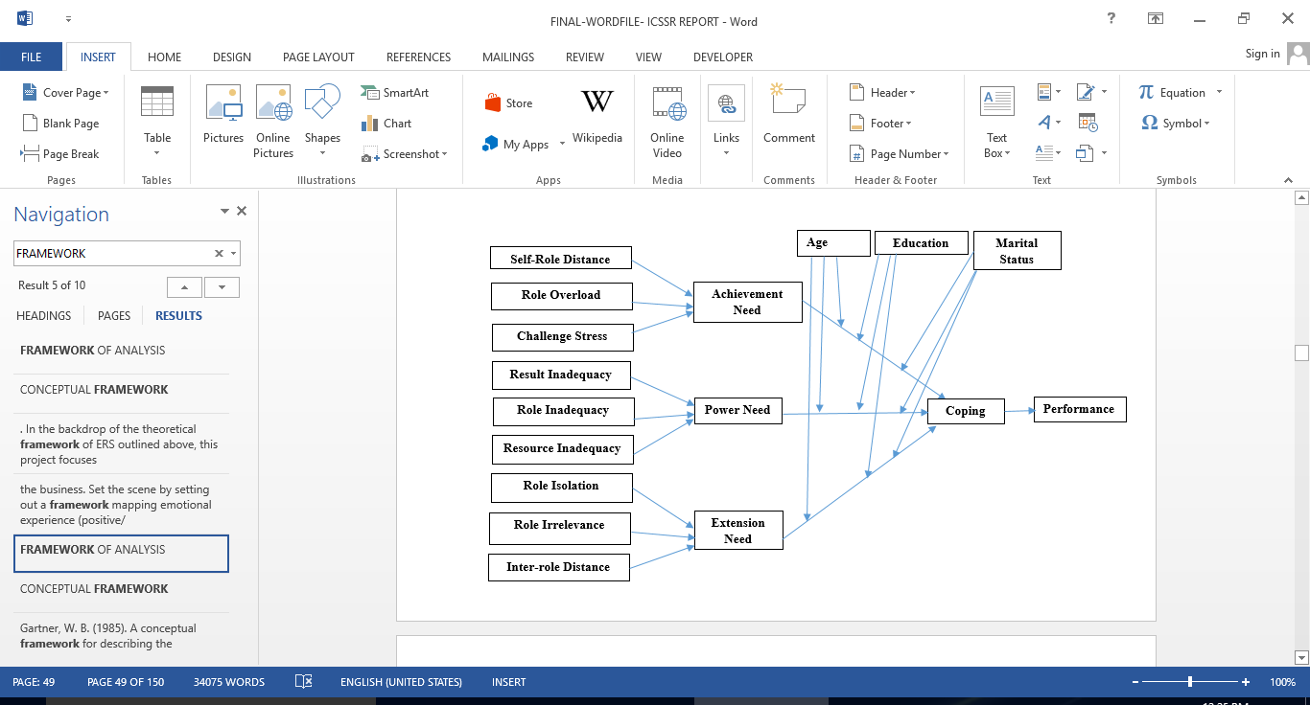
Publications
- Subashini R, Velmurugan G, Pannerselvam R (June 2012), ‘A Study on the present status of Self Help Group (SHG) in Kammavanpet Village, Vellore District’, JM International Journal of Management Research, 2229-4562, 2(4), 241-246
- Subashini R (May 2016), Stress Faced by Women Entrepreneurs - A Critical Review, Global Management Review, 10 (3), 85-91
- Subashini R., Velmurugan G., Sabharinath R. (Apr 2022). Women Entrepreneurs in Developing Nations: Barriers to Innovation, Emerging Trends in Business Management. Bonfring Publishers, 978-93-92537-22-6, 153-158.
- Kokila M., Subashini R., & Velmurugan G. (March 2017). Sources of Stress among Women Entrepreneurs – An Empirical Approach. Journal of Industrial Engineering and Management Science, Vol.7

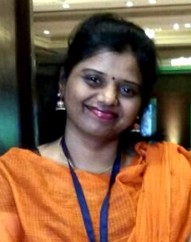
Biography
Dr.R.Subashini has her expertise in Human Resource Management domain and involves in projects on Women Entrepreneurship.
She is currently working at Vellore Institute of Technology (VIT), Vellore campus as a Faculty in Management in the Department
of Technology Management and also holds the administrative position as Director In-charge – VITCR.
Dr.R.Subashini has 55 Journal Publications; 10 Books and Book Chapters; more than 15 Conference Proceedings and Patents Published. She had been a presenter/ moderator /session chair (online & offline) for many National and International Conferences held at India and at Australia, China, Malaysia, Thailand, Singapore, UAE, USA. She has been the Principal Investigator of 10 Government of India funded projects from ICSSR, MSME-DI, MHRD and is also the key consultant and a trainer for middle level employees of various companies across sectors. She has delivered more than 24 Invited Talks at Professional Societies, Institutes and Industries. She has organized 102 events in the capacity as Convener/Chief Faculty Organizer/Faculty Coordinator/Committee Member for FDPs, MDPs, EDPs, Conferences, Workshops, VAPs, Technical and Non-Technical Events at National and International levels. She has been hhonored with many Awards. To mention a few, Faculty Research Award; Best PhD Thesis Award, Dynamic Teacher Award; Woman Leadership Award and many more. She is the Editorial Board Member of many Journals. She also involves in many societal benefit activities.

Email: rsubashini@vit.ac.in | subamail3@gmail.com

Keynote Speaker details
Full name : Dr.R.Subashini
Contact number : 9894449500
Category : Oral presentation – Key Note Speaker
Session name/No.:

