Exploring Age and Various Entrepreneurship
Farzana Chowdhury, University of Durham, Durham, UK

Abstract (300 word limit)

Entrepreneurs satisfy the needs of various stakeholders in society by introducing new products, processes, or societal needs. We test whether an individual's age influences their perception of time, which affects the decision to undertake different types of entrepreneurial activity, and whether access to resources such as knowledge, skills, and finances moderates this effect. Using a sample of 194,937 entrepreneurs, we find that formal education and entrepreneurial education play an important but different roles for entrepreneurs in various age groups. For example, middle-aged (45-64) and older individuals in the upper-income household are more likely to undertake both social and market-driven entrepreneurship, while younger entrepreneurs (25-44) belonging to the upper-income household are more likely to engage in market-driven entrepreneurship. While entrepreneurial experience is vital for both types of entrepreneurship, age negates the positive influence on entrepreneurship. In this study, we seek to contribute to the entrepreneurship literature by proposing that factors that influence the decision to engage in social entrepreneurship are different from those conducive to market-driven entrepreneurship. There are reasons to think those antecedents that influence social entrepreneurship are different from market-driven entrepreneurship. First, acquiring and orchestrating resources are essential for entrepreneurial activity to flourish. The knowledge and skills possessed by entrepreneurs and the ability to use these resources to access financial resources go hand in hand. Third, individuals equipped with various skills and knowledge can leverage resources in their possession to acquire additional resources for their venture to be successful. Fourth, existing studies suggest that venture capitalists are more likely to extend their resources to firms that have founders with high human capital (Brush et al., 2001). Finally, while resources are important for entrepreneurship, the ability of entrepreneurs to access these resources may differ systematically along with the entrepreneur's "vision and intuition'. In this case, an entrepreneur's judgment regarding combining different resources impacts the assessment of the attractiveness of different types of entrepreneurship.

Second, we contribute to the entrepreneurship literature by demonstrating that age significantly influences decisions related to engagement in social and market-driven entrepreneurship. In this regard, we consider entrepreneurs in different age groups and their decision to engage in market-based vs. socially motivated ventures. The results of the study suggest that motivation to engage in entrepreneurship varies by age. The theoretical basis of our expectation regarding age and different types of entrepreneurial activity is based on two streams of literature. First, construal level theory (CLT) argues that the experience of individuals influences their decision to engage not just in entrepreneurship but also in different types of entrepreneurship. To gain additional focus, we draw on the resource-based view (RBV) literature which suggests that resources are important for an entrepreneur to be able to undertake any type of entrepreneurial activity. Older entrepreneurs in the middle- and upper-income levels are less likely to be concerned about resource constraints in terms of capacity or financial resources. Older entrepreneurs tend to have greater capacity given the diversity of tasks they have tackled during their life. Being experienced with and prepared to address a broad spectrum of diverse tasks heightens their awareness of various social problems and induces them to pay attention to entrepreneurial opportunities to alleviate social problems.

Image

Figure 1: Predictive Margins of Interactive relationship between Age, Household Income, and Social Entrepreneurship

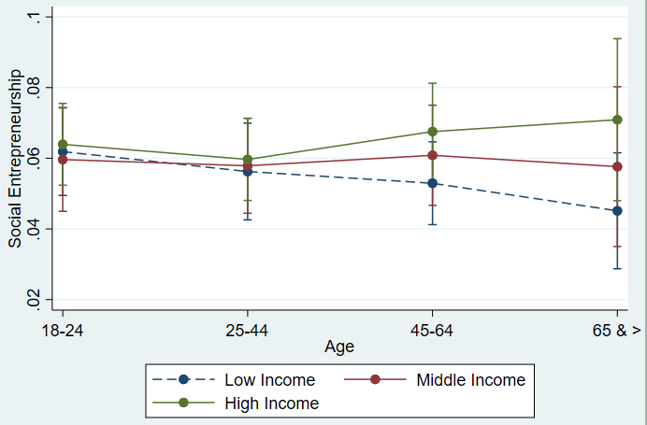

Figure 2: Predictive Margins of Interactive relationship between Age, Household Income, and Market-driven entrepreneurship
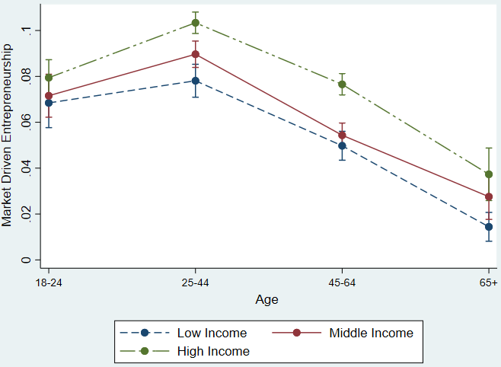
Recent Publications (minimum 5)
Brieger, S. A., Chowdhury, F, Hechavarria, D. M., Muralidharan, E., Pathak, S., Lam, Y. T. 2022. Digitalization, Institutional Voids and New Venture Internationalization. Journal of International Management (Accepted).
Audretsch, D., Belitski, M., Chowdhury, F., Desai, S. 2022. Gender, Corruption, and Firm Exports. International Business Review (Accepted).
Audretsch, D., Belitski, M., Chowdhury, F., Desai, S. 2021. Necessity or Opportunity? Government Size, Tax Policy, Corruption and Implications for Entrepreneurship. Small Business Economics, 58(4), 2025-2042.
Durst, S., Chowdhury, F., Davila, A., Kraus, S., Cheng, Cheng-F. 2021. Relationship between Employees' Psychological Characteristics and Sustainable Leadership in Entrepreneurial Organizations. Journal of Small Business Strategy, 31(3), 59-71.
Chowdhury, F., and Audretsch, D. 2021. A Dynamic Relationship between Entrepreneurial Orientation and Entrepreneurial Activity. Journal of International Entrepreneurship.
Audretsch, D., Belitski, M., Chowdhury, F., Desai, S. 2021. Home Country Institutions and Credit Market: Implications for Different Types of Internationalization. Transnational Corporations, 28(2), 31.
Chowdhury, F., Audretsch, D. 2020. Do corruption and regulations matter for home country nascent international entrepreneurship? The Journal of Technology Transfer, 46(3), 720-731.
Demircioglu, M.A., Chowdhury, F., 2020. Entrepreneurship in public organizations: the role of leadership behavior. Small Business Economics, 57(3), 1107-1123.
Entrepreneurship Quality, Entrepreneurship Theory and Practice, 43(1), 51-81.

Biography (150 word limit)
Paste your Logo here
I am an Assistant Professor of Entrepreneurship at the Durham University Business School. I received my Ph.D. from Indiana University. My research areas include entrepreneurship, strategic management, and organizational behavior and focuses on how entrepreneurship occurs in different contexts. Email: farzana.chowdhury@durham.ac.uk

Notes/Comments:

Presenting author details
Full name: Dr. Farzana Chowdhury
Contact number: (+1) 812-360-9358
Twitter account:@farzachow
Linked In account:
Session name/ number:
Category: Oral presentation

Equal contribution by authors

