A Neutrophil-Related Gene Signature Predicts Immune Status and Sensitivity to Nuclear Receptor-Targeting Agents in Triple-Negative Breast Cancer
Muyao Wu, Lian Xue, Xi Xu, Siyu Ding, Guangchun He, Chanjuan Zheng*, and Xiyun Deng*
Key Laboratory of Translational Cancer Stem Cell Research, Hunan Normal University, Changsha, Hunan, China

Abstract (300 word limit)
Purpose: To develop a neutrophil-related gene signature that can be used to predict survival outcomes and identify potential therapeutic drugs for triple-negative breast cancer (TNBC) patients. Design: iTRAQ-based proteomics analysis of breast cancer tissues and bioinformatics analysis of the TCGA-BRCA dataset were performed to evaluate the pathways enriched in TNBC. Immunohistochemistry was used to determine neutrophil infiltration in TNBC. Univariate and multivariate Cox analyses were performed on TNBC patients from TCGA-BRCA dataset to derive a neutrophil-related gene signature (NRGS). A nomogram model was generated to predict survival outcomes of TNBC patients. A Gene Expression Omnibus (GEO) dataset was used for independent validation. The NRGS was analyzed for tumor immune microenvironment and response to immune checkpoint inhibitors as well as sensitivity to therapeutic drugs. Results: Through iTRAQ-based proteomics profiling and TCGA-BRCA dataset mining, we found neutrophil-related pathways as the top enriched pathways in TNBC. A higher level of neutrophil infiltration was demonstrated by immunohistochemistry on TNBC compared with non-TNBC tissues. A 9-gene NRGS was identified and used to derive a risk score to stratify TNBC patients into high- and low-risk groups. A nomogram model with superior predicting power was generated via incorporating the NRGS with clinicopathological parameters. High-risk TNBC patients were associated with immune suppression and were less sensitive to immune checkpoint inhibitors. Furthermore, we found high-risk TNBC patients had enhanced sensitivity to nuclear receptor-targeting agents. Conclusions: A neutrophil-related gene signature could predict decreased sensitivity to immune checkpoint inhibitors but increased sensitivity to nuclear receptor-targeting agents in high-risk TNBC patients.

Image
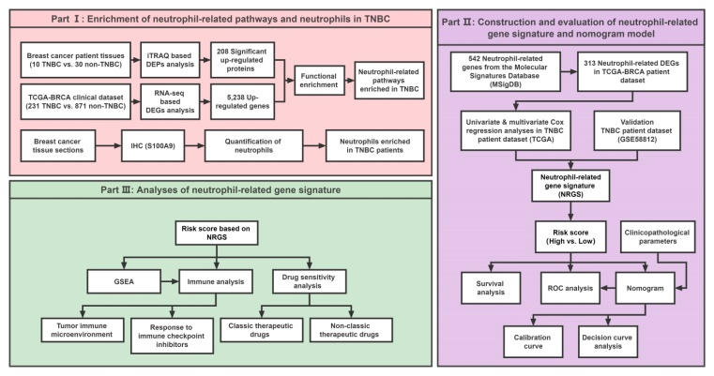
Recent Publications (minimum 5)
- Chanjuan Zheng, …, Xiyun Deng (2021). Lovastatin Inhibits EMT and Metastasis of Triple-Negative Breast Cancer Stem Cells Through Dysregulation of Cytoskeleton-Associated Proteins. Frontiers in Oncology 11:656687.
- Sisi Chen, …, Chanjuan Zheng, Xiyun Deng (2022). Nucleolar and Coiled-Body Phosphoprotein 1 (NOLC1) Is Associated with Stemness and Represents a Potential Therapeutic Target in Triple-Negative Breast Cancer. Frontiers in Oncology 12:731528.
- Zhe-Yu Hu, Chanjuan Zheng, …, Xiyun Deng (2022). Co-expression and Combined Prognostic Value of CSPG4 and PDL1 in TP53-aberrant Triple-Negative Breast Cancer. Frontiers in Oncology 12:804466.
- Huimei Yi, …, Chanjuan Zheng, Guangchun He, Xiyun Deng (2020). Reversal of HER2 Negativity: An Unexpected Role for Lovastatin in Triple-Negative Breast Cancer Stem Cells. Journal of Cancer 11(13): 3713-3716.
- Shichao Yan, …, Chanjuan Zheng, …, Xiyun Deng (2021). CD133 peptide-conjugated pyropheophorbide-a as a novel photosensitizer for targeted photodynamic therapy in colorectal cancer stem cells. Biomaterials Science 9(6):2020-2031.




Biography (150 word limit)
Xiyun Deng is a professor of Pathophysiology, chair of Department of Basic Medical Sciences, and director of Key Laboratory of Translational Cancer Stem Cell Research at Hunan Normal University. His research focuses on experimental therapeutics targeting cancer stem cells and the tumor microenvironment. In recent years, triple-negative breast cancer (TNBC) has been a focus of intense investigations for his lab. Dr. Deng has published over 100 articles/reviews in high-impact professional journals such as Blood, Clinical Cancer Research, Cancer Treatment Reviews, ACS Applied Materials & Interfaces, International Journal of Cancer, Biomaterials Science, etc. He is currently guest-editing a Research Topic for Frontiers in Oncology regarding heterogeneity, tumor microenvironment and targeted therapy in triple-negative breast cancer. As a principal editor, he has compiled a book titled “Triple-Negative Breast Cancer”, which was published by World Scientific Publishing (Singapore).
Email: Chanjuan Zheng: zhengchanjuan@hunnu.edu.cn
Xiyun Deng: dengxiyunmed@hunnu.edu.cn

Notes/Comments:

Presenting author details
Full name: Chanjuan Zheng/Xiyun Deng, Ph.D.
Contact number: (+86)18711006515
Twitter account:
Linked In account:
Session name/ number: Track 7: Breast Cancer and Immunology
Category: Oral

