A Case Report of Unilateral Cervical Lymphadenopathy and
Multiple Cranial Neuropathies following mRNA-COVID-19
Vaccination
________________________________________________________
Fatma Shalabi

Eberhard Karls University , Germany.

Abstract
Background: Various neurological syndromes have been reported in association with vaccines, including cranial nerve palsies, without exact relationship of these syndromes to the vaccinations. Vaccines in general, may act as triggers for autoimmune reactions, since they contain both infectious agents or their immunogenic proteins and chemical adjuvants, cumulatively acting as triggers of immune system activation, that involves humoral, cellular immunity and inflammatory cytokines’ release. We report a rare case of ipsilateral multiple cranial neuropathy and ipsilateral lymphadenopathy following mRNA-COVID-19 vaccination. Case Presentation: A 41-year-old male visited our emergency room complaining of dysphagia and hoarseness that started a week after receiving COVID19 mRNA vaccination (in his right arm). During his hospitalization, he also complained of right side hearing loss and diplopia. Neurological examination depicted a right IV nerve palsy, ipsilateral facial paresthesia and peripheral facial paresis. Otorinolaryngological examination revealed right vocal cord paralysis. A brain magnetic resonance imaging showed enhancement of the right VII and VIII cranial nerves in the auditory canal. The lumbar puncture revealed increased protein concentration and lymphocytic pleocytosis in the cerebrospinal fluid. Additionally, a neck computed tomography scan showed a swollen right supraclavicular lymph node. We hypothesize that the ipsilateral cranial neuropathies of IV, VI, VII, VIII and X, associated with cervical lymphadenopathy, was possibly caused by a post-vaccination immune-mediated reaction. The patient was treated with a 5-day course of intravenous methylprednisolone (1000mg/day), and a gradual improvement was observed. Conclusions: Similarly, to other vaccines, it is possible that also mRNA vaccines may act as triggers of non-specific autoimmune neurological syndromes.
Image
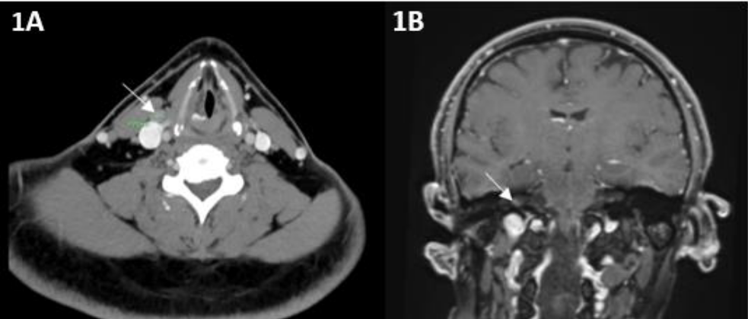
Figure 1A: Axial neck CT image demonstrating a 1 cm right supraclavicular reactive lymph
node (arrow). Figure 1B: Coronial brain (with Gadolinium) MRI image showing enhancement
in the right auditory canal, suggesting involvement of Cranial nerves VII and VIII (arrow).

References
(1) Augusto A Miravalle, Teri Schreiner. Neurologic complications of vaccinations. Handb Clin Neurol. 2014;121:1549-57
(2) Dimitrios Karussis, Panayiota Petrou. The spectrum of post-vaccination inflammatory CNS demyelinating syndromes. Autoimmun Rev. 2014 Mar;13
(3) Norbert Pardi, Michael J. Hogan, Frederick W. Porter and Drew Weissman. mRNA vaccines — a new era in vaccinology. Nature Reviews Drug Discovery volume 17, pages261–279(2018)

Biography
Fatma Shalabi is an Adultneurologist, who finished his residency this year, in Hadassah medical center in Jerusalem, Israel. Now she is doing intensive care medicine also in Hadassah medical center. She studied Medicine at Eberhard Karls University in Tuebingen, Germany.

