
Capsaicin: A Two-Decade Systematic Review of Global Research Output and Recent
Advances Against Human Cancer
Tomi Lois Adetunji1, Femi Olawale2, Chijioke Olisah3, Ademola Emmanuel Adetunji4* and Adeyemi Oladapo Aremu5

1 Unit for Environmental Sciences and Management, North-West University, Potchefstroom, South Africa, 2 Nano-Gene and Drug Delivery Group, Discipline of Biochemistry, School of Life Sciences, College of Agriculture, Engineering and Science, University of KwaZulu-Natal, Durban, South Africa, 3 Department of Botany and Institute for Coastal and Marine Research, Nelson Mandela University, Port Elizabeth, South Africa, 4 Department of Molecular and Cell Biology, University of Cape Town, Cape Town, South Africa, 5 Indigenous Knowledge Systems Centre, Faculty of Natural and Agricultural Sciences, North-West University, Mmabatho, South Africa, 6 School of Life Sciences, College of Agriculture, Engineering and Science, University of KwaZulu-Natal, Durban, South Africa




Introduction
- Capsaicin (8-methyl-N-vanillyl-6-nonenamide) is one of the most important natural products in the genus Capsicum (Olatunji and Afolayan, 2020). Due to its numerous biological effects, there has been extensive and increasing research interest in capsaicin, resulting in increased scientific publications in recent years.

- This study performs an in-depth bibliometric analysis of published literature on capsaicin from 2001 to 2021 (Figure 1) to assess the global research status, thematic and emerging areas, and potential insights into future research activities.

- Recent research advances of capsaicin and its combination therapy on human cancer as well as their potential mechanisms of action are described.

Methodology
Included Eligibility Screening Identification
Results
- Research outputs on capsaicin have increased by an estimated 18% per year and were dominated by research articles at 93% of the 3753 assessed literature.

- Anti-cancer/pharmacokinetics, cytotoxicity, in vivo neurological and pain research studies are the thematic domains for capsaicin research.

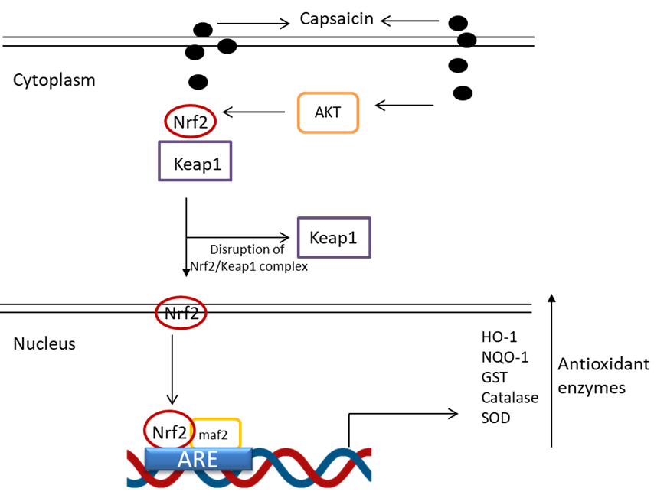
- The potential of capsaicin to mitigate cancer mainly involves its chemo-preventive properties, often linked to its multi-biological effects such as antioxidant (Figure 2), anti-mutagenic, and anti-inflammatory activities.

2914 records identified in WoS database: article – 2719, review – 2131, editorials – 41, book chapter – 23
3261 records identified in Scopus database: article – 3024, review – 184, editorials – 9, book chapter – 44

3753 records accessed for eligibility

3753 records included in bibliometric synthesis
Figure 1. Flow chart of the bibliometric study of capsaicin showing the selection and inclusion criteria from Web of Science (WoS) and Scopus databases

*
adetunjiademola@hotmail.com 0000-0001-8420-8914
@AEAdetunji

Figure 2. Antioxidant enzyme pathway regulation by capsaicin
6175 records screened for analysis
2422 records excluded after removing duplicates

Conclusion
- Although there is an increasing focus on assessing the clinical effects of capsaicin, especially the analgesic activity, such studies on its anticancer efficacy are currently limited.

References
- Olatunji and Afolayan, 2020. Doi: 10.1080/19315260.2019.1629519

