Insights Into Modifiable Risk Factors of Infertility: A Mendelian Randomization Study
Yueyuan You
Sichuan University, Chengdu 610041, China
Abstract
Objective: Observational studies have linked lifestyle, diet, obesity, and biochemical measures with infertility. Whether this association is causal is unclear. We sought to identify the causal relationship between modifiable risk factors with infertility. Methods: Using single-nucleotide polymorphisms (SNPs) as a genetic instrument variable, we carried out a two-sample Mendelian randomization (MR) analysis to estimate the causal effects for 22 modifiable risk factors on female infertility (6481 cases; 75,450 participants) and male infertility (680 cases; 73,479 participants). Results: The results of the study showed that BMI (OR: 1.24, 95% CI (1.09, 1.40)), body fat percentage (OR: 1.73,95% CI (1.13, 2.64)), and alcohol consumption (OR: 6.57, 95% CI (1.2, 36.14)) are associated with a higher risk of male infertility, and total fatty acids (OR: 1.16, 95% CI (1.03, 1.30), omega-6 fatty acids (OR: 1.14, 95% CI (1.00, 1.27)), and monounsaturated fatty acids (OR: 1.14, 95% CI (1.03, 1.28) are associated with a higher risk of infertility in women. We observed that higher education (OR: 0.77, 95% CI (0.64, 0.92)) was a protective factor for female infertility. Conclusions: BMI, body fat percentage, and alcohol consumption are risk factors for male infertility; total fatty acids, omega-6 fatty acids, and monounsaturated fatty acids are risk factors for female infertility, and education is a protective factor for female infertility.

Image

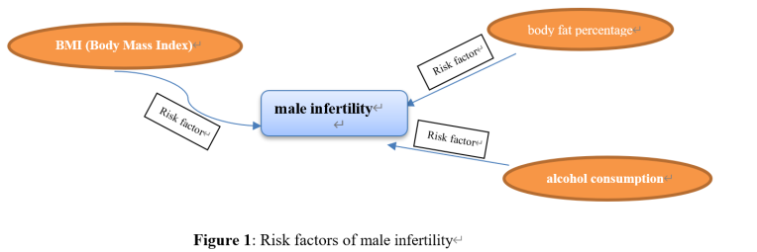

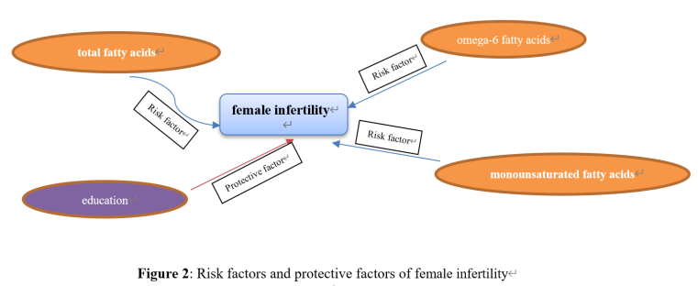

References
Patra, S.; Unisa, S. Addressing reproductive health knowledge, infertility and coping strategies among rural women in India. J. Biosoc. Sci. 2021, 53, 557–565.
Xie, F.; You, Y.; Guan, C.; Gu, Y.; Yao, F.; Xu, J. Association between physical activity and infertility: A comprehensive systematic review and meta-analysis. J. Transl. Med. 2022, 20, 237.
Finelli, R.; Mottola, F.; Agarwal, A. Impact of Alcohol Consumption on Male Fertility Potential: A Narrative Review. Int. J. Environ. Res. Public Health 2021, 19, 328.
de Angelis, C.; Nardone, A.; Garifalos, F.; Pivonello, C.; Sansone, A.; Conforti, A.; Di Dato, C.; Sirico, F.; Alviggi, C.; Isidori, A.; et al. Smoke, alcohol and drug addiction and female fertility. Reprod. Biol. Endocrinol. RBE 2020, 18, 21.
Eisenberg, E.; Legro, R.S.; Diamond, M.P.; Huang, H.; O’Brien, L.M.; Smith, Y.R.; Coutifaris, C.; Hansen, K.R.; Santoro, N.; Zhang, H. Sleep Habits of Women with Infertility. J. Clin. Endocrinol. Metab. 2021, 106, e4414–e4426.
Biography
Yueyuan You has her expertise and passion in epidemiology and the evidence based medicine. Her findings of risk factors and protective factors of male and female infertility using a mendelian randomization method shed light on the studies of infertility. She has built this work through years of experience in research, calculating, and application both in hospital and education institutions. A 2-sample MR using summary-level data from published GWASs is performed. This approach is responsive to all stakeholders and has a different way of focusing.
Email: 2021224080003@stu.scu.edu.cn

