Synthesis and characterization of Ag-MO encapsulated with anti-tumor drug “Doxorubicin” and their applications for controlled drug delivery
Mohamed G. El-Desouky^{1*}, Ashraf A. El-Bindary²
¹Egyptian Propylene and Polypropylene Company, Port Said 42511, Egypt
²Chemistry Department, Faculty of Science, Damietta University, Damietta 34517, Egypt.
*Corresponding author. E-mail: ch.moh.gamal@gmail.com

Abstract (300 word limit)
Metal-organic frameworks (MOFs) with nanoscale dimensions are a potential class of porous nanomaterials for biomedical applications. In this search A silver metal organic frame (Ag-MOF) was synthesized and characterized using: XRD, XPS, SEM, FT-IR, and BET surface area measurements of the resulting sample showed that Ag-MOF has a high surface area of 882 m²/g. Here, we present a straightforward and quick hydrothermal synthesis approach that involves combining 2-metryl imidazole with silver nitrate. Doxorubincin (DOX), an anticancer medication, will then be incorporated into the Silver Metal Organic Framework (Ag-MOF) and created as (DOX@Ag-MOF). They proved the ability to destroy cancer cells and release medications in response to pH. Using our straightforward one-pot method, MOFs NPs can be created as multipurpose delivery systems for a range of cargos, includes pharmaceutical and imaging agents. A pH of 5.4 can discharge the contained medication more quickly than a pH of 7.4. While DOX@Ag-MOF exhibits stronger cytotoxicity in HepG-2 and MCF-7 cells than free DOX at concentrations greater than 12.5 µg/mL, Ag-MOF nanoparticles displayed only moderate cytotoxicity. These results indicated a potential for DOX@Ag-MOF nanoparticles as a useful strategy for drug delivery to cancer cells. Additionally, Ag-MOF, DOX, and encapsulated DOX@Ag-MOF compounds were assessed for their potential antibacterial effectiveness against pathogenic bacteria in comparison to conventional antibiotics using the agar well diffusion methodology. The DOX@Ag-MOF displays a significant inhibitory zone against gram negative organisms when comparing to the reference drug Gentamycin (E. Coli). According to the theoretical research, the DOX has a low kinetic stability and a strong chemical reactivity. The results of the docking investigation showed that DOX has excellent biological action towards Covid-19, breast, prostate, and leukaemia. Low values of binding energy, inhibition constant, and many H-bonds all contribute to these findings. By computing the phipsi torsion angles for each amino acid residue in the protein molecules, Ramachandran plots were created with the goal to illustrate the energetically authorized regions of the amino acid residues in the homology models of our cell lines.

Image
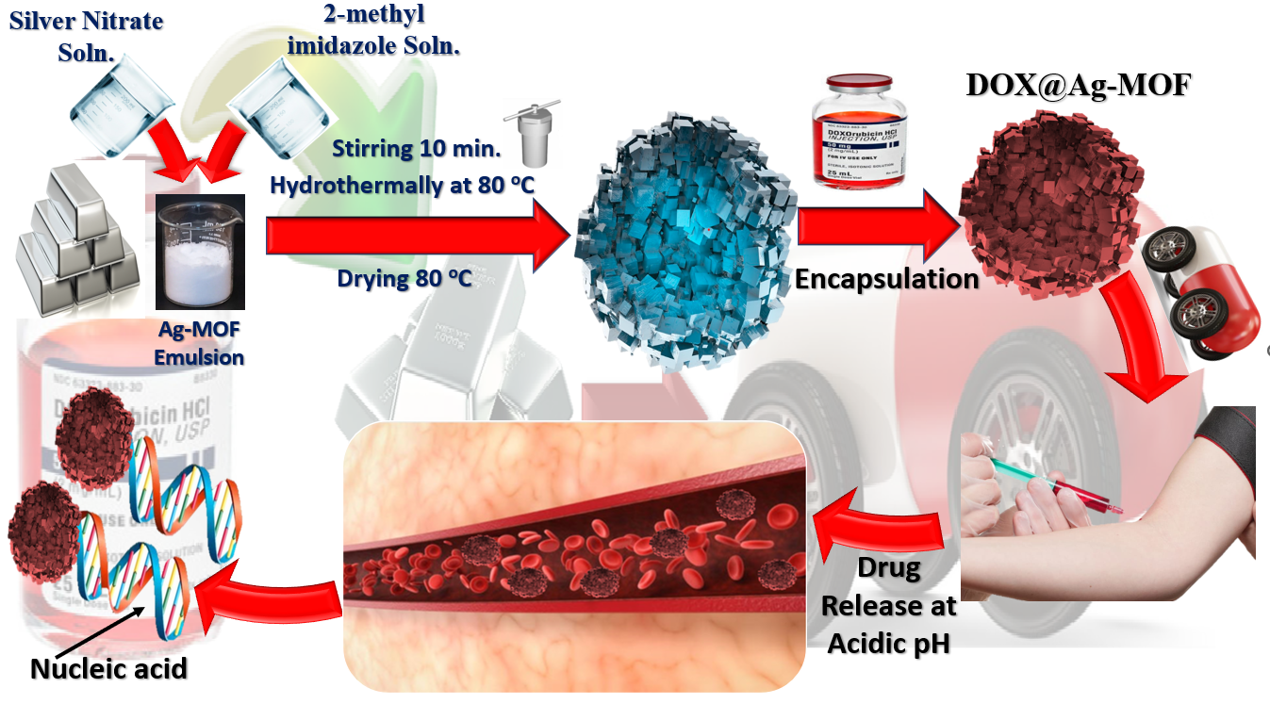
Recent Publications (minimum 5)
- M.A. El‐Bindary, M.G. El‐Desouky, A.A. El‐Bindary, Metal‐organic frameworks encapsulated with an anticancer compound as drug delivery system: Synthesis, characterization, antioxidant, anticancer, antibacterial and molecular docking investigation, Appl. Organomet. Chem., (2022) e6660.
- N. Hassan, A.Z. El-Sonbati, M.G. El-Desouky., Synthesis, characterization, molecular docking and DNA binding studies of Cu (II), Ni (II), Zn (II) and Mn (II) complexes, J. Mol. Liq., 242 (2017) 293-307.
- A.A. El‐Bindary, M.G. El-Desouky, M.A.M. El-Afify, Thermal and Spectroscopic Studies of Some Prepared Metal Complexes and Investigation of their Potential Anticancer and Antiviral Drug Activity against SARS-CoV-2 by Molecular Docking Simulation, Biointerface Res. Appl. Chem., 12 (2021) 1053-1075.
- G.A. Al–Hazmi, A.A. El-Zahhar, M.G. El-Desouky, M.A. El-Bindary, A.A. El-Bindary, Efficiency of Fe3O4@ ZIF-8 for the removal of Doxorubicin from aqueous solutions: Equilibrium, kinetics and thermodynamic studies, J. Environ. Technol., (2022) 1-48.
5. M.G. El-Desouky, A.A. El-Bindary, M.A. El-Bindary, Low-Temperature Adsorption Study of Carbon Dioxide on Porous Magnetite Nanospheres Iron Oxide, Biointerface Res. Appl. Chem., 12 (2021) 6252-6268.

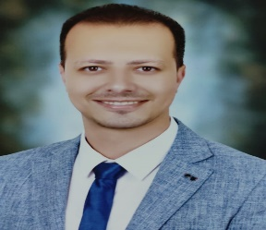
Biography (150 word limit)
Dr. Mohamed G. El-Desouky M.SC. in inorganic chemistry; Thermal and Spectroscopic Studies of Some Prepared Metal Complexes with Expected Antimicrobial and Anticancer Activities, Ph.D. in Analytical chemistry; Removal of Some Pollutants Using Some Adsorption Materials. Synthesis material for drug delivery system and work at Egyptian Propylene and Polypropylene Company
Email: ch.moh.gamal@gmail.com

Notes/Comments:

Presenting author details
Full name: Mohamed Gamal Ibrahiem El-Desouky
Contact number: 00201091883456
Mail id: ch.moh.gamal@gmail.com
Category: (Oral presentation)

