The Experiences of Romantic Relationships in Black Women with a History of Anorexia Nervosa
Lauren Duncan, City University, Third Year Doctoral Student, London.

Abstract
Statement of the Problem: Anorexia nervosa (AN) has been shown to significantly impact interpersonal relationships but there is limited qualitative research examining romantic relationships among women with AN, especially Black women. This is important as Black people are less likely than other ethnic groups to receive an eating disorder diagnosis and professional help, attesting their symptoms are minimised by professionals. The problem has been exacerbated by the Pandemic as 70% of AN sufferers report their feelings of loneliness have increased and, with Black communities having been disproportionately impacted by the Pandemic, Black women with anorexia may be among the biggest victims. The purpose of this study is to explore the experiences of romantic relationships in Black women with a history of AN.
Methodology: Through Interpretative Phenomenological Analysis, individual semi-structured interviews were conducted on ten UK-based Black cisgender females with experience of AN aged 20-45.
Preliminary Findings: British Black women can experience acculturative stress and pressures to assimilate to western ideals as they negotiate their dual identities. AN in Black women may be based upon starvation that is beyond a pre-occupation of the body and more representative of a hunger in the mind; it may not solely be a preoccupation with appearance and need for control but also a strategy for coping with stress, depression, trauma, and insecure attachment. Whilst AN can adversely impact sufferers’ romantic relationships, it may also be a protective factor for some.
Conclusion & Significance: Most facilitators of, and barriers to, AN treatment concern interactions between the client and their social environment so understanding sufferers’ lived experiences of intimacy may elucidate both the antecedents and consequences of AN, both of which are important to explore in therapy. Offering greater insight into the lived experience of romantic relationships of Black women with AN may give a greater voice to this unrepresented population in the context of their illness, romantic relationships, racial/cultural expectations, and so better support those seeking help – crucial as sufferers lament professional focus on the physical manifestations of AN at the expense of their underlying emotional difficulties.

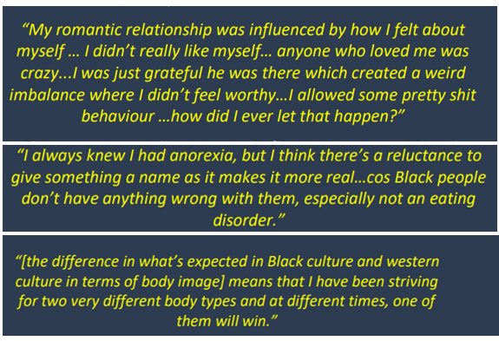
Recent Publications
- Schoeler, T., Duncan, L., Cecil, C. M., Ploubidis, G. B., & Pingault, J. B. (2018). Quasi-experimental evidence on short-and long-term consequences of bullying victimization: A meta-analysis. Psychological bulletin, 144(12), 1229.
- Schoeler, T., Choi, S. W., Dudbridge, F., Baldwin, J., Duncan, L., Cecil, C. M., ... & Pingault, J. B. (2019). Multi–polygenic score approach to identifying individual vulnerabilities associated with the risk of exposure to bullying. JAMA psychiatry, 76(7), 730-738.



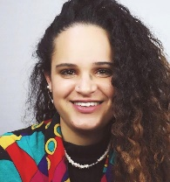
Biography
Lauren Duncan is a final year student on the Doctoral Psychology Course at City University, London. As a woman of dual heritage with previous employment and personal experience in mental health, she decided to conduct her doctoral research on the experiences of intimacy in Black women with anorexia nervosa. Her clinical work as a trainee counselling psychologist in an eating disorder service has given her further insight into the effects anorexia can have on close relationships and has highlighted the relevance of the intersectionality between race, culture, and religion and how this may impact eating disorder behaviour in Black women specifically.

Email: lauren.duncan@city.ac.uk

Presenting author details
Full name: Lauren Duncan
Contact number: 07801 520 737
Twitter account: @LaurenJDuncan3
Linked In account: www.linkedin.com/in/laurenJJduncan
Session name/ number:
Category: (Oral presentation/ Poster presentation

