Observational Case Study on the Efficacy of the polyherbal decoction Varanadi Kashaya in Managing Obesity of an Individual with Metabolic Disorders


W.K.A.A.T. Perera* - Institute of Indigenous Medicine, University of Colombo, Rajagiriya, Sri Lanka
N.D.N. Jayawardena -Institute of Indigenous Medicine, University of Colombo, Rajagiriya, Sri Lanka

Abstract:
Obesity is increasing at epidemic proportions globally giving rise to many serious non-communicable diseases like cardiovascular diseases, hypertension, type 2 diabetes and dyslipidemia. Even though there are Food and Drug Administration (FDA) approved drugs and synthetic pharmaceuticals in the market they have many more side effects and don’t have any direct effect on adipocytes which play a major role in making an individual obese. But the polyherbal drug Varanadi kashaya (VK) addresses the root cause by downregulating adipogenic genes, preventing proliferation and hypertrophy of adipocytes and pre-adipocytestes without any side effects. Moreover hypocholesterolemic, anti-diabetic, anti-oxidant and free radical scavenging characteristics of the herbals which constitute VK make it a possibility to address metabolic disorders as well. However, the efficacy of VK in managing obesity in individuals with metabolic disorders has not yet been evaluated in detail. The aim of this study is to determine the efficacy of VK in an obese individual with metabolic disorders. Materials and methods: VK was given for 30 days to an obese person with diabetes and hyperlipidemia. The effect of VK was dictated by analyzing the changes in anthropometry, Ayurveda parameters and laboratory investigations such as SGOT, SGPT, FBS, HbA1C and lipid profile. Results: High-risk apple shape body was shifted into a ratio between apple and pear threshold which is of moderate risk to health problems by reducing the weight/hip ratio from 0.95 to 0.84. Markedly reductions in LDL levels were observed from 112.6 mg/dl to 106.2 mg/dl. The reduction of Total cholesterol levels from 180 mg/dl to 171 mg/dl, and Non-HDL levels from 132 mg/dl to 129 mg/dl were noticed in laboratory findings while some other parameters were constant throughout. Conclusion: The results reveal the potency of anti-obesity action of VK which addresses both subcutaneous and visceral fat. Hence, opens up the potentia of control obesity-related metabolic disorders.

Importance of Research:

Varanadi Kashaya (VK) is a polyherbal decoction which is mentioned in Ayurveda classic Ashtanga Hrudaya. Several clinical studies have shown the potentiality of VK in treating obesity. However, the effectiveness of VK in managing obesity in individuals with metabolic disorders has not yet been evaluated in detail. Hence, the aim of our study is to determine the effectiveness of VK in an obese individual with metabolic disorders via an observational case study. Varanadi Kashaya was prescribed over a period of 30 days to an obese individual with diabetes mellitus and hyperlipidemia. Anti-obesity action and the effect on metabolic disorders were determined by analyzing the changes in anthropometry, Ayurveda parameters and laboratory reports

Biography

W.K.A.A.T Perera (Corresponding author) is reading Bachelor of Ayurveda Medicine and Surgery in the Institute of Indigenous Medicine, University of Colombo, Sri Lanka, and is in the final year. As per the interest in carrying out research studies in Ayurveda, has participated in expert talks, webinars, and national and international training programs and has submitted abstracts and papers to international conferences, and is in the process of publishing in journals.

N.D.N Jayawardhane (Supervisor) is a senior lecturer for 13 years in the Institute of Indigenous Medicine, University of Colombo, Sri Lanka. Served as Unit Head for Kayachikitsa Unit and also an Ayurveda Medicine consultant for National Ayurveda Teaching Hospital. He has
completed MD in the year of 2012 in the field of Kayachikitsa (Ayurveda General Medicine), specialized area as Hepatobiliary System, from the Benaras Hindu University, India and Ayurveda undergraduate studies at the Institute of Indigenous Medicine University of Colombo, Sri Lanka. He has served roughly on fifteen conference and workshop programs nationally and internationally.
Professional career outside of academia includes practicing specifically focusing on the traditional medicine with the background support of “Kirineliya Traditional Medicine pedigree” which is specialized in wound healing and cancer treatment.

Information of Institute/ University/ Laboratory :

Institute of Indigenous Medicine (IIM), University of Colombo remains one of the country’s traditional health care systems in the field of Medical education by maintaining high standards and values. The Institute of Indigenous Medicine is the one and only institute which teaches indigenous medicine in Sri Lanka and produce Ayurveda Medical doctors and Unani Medical doctors. Hence, the IIM provides a brilliant opportunity for its undergraduate students to expand the knowledge and skills on indigenous medicine with hands on experience on Ayurveda system of medicine or Unani system of medicine with the exposure for a highly diverse and nourishing environment with clinically-based study programs as top-priority. The institute also actively conducts various diploma courses, certificate courses and postgraduate diploma courses related to different disciplines in Ayurveda and Unani systems of medicine. The Institute has a dynamic, vibrant and highly stimulating clinical based teaching and research environment which is achieved through a blend of high quality academic staff members who are committed to disseminate knowledge in all the areas of Ayurveda and Unani systems of Medicine. Ultimate goal of the institute is to produce knowledgeable skilled doctors in Ayurveda or Unani systems of Medicine.
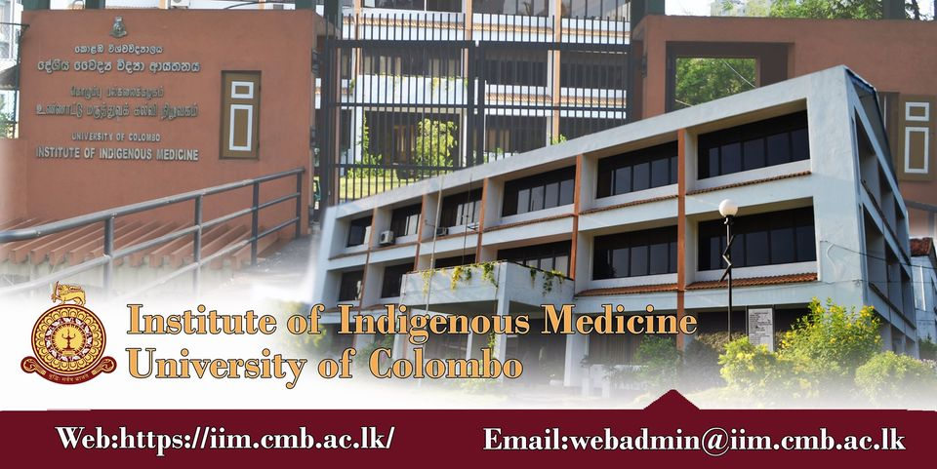

References (15-20):

[1] Samhita C. (2007) Ayurveda Dipika Commentary of Chakrapanidatta. Chaukhambha Surbharati Prakashan, Varanasi, Reprint, Sutra Sthana; 1 (68), 20.
[2] Srikanthamurthy, K. R. (1998). Bhāvaprakāśa of Bhāvamiśra: text, English translation, notes, appendences and index (Vol. 2). Krishnadas Academy.
[3] Mohamed, G. A., Ibrahim, S. R., Elkhayat, E. S., & El Dine, R. S. (2014). Natural anti-obesity agents. Bulletin of faculty of pharmacy, Cairo University, 52(2), 269-284.
[4] Chinchu, J. U., & Mohan, M. C. (2020). Downregulation of adipogenic genes in 3T3-L1 Pre adipocytes-a possible mechanism of anti-obesity activity of herbal decoction Varanadi Kashayam. Journal of herbal medicine, 19, 100309.
[5] Blundell, J. E., & Halford, J. C. (1995). Pharmacological aspects of obesity treatment:

towards the 21st century. International journal of obesity and related metabolic disorders: journal of the International Association for the Study of Obesity, 19, S51-5.
[6] Parasuraman, S., Thing, G. S., & Dhanaraj, S. A. (2014). Polyherbal formulation: Concept of Ayurveda. Pharmacognosy reviews, 8(16), 73.
[7] Chinchu, J. U., & Kumar, B. P. (2018). In-vitro anti-lipase and antioxidant activity of polyherbal ayurvedic medicine varanadi kashayam. International journal of pharmaceutical sciences and research, 9(12), 5373-5381.
[8] Labhade, S. D., Sharma, S., Paliwal, S., & Desai, S. (2021). An Overview of Some Plant Based Products With Hepatoprotective Activity. Iraqi Journal of Pharmaceutical Sciences (P-ISSN: 1683-3597, E-ISSN: 2521-3512), 30(2), 1-15.
[9] Talukdar, S. N., Rahman, M. B., & Paul, S. (2015). A Review on Barleria prionitis: its pharmacognosy, phytochemicals and traditional use. Journal of the Academy of Marketing Science, 4(4), 1-13.
[10] Banerjee, S., Banerjee, S., Jha, G. K., & Bose, S. (2021). Barleria prionitis L.: An Illustrative Traditional, Phytochemical and Pharmacological Review. The Natural Products Journal, 11(3), 258-274.
[11] Wishnofsky, M. (1964). Use of Diuretics in the Treatment of Obesity. JAMA, 187(5), 377-377.
[12] Dhale, D. A., & Markandeya, S. K. (2011). Antimicrobial and phytochemical screening of Plumbago zeylanica Linn.(Plumbaginaceae) leaf. Journal of Experimental Sciences, 2(3).
[13] Nayak, A., & De, S. (2014). Phytopharmacognostic investigation of Marsdenia tenacissima (ROXB) moon. World J. Pharm. Res, 3, 891-904.
[14] Rahman, S., & Parvin, R. (2014). Therapeutic potential of Aegle marmelos (L.)-An overview. Asian Pacific journal of tropical disease, 4(1), 71-77.
[15] Srinivasan, K., & Kumaravel, S. (2016). Unraveling the potential phytochemical compounds of Gymnema sylvestre through GC-MS study. Int J Pharm Sci, 8(1), 1-4.
[16] Parmar, S., Gangwal, A., & Sheth, N. (2010). Solanum xanthocarpum (yellow berried night shade): a review. Der Pharm Lett, 2(4), 373-383.
[17] Sharma, V., Hem, K., Seth, A., & Maurya, S. K. (2017). Solanum indicum Linn.: An ethnopharmacological, phytochemical and pharmacological review. Curr. Res. J. Pharm. Allied Sci, 1, 1-9.
[18] Chopade, V. V., Tankar, A. N., Pande, V. V., Tekade, A. R., Gowekar, N. M., Bhandari, S. R., & Khandake, S. N. (2008). Pongamia pinnata: Phytochemical constituents, traditional uses and pharmacological properties: A review. International Journal of Green Pharmacy (IJGP), 2(2).
[19] Lima, A. L., Parial, R. A. M. E. N. D. U., Das, M. A. N. I. S. H. A., & Das, A. K. (2010). Phytochemical and pharmacological studies of ethanolic extract from the leaf of mangrove plant Phoenix paludosa Roxb. Malaysian Journal of Pharmaceutical Sciences, 8(2), 59-69.
[20] Vishnu, P. M., & Acharya, S. (2017). Varanadigana kashaya in the management of sthaulya (obesity)-A clinical trial. Ayurpharm Inte J Ayurveda Allied Sci, 6, 149-56.

