Classification and Identification of Individuals Using Analysis Lip Prints

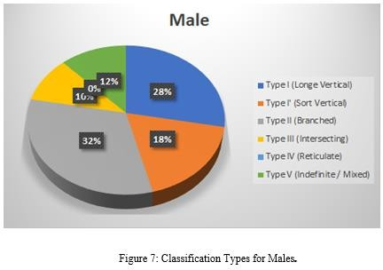
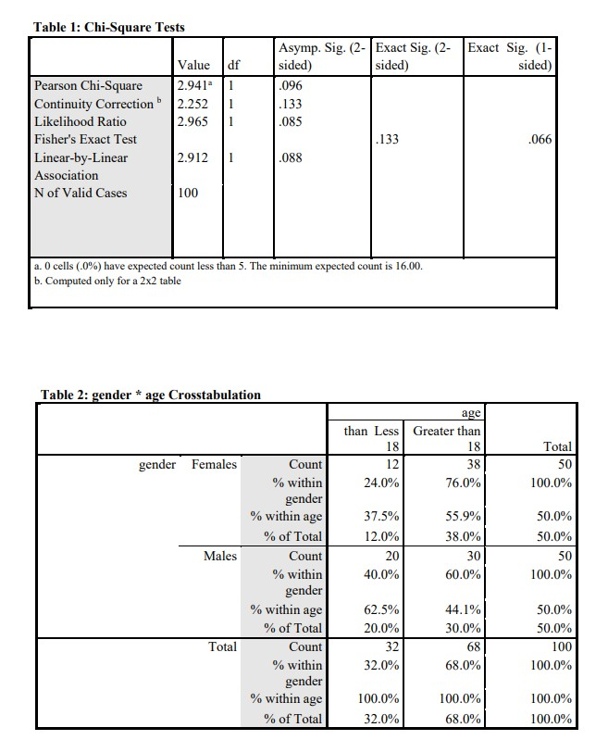
Introduction

Dentistry, Tikrit University, Iraq. Email: tamsamka@tu.edu.iq
Tamara A. Anai, BCS, MSC, IQ Muthenna Sh. Rajab, BDS, MSC, IQ
Muhaned Al-Hashimi, BCS, MSC, PhD, IQ
Identifying individuals is a major challenge for forensic investigators, as DNA and fingerprints are highly valuable, but are not always readily available at crime scenes. Lip prints could be used in this context since they are unique to each individual. Lip-print study (Cheiloscopy) is a reliable biometric technology and is considered a unique parameter for identification. This study determined lip print patterns among samples of the Salah El-Din population in Iraq and distribution their pattern type of lip print by using a program in MATLAB. In this study, it was established that there are significant differences between populations, countries, and genders when it comes to the distribution of lip prints.

Materials and Methods

Samples:
The study included 100 healthy individuals (50 males and 50 females) from the Salah El-Din population in Iraq, all of whom were over the age of ten. All the samples gave their informed consent.

A Guide to Recording Lip Prints:
Individuals were provided with good status for recording lip prints, as illustrated in Fig. 1. Before the treatment, the participants' lips were wiped using tissue paper. Fig.1-A shows the materials that are used to take lip prints, dark-colored healthy) (White Lian) is a food color for foods) like rouge was put evenly using the brush. The sticky side of a 15 cm transparent cellophane strip was placed over the lips as indicated in Fig. 1-B and 1- C. The impression was formed by compressing softly from the middle to the corners of the lips while in the normal resting position. Later, we removed the imprint and put it onto a white paper for recording Fig. 1-D. We used a survey table sheet for each individual information as Fig. 1-E. After that, we collected all lip prints in the computer after scanner it to analyze, the final lip print
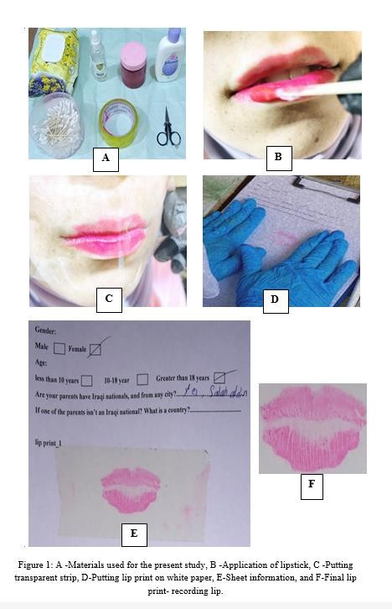
Results
The generality of common lip patterns in the Salah El-Din population, in Iraq, was the type I (42%) followed by type I’ (20%), type II & V (14%), type III (10%), and IV (0%), in females as shown in Figure 6. Type II accounts for (32%) of males, after type in I (28%), I' (18%), V (12%), III (10%) and IV (0%) as shown in Figure 7. Using the Chi-square test to determine gender dimorphism among the Salah El-Din population. Table 1 shows the Chi-square test for data. Table 2 distribution gender * age Crosstabulation.
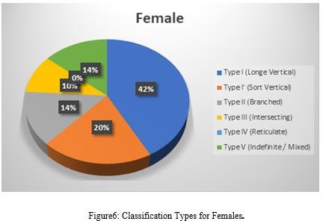
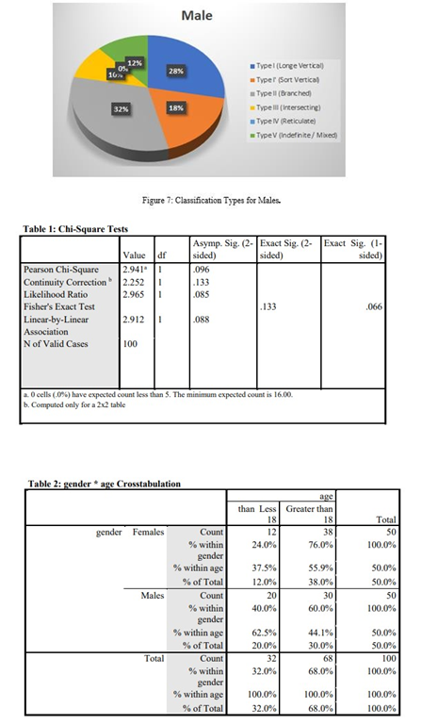

Conclusion

- This study confirmed the uniqueness of lip print patterns even between family relatives. There may be a role for Cheiloscopy in the identification process, both in civil and criminal matters.
- The lip print pattern among the Salah El-Din population in Iraq showed significant gender dimorphism.
- The study discovered type I is (42%) in females and Type II (32%) in males were the most and there is no type IV (0%) in females and males among the population of the Salah El-Din in Iraq.

Tamara A. Anai, BCS, MSC, IQ
Dentistry, Tikrit University, Iraq.
Email: tamsamka@tu.edu.iq
Poster Presentation

