Clinical Applications of Trauma Therapy with Substance Abusers: Therapeutic Strategies and Insights to Help Patients Overcome Addiction
The inner world of the healthy child is filled with wonder, awe and faith in the benevolence of a just and fair world. But for people who have suffered a trauma in childhood, this belief is hard to achieve. This dialectic has been the central theme of psychological research and substance abuse recovery programs whose aim it is to help curb the impact of trauma on addiction in young adults. Historically, trauma and recovery therapists have long wrestled with the unending swing of the addiction pendulum; where suffering and despair is transformed into a more therapeutically pure state of mind, while possibility of relapse continues to loom overhead.
This lecture is designed to further the growth of healthy functioning through teaching strategies and interventions that are gleaned from therapy, research and lived experience. We will explore recent findings from clinical research on trauma and recovery, and we will discuss ways that these findings are applied to every day psychotherapy with survivors of abuse. In addition, we will discuss first-hand accounts of recovery from child abuse, drug abuse and despair, and we will identify key factors that lead to adult sobriety and optimal mental health functioning. Time will be set aside for questions, comments and debriefing before the end of the talk.
In the end, participants will:

- Be more equipped to identify the signs and symptoms of trauma, and how these symptoms manifest in the physical body, as well as in the psyche, of the victim.
- Gain greater insight into how trauma and abuse in childhood are significantly correlated with addiction in adolescence and adult life.
- Develop an appreciation for the latest clinical and empirical findings and strategies for healing addiction behaviors as they are related to Post Traumatic Stress symptomatology and childhood abuse.
- Discover the overlap between psychiatry and addiction, and learn how to apply psychological and existential (as well as spiritual) concepts in their work with patients who are in recovery.

About the Speakers:

Nathan Spiteri is a film maker, actor and writer. He is also a sexual abuse survivor, activist and advocate. Born in Canberra, Australia, Nathan was sexually abused as a child, threatened with his life and the lives of his family members. Keeping the abuse a secret, he turned to drugs, violence and sex in an effort to regain a sense of power and identity. Nathan came out about his trauma after twenty-five years of self-destruction. Through intensive therapy and group work,

including AA, NA and SA, Nathan now educates people on the stigma of child sexual abuse and its relation to addiction and substance abuse. Through this medium, Spiteri helps other survivors find closure and move forward with their lives while raising awareness of men’s mental health.

Nathan works with a number of charitable organizations both in the U.S. and Australia. He is currently the Global Ambassador for the Child Liberation Foundation, a child sex trafficking foundation with the goal to eliminate child sex trafficking around the world. He also works with the ‘Aussies Say No More’ Campaign, as part of the global “No More” Campaign, ‘Menslink’ in Canberra, Australia, and ‘SAMSN’, Survivors and Mates Support Network, one of Australia’s leading associations for male survivors of child sexual abuse. Nathan will be giving a TEDx Talk
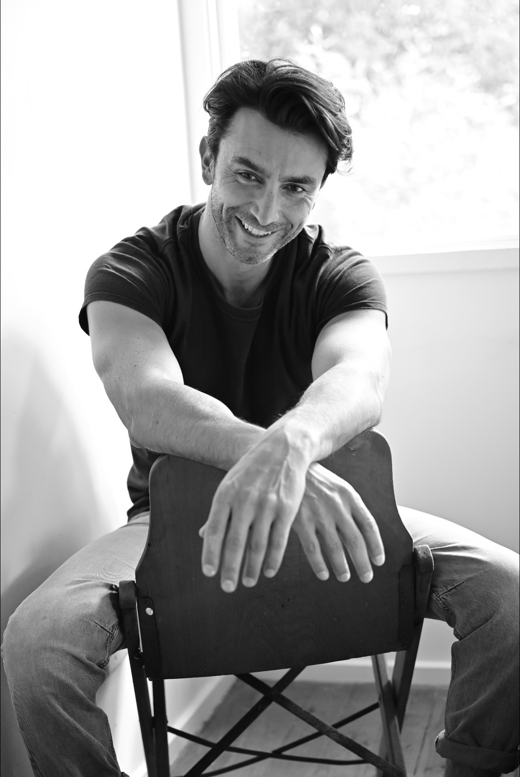
this October 2022 about “Breaking Up with Your Abuser: Recovery from Trauma and Addiction.”

Nathan’s memoir, TOY CARS, is his powerful account of survival and inspiration. The highly acclaimed book dives into the aftermath of being abused and manipulated by the actions and lies of a vicious pedophile. Written as an honest and compelling account of his struggle with child abuse (including a descent into addiction, violence and prostitution), Nathan’s story ultimately offers the redemptive lessons of recovery and acquired wisdom. Nathan introduces readers into the heart and the mind of one who struggles, grieves and ultimately heals to see the value of living after traumatic experiences.

Dr. Norman Fried is a Clinical Psychologist specializing in Trauma and addiction. After receiving his PhD in Clinical
and Pediatric Psychology from Emory University, Dr. Fried served as the Chief Psychologist for the Division of Pediatric Hematology/Oncology at Northwell Health and Winthrop University Hospitals for 30 years. His academic appointments include Assistant Professor in Pediatrics and Psychiatry at New York University Medical School, Adjunct Assistant Professor of Pastoral Counseling at the Jewish Theological Seminary/Columbia University; and was a Fellow in Clinical and Pediatric Psychology at Harvard Medical School. Dr. Fried lectures on the Practice of Psychotherapy with Addiction and Trauma at conferences across the U.S. and Europe.
Additionally, he is a Disaster Mental Health Specialist for The American Red Cross of Greater New York. He is the author of five books; including the made-for-television series The Angel Letters: Lessons that Dying Can Teach Us About Living (Ivan R. Dee Press, 2007), Every Day I Bless You; Reflections on the Healing Power of Shiva (Urim Publications, 2012), Reclaiming Humanity: Helping Children Survive Trauma (Urim Publications, 2017) and A Heart of Wisdom: Notes on Love and Courage from the Desk of a Trauma Therapist (Three Birds Press, 2021). Dr.

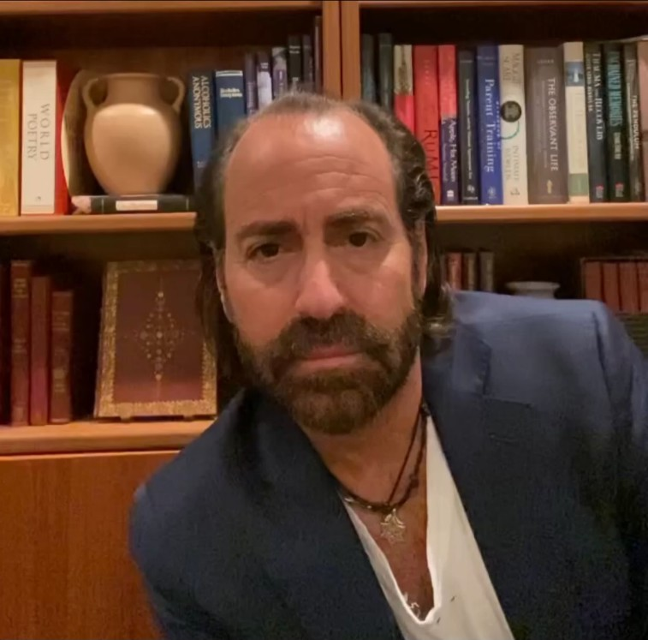
Fried has written the National Standards on Mental Health for School Children When a Classmate Dies. Additionally, he is a regular contributor to television news shows regarding crisis intervention, addiction and recovery, including Dr. Phil, Fox News, BBC World News, NBC News and the Bravo Channel.

