Bi₄TaO₈Cl as a new class of layered perovskite oxyhalide materials for piezopotential driven efficient seawater splitting
Maqsuma Banoo, Ujjal K. Gautamª *

ABSTRACT: Piezocatalytic water-splitting is an emerging approach to generate ‘green hydrogen’ that can address several drawbacks of photocatalytic and electrocatalytic approaches. However, existing piezocatalysts are few and with minimal structural flexibility for engineering properties. Besides, the scope of utilizing unprocessed water is yet unknown and may widely differ from competing techniques due to the constantly varying nature of surface potential. Herein, we present Bi₄TaO₈Cl as representative of a class of layered perovskite oxyhalide piezocatalysts with high hydrogen production efficiency and exciting tailorable features including the layer number, multiple cation-anion combination options, etc. In absence of any co-catalyst and scavenger, an ultrahigh production rate is achievable (1.5 mmol g⁻¹ h⁻¹), along with simultaneous generation of value-added H₂O₂. The production rate using seawater is somewhat less, yet appreciably superior to photocatalytic H₂ production by most oxides as well as piezocatalysts, and has been illustrated using a double-layer model for further development.

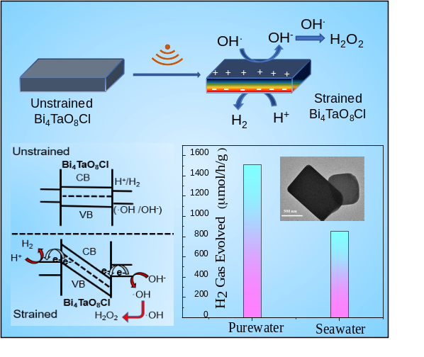
IMAGE:

Figure: schematic showing simultaneous H2 and H2O2 generation through piezocatalysis.

References:
- Tu, S. et.al. Adv. Funct. Mater. 2020, 30 (48), 1–31.
2. Wang, K. et. al. Angew. Chemie - Int. Ed. 2022, 61 (6).
- Starr, M. B et.al. Materials. Sci. Rep. 2013, 3 (1), 1–8.
- Wang, Z. L.; et.al. Science (80-. ). 2006, 312 (5771), 242–246.
- Hu, C et al.Adv. Mater. 2021, 33 (24), 1–9.
- You, H et. al. Angew. Chemie 2019, 131 (34), 11905–11910.

Biography: Maqsuma Banoo has expertise in the synthesis of materials and their application in photocatalytic and piezocatalytic energy harvesting reactions.

