Response of a Multi-Nutrient Intravenous Infusion on hyperpigmentation and Skin Quality: A Clinical Case Study.

Dr Michael. J. A. Barnish MBChB
Clinical Case Studies.
REVIV Global Ltd.

Abstract
Hyperpigmentation is a common condition affecting all ethnicities, in particular those with darker skin tones. Current treatment interventions are topical hydroquinone and oral tranexamic acid. Due to their potential interaction with melanin production, glutathione, vitamin C have been studied as potential interventions for this condition and also as a cosmetic skin lightening therapy. Whether these are successful interventions on their own is inconclusive. This case study explores combined glutathione and vitamin C, intravenous injection and observes the skin, following an eight-week protocol.
Although firm findings cannot be ascertained from this study, a perceived effect is noted, with no reported adverse events, and further study would be required.

Keywords
hyperpigmentation, glutathione, ascorbic acid, vitamin c, intravenous infusion, melanin, hypermelanosis, skin lightening, melasma

Introduction
Melanocytes, in the skin’s basal epidermal layer, produce melanin, the pigment responsible for producing skin colour and providing photoprotective protection to the skin.1 Melanogenesis occurs in organelles, within the melanocytes, called melanosomes where dopaquinone is formed when tyrosinase oxidises tyrosine as the first step to forming both eumelanin (brown) and pheomelanin (red) pigments.2 Melanin production, induced by the sun’s ultraviolet (UV) results in the production of reactive oxygen species (ROS).1
Hyperpigmentation, or melasma, of the skin, is a local and acquired hypermelanosis of the skin. It a common condition affecting all ethnicities, however epidemiological studies report higher prevalence in higher pigmented phenotypes.3 The aetiology of this condition is still not fully determined.4 Hyperpigmentation often appear as brown maclules of the face, often affecting quality of life, even in individuals with a small area of pigmentation.5 Hypermelanosis is not fully understood, however it could occur following excessive inflammation to the skin, or from an inability to successfully clear ROS’s, built up from melanin production.1
Gold standard treatment of hyperpigmentation has been topical hydroquinone, but this has been superseded by tranexamic acid (TA), in recent years, following clinical trials that have revealed its effectiveness and safety for treating the condition.5
Glutathione and vitamin C both play a role in melanin production, in different ways and therefore could provide a potential intervention for treating this condition. Glutathione is thought to play a potential role in changing skin colour because in its reduced form it is essential for pheomelanin formation, mediating the switch from eumelanin production to pheomelanin production.6 Reduced glutathione (GSH) is also thought to bind to the copper containing active site of tyrosinase, therefore proposing that glutathione could also inhibit melanin production, via this method.6 Despite these potential mechanisms of action, glutathione’s efficacy for skin lightening skin colour or for improving hyperpigmentation conditions is not proven. A randomized control trial of 60 women, from Bangkok, measuring oral glutathione supplementation on melanin index found

no statistically significant difference between those taking it and the placebo group.7 An alternative method of measuring skin colour may have found a different result. There were no serious adverse events throughout this study, involving 250mg oral supplementation. Oral supplementation of glutathione may not be an efficacious route for administration of glutathione as it can be easily degraded by the intestinal enzyme gamma-glutamyl transpeptidase (GGT), making cellular bioavailability potentially challenging and may have accounted for the result.8 In general, glutathione supplementation has been observed in several clinical trials, with no serious adverse events being recorded.7
Sonthalia et al, in 2018, argue the safety and efficacy of glutathione use parenterally for cosmetic use around cosmetic skin whitening treatments, suggesting evidence for these, in particular parenteral glutathione, was limited to one study of poor design and concluded that there was little convincing evidence in favour of glutathione use for hyperpigmentation, calling for more evidence to explore glutathione’s efficacy and safety for this condition.9 The authors appear to have a clear bias tone against intravenous glutathione use, focusing on the negative aspects of the one study that they explored for this IV intervention. They reported that this study did not show an effective or lasting treatment for skin tone lightening.9 However, the authors explore the studies faults and limitations in detail. This negative outcome could therefore be down to poor study design and not representative of a true outcome. The authors do not suggest this.
Wantanabe et al share the results of a randomized control trial assessing the effect of topical glutathione on melanin index value, moisture content, smoothness, wrinkle formation and elasticity of the skin. Their findings revealed a significantly lower skin melanin index in the 30 women, as well as significant increases in moisture content, suppression of wrinkle formation and improvement in skin smoothness. None of the case subjects reported adverse events, hinting at its safe use.10
Vitamin C, a potent antioxidant exerts several roles supporting skin physiology, including collagen synthesis and photoprotection.11 It is currently a controversial topic, that vitamin C can inhibit melanogenesis. Studies have demonstrated its ability to do this, but some have only revealed weak effects, especially in the absence of vitamin E.12 Vitamin C also has antioxidant properties, which helps to counteract the accumulation of ROS species caused from melanin production and UV radiation.11
A study of 17 patients, measuring the efficacy between tranexamic acid vitamin C showed that independently they both improved melasma statistically significantly, however there was no statistically significant difference observed between the two interventions.5
There are several methodologies for measuring interventions for hyperpigmentation in individuals. High resolution cross polarized digital photographs at different profiles can be taken and can be an effective way of observing the result.13 However, there are also several scores that can be determined for measuring a whitening effect. Calculating the individual typology angle (ITA°) using a spectrophotometer, utilizing a white ceramic plate is one methodology for measuring whitening effect in clinical study. Alternatively, many studies measure either melasma area and severity scoring (mMASI) or Taylor hyperpigmentation scale. Individuals in studies are often scored using the Fitzpatrick methodology to assess baseline
skin type. Scoring methodologies will be subjectivity and therefore, computed and systematic methodologies are more favourable to reduce the chance of subjectivity with these outcomes.

Case Presentation
The case in this study was a 49-year-old, Caucasian female who presented with post-inflammatory hyperpigmentation, diagnosed at a specialist aesthetic clinic. The case is of Greek heritage. Alongside examination, Mediterranean skin type and chronic excessive sun exposure, without SPF protection, were the two risks that helped to establish diagnosis. The case also complained of dark circles under her eyes and a dull skin tone. The case had not previously received any topical or oral treatment for this condition.
Fig. 1 (below) highlights the hyperpigmentation observed and the main areas of concern for the case.
The case had been wearing SPF sun protection on the face for 2 years prior to the study and had a baseline skin care routine that had been long standing for more than 1 year.

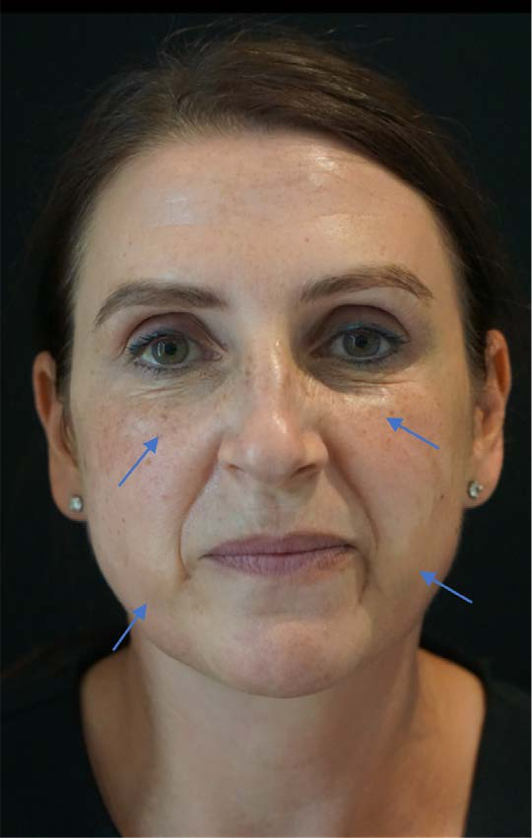
Figure 1. Unedited case photo prior to the treatment displaying significant hyperpigmentation of the lower face and freckling on the mid face. Arrows demarking main areas of concern.

The case received a weekly, multi-nutrient, intravenous (IV) infusion over the course of an eight-week period, having 8 treatments in total. The multi-nutrient IV infusion contained the ingredients, glutathione (3600mg), alongside N-acetyl cysteine (400mg) and vitamin C (500mg). Rationale for this was based upon literature review of relevant nutrients for hyperpigmentation states and adequate certificate of analysis for the safety of an appropriate intravenous infusion.
The case did not change any skin care or SPF habits, keeping them static, as they had been for a long time prior to this study. There were no other treatment interventions, during this study.
Prior to and during the treatment schedule, the case’s blood pressure, heart rate, temperature, oxygen saturation and respiratory rate fell within normal limits. The case reported no side effects from the treatments throughout the study.
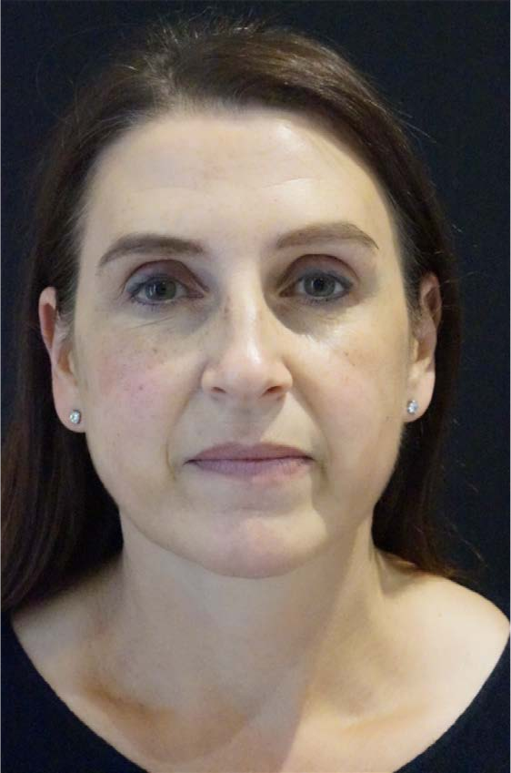
High resolution, cross polarized photography was not available for this case experiment and the method of measuring the intervention was via standard high-resolution photography and patient perceived effect.
Figure 2: Unedited case photo following the eight-week treatment schedule, displaying a reduction in hyperpigmentation of the lower face and freckling on the mid face with improved under eye skin quality.

The post-treatment image’s lighting is slightly different from the pre-treatment image, despite using the same location and camera for the image, at a similar time of day with the window being covered by a blind. However, the image does highlight several improvements. Firstly, the skin tone is more even. The hyperpigmentation is still present around the lower face, bilaterally, but it is softer with a less marked difference between the two skin tones on the first image. The lighting may account for some of this difference. Secondly, the under-eye region of this case appears improved with reduction of fine lines and improved tone. The freckles are also improved and more blended with the surrounded skin tone. Finally, fine lines on the upper lip are also reduced.
Following the treatment schedule, the case reported a significant improvement in the skin’s tone and quality and was content with her perceived reduction of the hyperpigmentation.

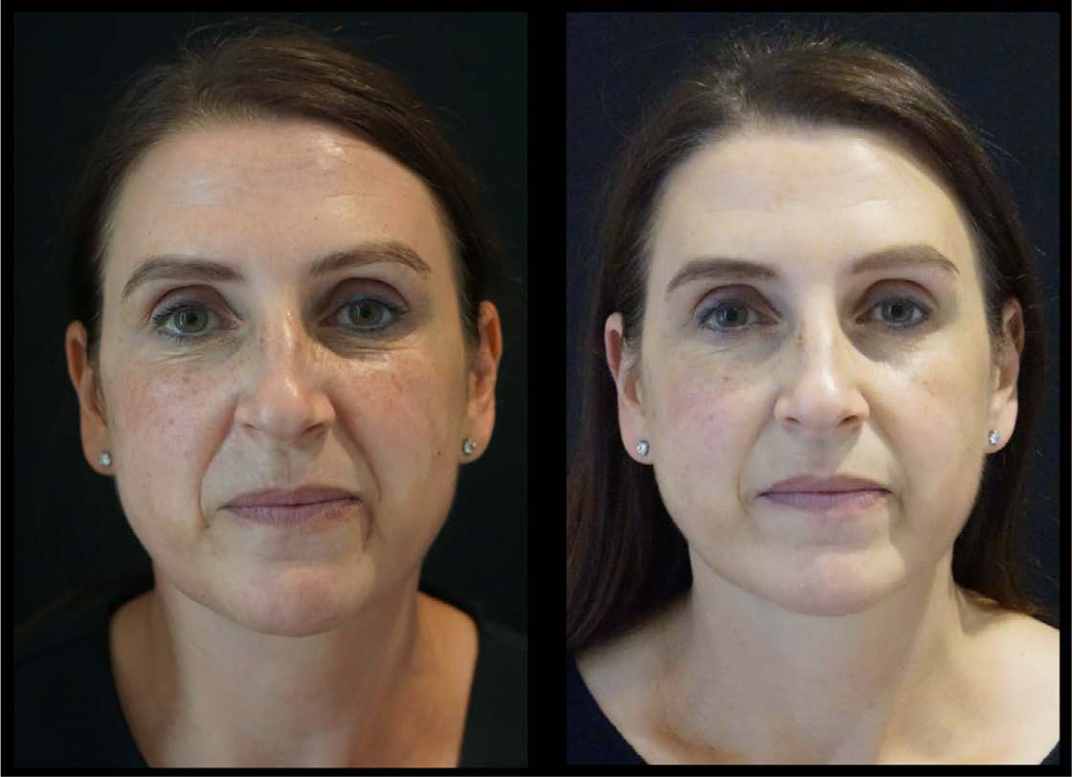
Figure 3: Comparative photos of the case pre and post treatment schedule.

Discussion
The current literature suggests that glutathione and vitamin C may be helpful stand alone or adjunctive interventions for improving conditions involving hypermelanosis. To date there has been only small scale clinical trials to look into this with only marginal evidence of its efficacy.
Combining these two interventions, in different forms (NAC & glutathione, for example) and providing them to the case in larger, intravenous doses, was tested during this case study, with perceived improved outcomes. With the lack of
standardised calculations of skin colour or advanced photographic methods for recording findings, this case is limited in its ability to make a firm judgment, however the perceived result is apparent, following the intervention.
It would be appropriate to explore the same experiment considering cross polarized photography, mMASI scoring, skin melanin index scoring and spectrophotometer use, to measure pigmentation outcomes. Additionally skin moisture, wrinkle definition, skin smoothness and firmness could be quantified via several specialist sensors or devices, manufactured for theses purposes. Testing the safety of this multi-nutrient infusion by monitoring renal and liver function throughout the experiment would also be beneficial when intravenous glutathione is used. Comparing these interventions with placebos will also be beneficial to establish potential efficacy of this intervention.

Declaration of Conflicting Interests
REVIV Global Ltd delivers various nutritional intravenous infusions and offers genetic and blood diagnostic testing. The author is fully employed by REVIV Global Ltd and holds the post of Head of Life Science & Genetics.
Full consent was received from the case to discuss this case study.

Funding
The authors received no financial support for the research, authorship, and or publication of this article.

References
- Lu, Yaoying, Kathryn F. Tonissen, and Giovanna Di Trapani. ‘Modulating Skin Colour: Role of the Thioredoxin and Glutathione Systems in Regulating Melanogenesis’. Bioscience Reports 41, no. 5 (28 May 2021): BSR20210427. https://doi. org/10.1042/BSR20210427.
- Hearing, Vincent J., and Mercedes Jiménez. ‘Mammalian Tyrosinase—The Critical Regulatory Control Point in Melanocyte Pigmentation’. International Journal of Biochemistry 19, no. 12 (January 1987): 1141–47. https://doi. org/10.1016/0020-711X(87)90095-4.
- Handel AC, Miot LDB, Miot HA. Melasma: a clinical and epidemiological review. An Bras Dermatol. 2014 Sep;89(5):771– 82.

- Iraji, Fariba, Mojtaba Nasimi, Ali Asilian, Gita Faghihi, Samaneh Mozafarpoor, and Hossein Hafezi. ‘Efficacy of Mesotherapy with Tranexamic Acid and Ascorbic Acid with and without Glutathione in Treatment of Melasma: A Split Face Comparative Trial’. Journal of Cosmetic Dermatology 18, no. 5 (October 2019): 1416–21. https://doi.org/10.1111/jocd.12874.
- Zhao, Huijuan, Mengna Li, Xiaofeng Zhang, Li Li, Yan Yan, and Baoxi Wang. ‘Comparing the Efficacy of Myjet-assisted Tranexamic Acid and Vitamin C in Treating Melasma: A Split-face Controlled Trial’. Journal of Cosmetic Dermatology 19, no. 1 (January 2020): 47–54. https://doi.org/10.1111/jocd.13112.
- Chung, Bo, So Choi, Ik Moon, Chun Park, Young-Hoon Kim, and Sung Chang. ‘The Glutathione Derivative, GSH Monoethyl Ester, May Effectively Whiten Skin but GSH Does Not’. International Journal of Molecular Sciences 17, no. 5 (27 April 2016): 629. https://doi.org/10.3390/ijms17050629.
- Weschawalit, Sinee, Siriwan Thongthip, Phanupong Phutrakool, and Pravit Asawanonda. ‘Glutathione and Its Antiaging and Antimelanogenic Effects’. Clinical, Cosmetic and Investigational Dermatology Volume 10 (April 2017): 147–53. https://doi. org/10.2147/CCID.S128339.
- Schmitt B, Vicenzi M, Garrel C, Denis FM. Effects of N-acetylcysteine, oral glutathione (GSH) and a novel sublingual form of GSH on oxidative stress markers: A comparative crossover study. Redox Biology. 2015 Dec;6:198–205.
- Sonthalia S, Jha A, Lallas A, Jain G, Jakhar D. Glutathione for skin lightening: a regnant myth or evidence-based verity? Dermatol Praat Concept. 2018 Jan 31;15–21.
- Watanabe F, Hashizume E, Chan GP, Kamimura A. Skin-whitening and skin-condition-improving effects of topical oxidized glutathione: a double-blind and placebo-controlled clinical trial in healthy women. CCID. 2014 Oct;267.
- Sanadi, RizwanM, and RevatiS Deshmukh. ‘The Effect of Vitamin C on Melanin Pigmentation – A Systematic Review’. Journal of Oral and Maxillofacial Pathology 24, no. 2 (2020): 374. https://doi.org/10.4103/jomfp.JOMFP_207_20.
- Wang, Kaiqin, Hui Jiang, Wenshuang Li, Mingyue Qiang, Tianxiang Dong, and Hongbin Li. ‘Role of Vitamin C in Skin Diseases’. Frontiers in Physiology 9 (4 July 2018): 819. https://doi.org/10.3389/fphys.2018.00819.
- Duperray, Joël, Renaud Sergheraert, Kunyanatt Chalothorn, Preeyanuch Tachalerdmanee, and Fabrice Perin. ‘The Effects of the Oral Supplementation of L-Cystine Associated with Reduced L-Glutathione-GSH on Human Skin Pigmentation: A Randomized, Double-blinded, Benchmark- and Placebo-controlled Clinical Trial’. Journal of Cosmetic Dermatology, 22 April 2021, jocd.14137. https://doi.org/10.1111/jocd.14137.

