Nanoemulsion Concept for Water-Poor Soluble Anti-Cancer Drugs to Improve Therapeutic Benefit
Dr Bhupendra G. Prajapati, PhD, Ganpat University, India

Abstract
nature of the majority of newly developed anticancer drugs has resulted in poor bioavailability and pharmacokinetic variations (BCS II or IV drugs). Nanoemulsion formulations are becoming an effective delivery system for poorly water-soluble drugs. The term "Nanoemulsion" refers to a thermodynamically stable isotropically clear dispersion of two immiscible liquids, such as oil and water, stabilized by an interfacial film of surfactant molecules. The Nanoemulsion is formed readily and sometimes spontaneously, generally without high-energy input. The method of preparation of nanoemulsion includes high-pressure homogenizer or ultrasonication or microfluidization as part of the high-energy method. In the low energy category or condensation method, scientists had applied phase transition and spontaneous emulsification. The formulation consists of the surfactant, the oil phase and the water phase. In some of the cases, co-surfactant or co-solvent is also used to improve the formulation stability and increase drug loading. The systems are characterized based on globule size and its distribution, surface charge, dispersion/aggregation state etc. In many cases to improve stability anhydrous emulsion or solid self-emulsified systems developed. Overall, nanoemlsion is proven to be an important and effective tool to improve the bioavailability of water-poor soluble drugs.

Image

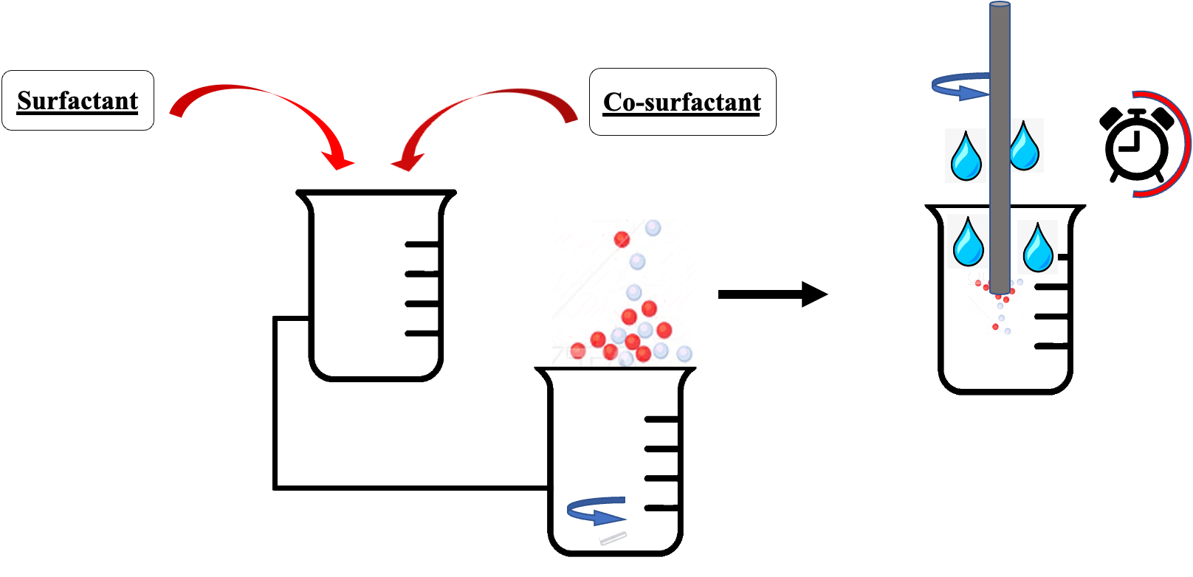
Recent Publications
1. Bhattacharya, S., Saindane, D., & Prajapati, B. G. (2022). Liposomal Drug Delivery and Its Potential Impact On Cancer Research. Anti-cancer agents in medicinal chemistry, 10.2174/1871520622666220418141640. Advance online publication.
2. Paliwal, H., Parihar, A., & Prajapati, B. G. (2022). Current State-of-the-Art and New Trends in Self-Assembled Nanocarriers as Drug Delivery Systems. Front. Nanotechnol. 4: 836674. doi: 10.3389/fnano.
3. Prajapati, B., Paliwal, H., & Patel, J. (2022). Pharmacokinetics of Nanoparticle Systems for Pulmonary Delivery. In Pharmacokinetics and Pharmacodynamics of Nanoparticulate Drug Delivery Systems (pp. 347-364). Springer, Cham.
4. Prajapati, B. G., Patel, H. P., & Patel, J. K. (2022). Nanoparticle Pharmacokinetic Profiling In Vivo Using Magnetic Resonance Imaging. In Pharmacokinetics and Pharmacodynamics of Nanoparticulate Drug Delivery Systems (pp. 399-416). Springer, Cham.
5. Prajapati, B. G., Jivani, M., & Paliwal, H. (2021). Formulation and optimization of topical nanoemulsion based gel of mometasone furoate using 32 full factorial design. Indian drugs, 58(06), 19.

Figure 1: Method of Preparation



Biography

Dr. Bhupendra Prajapati is a Professor in Department of Pharmaceutics, Shree S.K.Patel College of Pharmaceutical Education and Research, Ganpat University, Gujarat, India. He has more than 20 years of academic and research experience, has published more than 100 research and review papers in international and national Journals. Under his editorial two book under process and he authored 20 book chapters in the field of novel drug delivery. He published two Indian patent and three applications under evaluation. He is a reviewer in three high impact journals and is on the editorial board of several scientific journ

Email: bhupen27@gmail.com

