Thermoresponsive surfaces designed for the proliferation and differentiation of human pluripotent stem cells
Akon Higuchi^{a,b,c,d,e,f,*}, Abdurahman H. Hirad^{f}, S. Suresh Kumar^{g,h}, Murugan A. Munusamy^{f}, Abdullah A. Alarfaj^{f}

Abstract (300 word limit)

Thermoresponsive surfaces enable the detachment of cells or cell sheets by decreasing the temperature of the surface when harvesting the cells. However, human pluripotent stem cells (hPSCs), such as embryonic stem cells and induced pluripotent stem cells, cannot be directly cultured on a thermoresponsive surface; hPSCs need a specific extracellular matrix to bind to the integrin receptors on their surfaces. We prepared a thermoresponsive surface by using poly (N -isopropylacrylamide-co-butylacrylate) and recombinant vit- ronectin to provide an optimal coating concentration for the hPSC culture. hPSCs can be cultured on the same thermoresponsive surface for 5 passages by partial detachment of the cells from the surface by de- creasing the temperature for 30 min; then, the remaining hPSCs were subsequently cultured on the same dishes following the addition of new cultivation media. The detached cells, even after continual culture for five passages, showed high pluripotency, the ability to differentiate into cells derived from the 3 germ layers and the ability to undergo cardiac differentiation.
Image
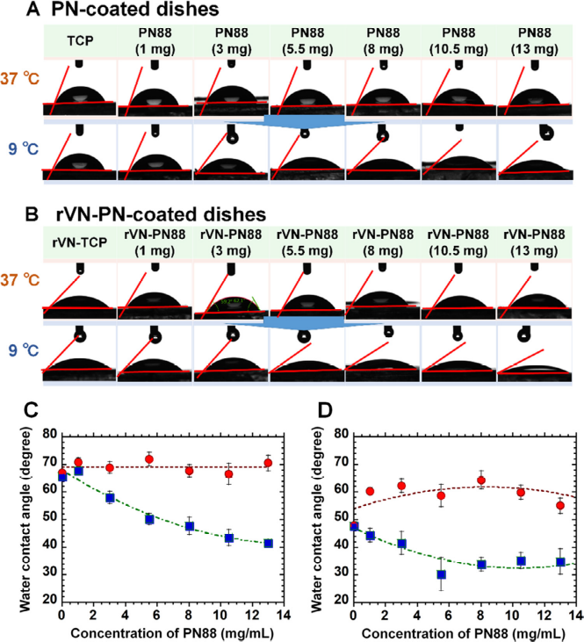
Fig. 3. The response of the hydrophobicity-hydrophilicity of the thermoresponsive PN88-coated plates to temperature. (A) Photos of water droplets evaluated by the sessile drop method performed on the TCP, PN88(1)-TCP, PN88(3)-TCP, PN88(5.5)-TCP, PN88(8)-TCP, PN88(10.5)-TCP, PN88(13)-TCP plates at 37 °C and 9 °C. (B) Photos of water droplets evaluated by the sessile drop assay performed on the TCP, rVN-PN88(1)-TCP, rVN-PN88(3)-TCP, rVN-PN88(5.5)-TCP, rVN-PN88(8)-TCP, rVN-PN88(10.5)-TCP, rVN- PN88(13)-TCP plates at 37 °C and 9 °C. (C) The water contact angle on the TCP, PN88(1)-TCP, PN88(3)-TCP, PN88(5.5)-TCP, PN88(8)-TCP, PN88(10.5)-TCP, PN88(13)-TCP plates at 37 °C (red circle) and 9 °C (blue square). (D) The water contact angle on the rVN-TCP, rVN-PN88(1)-TCP, rVN-PN88(3)-TCP, rVN-PN88(5.5)-TCP, rVN-PN88(8)-TCP, rVN- PN88(10.5)-TCP, and rVN-PN88(13)-TCP plates at 37 °C (red circle) and 9 °C (blue square).
Recent Publications (minimum 5)
- Tian, Z; Wang, CK; Lin, FL; Liu, Q; Wang, T; Sung, TC; Alarfaj, AA; Hirad, AH; Lee, HHC; Wu, GJ; Higuchi, A. (2022). Effect of extracellular matrix proteins on the differentiation of human pluripotent stem cells into mesenchymal stem cells. Journal of Materials Chemistry B.
- Nirmaladevi, J., Vidhyalakshmi, M., Edwin, E. B., Venkateswaran, N., Avasthi, V., Alarfaj, A. A., Hirad, A. A. & Hailu, T. (2022). Deep Convolutional Neural Network Mechanism Assessment of COVID-19 Severity. BioMed Research International.
3. Hirad, A. H., Ansari, S. A., Ali, M. A. E., & Egeh, M. A. (2022). Microwave-mediated synthesis of iron oxide nanoparticles: Photocatalytic, antimicrobial and their cytotoxicity assessment. Process Biochemistry, 118, 205-214.
4. Sung, T. C., Heish, C. W., Lee, H. H. C., Hsu, J. Y., Wang, C. K., Wang, J. H., Zhu, YR; Jen, SH; Hsu, ST; Hirad, AH; Alarfaj, AA & Higuchi, A. (2021). 3D culturing of human adipose-derived stem cells enhances their pluripotency and differentiation abilities. Journal of Materials Science & Technology, 63, 9-17.
5. Higuchi, A., Hirad, A. H., Kumar, S. S., Munusamy, M. A., & Alarfaj, A. A. (2020). Thermoresponsive surfaces designed for the proliferation and differentiation of human pluripotent stem cells. Acta biomaterialia, 116, 162-173.


Biography (150 word limit)

I have been actively involved in research mainly in the field of Molecular Microbiology, Nano-biotechnology, Environmental and Applied Microbiology. In a more general, sense my research interest spans across the following fields: biological sciences, industrial microbiology, medical biotechnology, materials sciences, environmental biotechnology, industrial biotechnology, nanotechnology, medical Biotechnology, and molecular microbiology.
Email: ahirad@ksu.edu.sa

