Hydroxyapatite bioceramics doped with ions for orthopedic and dentistry surgery

Mustapha Hidouri,
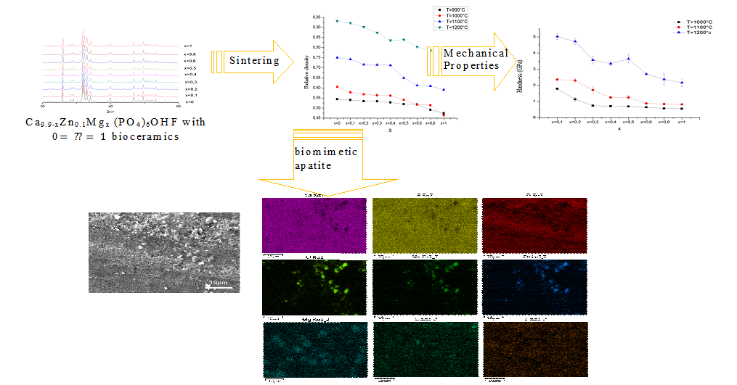
Gabes University, Tunisia

Abstract

Bioceramics designed to replace failing bone, teeth and dentins have two important properties: biocompatibility and the ability to absorb at a rate comparable to bone growth. Because of its close similarity to the inorganic mineral components of the bone and teeth, calcium phosphate, and particularly hydroxyapatite (HAp, Ca₁₀(PO₄)₆OH₂), is the most widely used bioceramics in a variety of biomedical applications, most notably orthopedics and dental repair. Indeed, due to the complexity of the chemistry of bone and dentine, which contain multiple elements, no identical to natural material has been discovered. All existing research has attempted to obtain the most comparable material. Several attempts have been made to introduce as many ions as possible into the structure of the HAp. As a result, magnesium Mg²⁺, strontium Sr²⁺, zinc Zn²⁺, sodium Na⁺, potassium K⁺, carbonates CO₃²⁻, fluorures F⁻, and chlorine ions Cl⁻ have been incorporated into the apatite structure. Several techniques (DRX, FTIR, chemistry analysis, G-DTA, RMN 31P, Raman, SEM,...) were used to verify the purity of the materials and confirm the ions' incorporation into the structure. The materials were pressure-less sintered, and the densification conditions were optimized. The densest materials have also been mechanically characterized. The biological properties of dense bodies have been tested in vitro, and the bioactivity and biocomtability of the materials have been determined. In the final stage, the appropriate materials were tested in vitro for their potential use as implants.

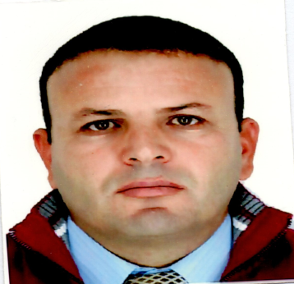
Figure 1. Densification, mechanical and biological characterization of multiple substituted hydroxyapatite bioceramics

Recent Publications
- Ben Slimen J, Mehnaoui M, Jebahi S, Boughzala K, Hidouri M(2022), Thermal and structural properties of sodium, potassium and carbonate doped strontium hydroxyfluorapatite, Journal of the Indian Chemical Society, 99-6100475,
- Kthiri K, Mehnaoui M, Hidouri M, Boughzala K(2022), Comparative Evaluation of Industrial Phosphoric Acids Desulfation Capabilities of Limes and Barium Carbonate. International Research Journal of Pure and Applied Chemistry, 23:17-27
- Mohamedou Ba , Ezzeddine A, Dorohzkin S V , Hidouri M (2022), Application of the Doehlert design for the defluornation of industrial wastewater by adsorption onto natural clay, Desalination and Water Treatment 1-10.
- Jbahi S, Zagrouba M, Hajji S, Raoufi A, Hidouri M (2022), The Effect of Gamma Rays on Gelatin / Chitosan Wound Dressing Physico - Chemical and Biological Properties, Iranian Journal of Materials Science and Engineering, 19-2.
- Raouafi, Jbahi S, Daoudi M, Dridi W, Hamzaoui A H, Dorohzkin S V, Hosni F, Hidouri M (2022), Natural red dyes from Beta vulgaris L. extract for gamma-rays color indicator: Physico-chemical and biological characterizations, Journal of the Indian Chemical Society,99-10.

Biography
Pr. Mustapha Hidouri is a Teacher-Researcher in the field of materials and environment. Mustapha Hidouri received his Phd in Materials Chemistry in 2004. Currently he occupied the post of associate professor at Gabes University, Tunisia. His researches deal with biomaterials and environmental studies. He published more than 25 papers and 2 books and presented more than 30 oral and poster presentations in scientific congresses. His is a reviewer in many impacted journals.
.

Email: mustapha.hidouri@laposte.net

Notes/Comments:

Presenting author details
Full name:
Contact number:
Mail id:
Category: (Oral presentation/ Poster presentation)

