Emerging Challenges in Aligners and Cleft Care in Orthodontics

In recent years, clear aligners have become increasingly becoming popular as an alternative to braces. Many patients particularly adults opt them for their cosmetic appearance, ease of placement and removal, better oral hygiene maintenance. Simple malocclusions can be effectively corrected with the aligners. But complex and mutilated malocclusions can be corrected only by fixed appliances. Treatment challenges with aligners include, cases needing extraction, growth modification, rotation of canines and premolars, extrusion, root torque, use of auxiliary anchorage devices, cleft lip and palate cases etc., Breakage, non-compliance, stain formation could delay the treatment. Inter-proximal reduction of teeth(IPR), elastics, bite rim, other attachments may be required for completion of the treatment. The IPR technique involves judicious grinding of the proximal enamel surface to create space for alignment of teeth. Overgrinding can lead to sensitivity, loss of vitality, and pain in the teeth.

Currently, there are many players in the market for Aligner production. Most do vigorous marketing and make tall claims about their success rates. Practitioners should be cautious while choosing the manufacturer. Treatment planning is more crucial to orthodontic success than aligners alone. An orthodontist's in-depth knowledge of facial growth and development enables him to predict the growth pattern of a patient, anticipate problems, and treat them accordingly. A visit to an orthodontist is the right step towards a brighter smile!
References:
- Rossini G, Parrini S, Castroflorio T, Deregibus A, Debernardi CL. Efficacy of clear aligners in controlling orthodontic tooth movement: a systematic review. Angle Orthod. 2015;85:881–889. doi: 10.2319/061614-436.1
- Shotell MD. The proliferation of clear aligner orthodontics: Workflows, materials, and designs. Compend Contin Educ Dent 2020;41:340-41
- Tamer İ, Öztaş E, Marşan G. Orthodontic treatment with clear aligners and the scientific reality behind their marketing: A literature review. Turk J Orthod 2019; 32:241-6.
- Bilello, G., Fazio, M., Amato, E. et al. Accuracy evaluation of orthodontic movements with aligners: a prospective observational study. Prog Orthod. 23 12 (2022). https://doi.org/10.1186/s40510-022-00406-7
- Hartshorne J, Wertheimer M B Emerging insights and new developments in clear aligner therapy: A review of the literature AJO-DO Clinical Companion2022,, 2 ( 4) 311 -24https://doi.org/10.1016/j.xaor.2022.04.009
Biography:

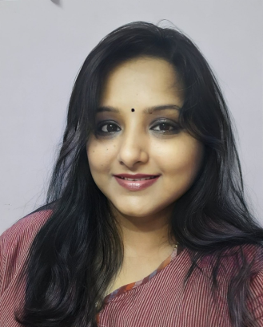
An enthusiastic clinician, Dr. Sangeetha is a faculty member and researcher. Her clinical practice spans more than two decades. Orthodontics is her area of expertise. She has a great interest in clear aligners and other cutting-edge technologies like 3D and 4D printing. She authors a book titled " 3D to 4D printing " and has given guest lectures on the same. She has also applied for a patent for her new technoque with aligners and 3D printing. She also has a special interest in treating babies with cleft lip and palate. Being empathic, she counsels and guides parents to cope with their lifestyles. She is engaged in research and development of innovative feeding techniques for babies with cleft lip and palate. Her research interests have earned her the title of best young researcher in her field. She enjoys learning about cultures and lifestyles around the world as well as growing plants as a hobby.

Mobile Number*:919941314956
Email: sangsortho@gmail.com
Category*: (Oral presentation/ Poster presentation)
Research Interest*: Aligners and 3 D printing, Cleft lip and palate,psychology

