Microphysiological Systems: Tissue Chips for Drug Screening Program for Safety, Efficacy and Precision Medicine
Danilo A. Tagle, MS PhD, National Center for Advancing Translational Sciences, NIH, USA

Abstract (300 word limit)
Approximately 90% of drugs fails in human clinical trials due to adverse reactions and/or due to lack of efficacy. These failures can be attributed to poor predictability of human response from animal studies and 2D in vitro models being used preclinical drug development. To address these challenges, the Tissue Chips or Microphysiological Systems for Drug Screening program supports the development of alternative approaches for more predictive readouts of toxicity and efficacy of candidate drugs. Tissue chips are bioengineered 3D microfluidic chips with human-derived cells and tissues that mimic the cytoarchitecture and functional units of human organs and systems. Initially tissue chips were used for in vitro models for risk assessment in safety pharmacology. As an example, human liver on chips have been shown to have 87% sensitivity and 100% specificity in anticipating the drug toxicities of 22 compounds with known hepatotoxic (was advanced to human use based on previous preclinical data but was withdrawn due to toxicities which collectively are responsible for more than 200 patient deaths and 10 liver transplants) outperforming liver spheroids which showed a sensitivity of only 47%. In addition to toxicity studies in drug development, tissue chips are also being used to model various human diseases and conditions when animal models do not mirror the pathology or are unavailable. Tissue chips was used to model chronic inflammatory demyelinating polyneuropathy and multifocal motor neuropathy, a pair of rare, devastating neuromuscular diseases, which led to the identification of a repurposed drug and approval by the FDA for phase 2 clinical trial. A more recent application of tissue chips is on its use as “clinical trials on chips” to inform clinical trial design and implementation. This new initiative will help establish patient recruitment criteria, stratify patients to determine who are the best responders to specific therapies, include population diversity, and identify clinically relevant biomarkers. Presentation will also include an overview over the decade of support from NIH, partnerships with various stakeholders including the FDA and pharmaceutical industry.

Image
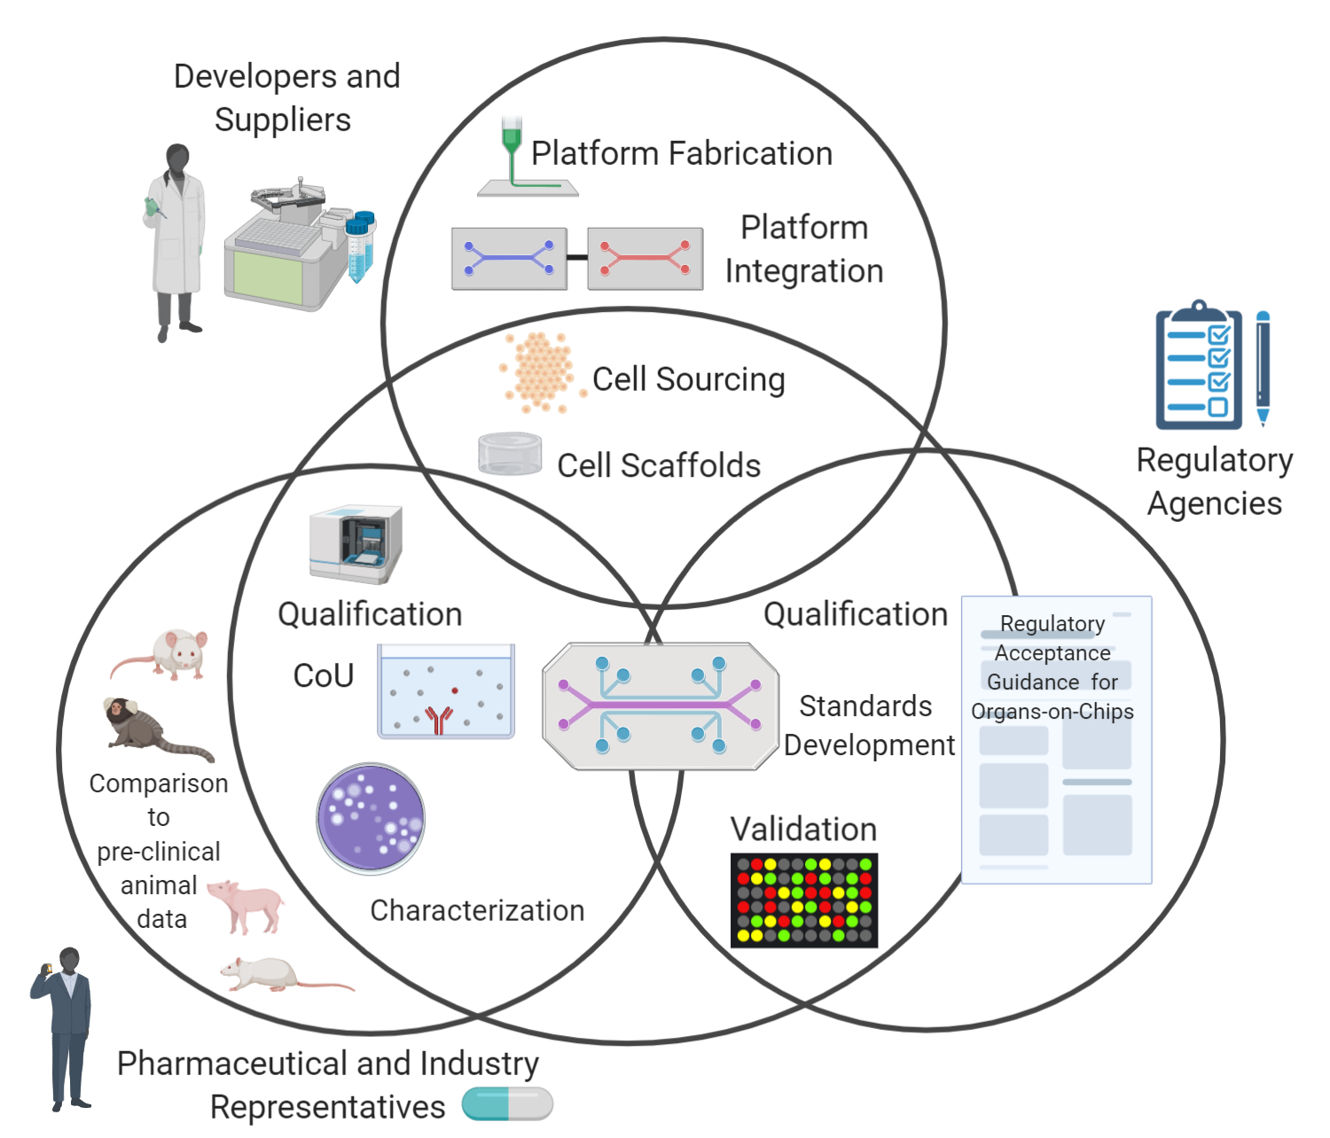
Recent Publications (minimum 5)
- Low LA, Mummery C, Berridge BR, Austin CP, Tagle DA., Organs-on-chips: into the next decade, Nat Rev Drug Discov. 2021, 20:345-361. PMID: 32913334
- Hargrove-Grimes P, Low LA, Tagle DA., Microphysiological systems: What it takes for community adoption. Exp Biol Med. 2021, 246:1435-1446. PMID: 33899539
- Hargrove-Grimes P, Low LA, Tagle DA. Microphysiological Systems: Stakeholder Challenges to Adoption in Drug Development. Cells Tissues Organs. 2021 11:1-13. PMID: 34380142
- Anklam E, Bahl MI, Ball R, Beger RD, Cohen J, Fitzpatrick S, Girard P, Halamoda-Kenzaoui B, Hinton D, Hirose A, Hoeveler A, Honma M, Hugas M, Ishida S, Kass GE, Kojima H, Krefting I, Liachenko S, Liu Y, Masters S, Marx U, McCarthy T, Mercer T, Patri A, Pelaez C, Pirmohamed M, Platz S, Ribeiro AJ, Rodricks JV, Rusyn I, Salek RM, Schoonjans R, Silva P, Svendsen CN, Sumner S, Sung K, Tagle DA, Tong L, Tong W, Eijnden-van-Raaij JVD, Vary N, Wang T, Waterton J, Wang M, Wen H, Wishart D, Yuan Y, Slikker W Jr. Emerging technologies and their impact on regulatory science. Exp Biol Med. Epub 2021 Nov 16. PMID: 34783606
- Roth A, The MPS-WS Berlin 2019 group: Marx U, Vil√©n L, Ewart L, Griffith LG, Hartung T, Ingber DE, Mendrick DL, Steger-Hartmann T, Tagle DA. Human microphysiological systems for drug development. Science. 2021 Sep 17;373(6561):1304-1306. doi: 10.1126/science.abc3734. Epub 2021 Sep 16. PMID: 34529479
- Happel C, Penalber-Johnstone C, Tagle DA. Pivoting Novel Exosome-Based Technologies for the Detection of SARS-CoV-2. Viruses. 2022 May 18;14(5):1083. PMID: 35632824

Biography (150 word limit)

Danilo Tagle is Director, Office of Special Initiatives at the National Center for Advancing Translational Sciences (NCATS) of the National Institutes of Health (NIH) where he coordinates efforts towards developing microphysiological systems or organs on chips. He also coordinates efforts on 3D bioprinting for drug discovery and development, on automated chemistry, on the use of electronic nose technology for disease diagnosis, and the clinical utility of secreted RNA in exosomes for biomarker and therapy development. He has served on numerous committees, advisory boards, and editorial boards. Dan obtained his Ph.D. in molecular biology and genetics from Wayne State University School of Medicine. He was an NIH National Research Service Award postdoctoral fellow in human genetics at the University of Michigan. Dan has authored many scientific publications and has garnered numerous awards, including more recently the Roscoe O. Brady Award for Innovation and Accomplishment; the Henry J. Heimlich Award for Innovative Medicine; and the HHS Secretary's Award for Distinguished Service: Rapid Acceleration of Diagnostics (RADx) Initiative.
Email:danilo.tagle@nih.gov

Notes/Comments:

Presenting author details
Full name: Danilo A. Tagle
Contact number: +1–240-418-5017
Twitter account: https://twitter.com/ncats_nih_gov
Linked In account: www.linkedin.com/in/danilo-tagle-3ab02b79
Session name/ number: Pharmaceutical Toxicology
Category: (Oral presentation)

