Crescentic IgA Nephropathy Presenting with Erythrocytosis in a 70-year-old Male: A Case Report
Gabrielle Anjela T. Albay, MD, Melvy June Balasa, MD, Maia Celeste Arbatin, MD, FPCP, FPSN Chong Hua Hospital, Philippines

Abstract

Erythrocytosis is defined as an increase in RBCs relative to the blood volume or an increase in red cell mass. Rarely, it can be associated with renal manifestations, including IgA nephropathy, FSGS, MPGN, and RPGN. IgA nephropathy is the most common of which and usually occurs in males. Despite being the most common cause of primary glomerular disease worldwide, IgA Nephropathy exhibits marked heterogeneity in its clinical and pathological features. The pathophysiologic correlation between IgA nephropathy and Erythrocytosis is complex. It can be briefly explained by the formation of vascular microthrombi and glomerular capillary occlusion, which reduces GFR and tissue ischemia. Keywords: IgA Nephropathy, erythrocytosis, polycythemia

CLINICAL PRESENTATION: The patient is a 70-year-old male with nephrotic range proteinuria and erythrocytosis. Further probing narrowed down the diagnosis between smoker’s polycythemia, polycythemia vera, and secondary to glomerulonephritis. During admission, the patient underwent sessions of therapeutic phlebotomy, with serial monitoring of CBC and creatinine. Renal biopsy showed crescentic IgA nephropathy. Optimization of kidney protective measures was done, which include: BP control, RAAS blockade, lifestyle modification, and addressing cardiovascular risks.

CONCLUSION: To the best knowledge, there have been 24 cases of polycythemia associated with the renal disease described so far, and out of them, only ten have been associated with IgAN. The pathophysiologic relationship between erythrocytosis and IgA Nephropathy remains unclear. However, the hypercoagulable state and circulatory disturbances that ensue may contribute to the disease progression. Given the current uncertainty over the safety and efficacy of existing immunosuppressive treatment choices in IgA Nephropathy, all patients who remain at high risk of progressive CKD despite maximal supportive care should be offered immunosuppressive drugs with a detailed discussion of the risks and benefits, and the opportunity to take part in a clinical trial if feasible. Understanding their pathophysiologic process despite their atypical incidence may pave further advances in the management and attenuation of worsening renal function.

Biography
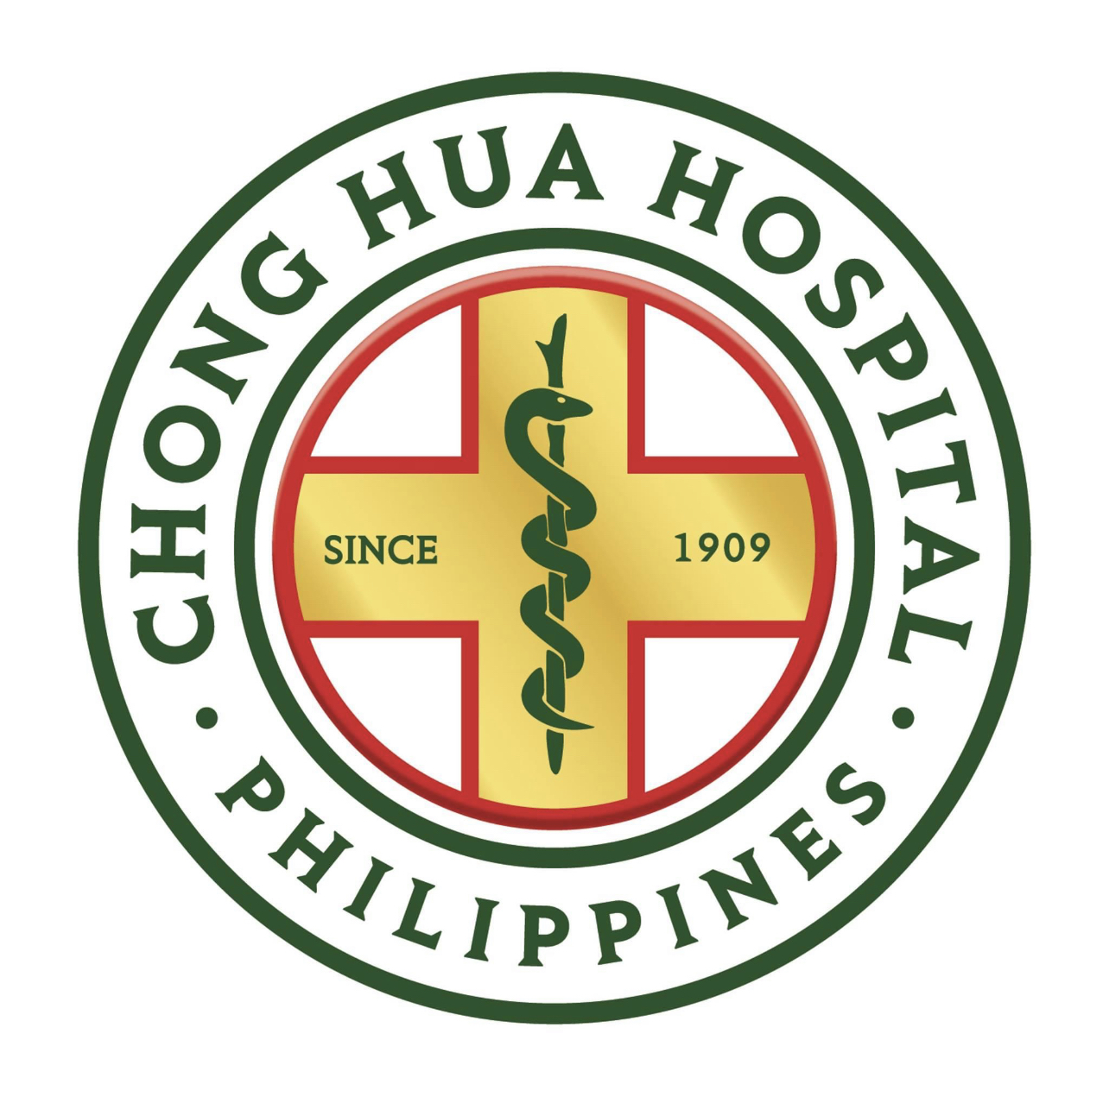
Our team consists of 2 resident physicians- Dr. Melvy June Balasa and Dr. Gabrielle Anjela Albay, and one Nephrologist, Dr. Maia Celeste Arbatin, who guided us through the dilemmas and approach to this patient’s case. We took an interest in reporting this case due to its rare presentation and limited documentation of its incidence. This case report would like to highlight its unique manifestations and dilemmas in managing IgA Nephropathy, which remains controversial regarding the benefit of immunosuppressive therapy to prevent the progression of worsening renal function.
Email: hemerythrin29@gmail.com

Notes/Comments:

Presenting author details
Full name: MelvyJune Balasa
Contact number: +(639)-17-307-5350
Twitter account: melvyjune
Linked In account: N/A
Session name/ number:
Category: (Oral presentation/ Poster presentation)

