Process intensification and optimization for sonocrystallisation of uranium peroxide

Shrishma Paik^{1,3}, SK Satpati^{1,3} and DK Singh^{2,3}

¹Uranium Extraction Division, Materials Group, Bhabha Atomic Research Centre, India
²MP&CED, Materials Group, Bhabha Atomic Research Centre, India
³Homi Bhabha National Institute (HBNI), Anushakti Nagar, Mumbai 400 094, India

Abstract

Peroxide precipitation is an emerging process in nuclear technology and one of the well-knownmethod for production of first intermediate uranium compound before uranium bearing fuel production. Though the conventional method of precipitation is practiced worldwide, it suffers from the limitation of non-uniform particle formation and lesser control over particle growth and size. Hence there is always a scope to study the effect of novel technique for process intensification. Application of ultrasound or sonochemical technique is one of the techniques which can intensify the crystallization event to a large extent by the impact of its cavitaional process imparting micromixing, enhanced mass transfer and the effect of additional spontaneous nucleation. It also facilitates in enhancing the crystal shape and size with better consistency and can control physical and morphological characteristics of the powder in several ways. Here, study was carried out for establishing important process parameters namely uranium cocn and temperature forultrasonic precipitation compared to conventional methods in laboratory scale with a ultrasound horn at 35 KHz. Uranyl nitrate with 30% hydrogen peroxide was used for the reaction in 1 litre scale. Noappreciable difference in the phases have been found from the XRD study. However a more homogeneous, regular and smooth crystalline appearance is observed in sonochemical precipitation route compared to conventional route under SEM study at 100 g/L uranium with 60 ◦C temperature. The crystal shape is rhombohedra with a spherical aggregation in comparison to needle shaped crystals in conventional route. Significant improvement is also seen in specific surface area and tap density of the prepared powder in sononchemical route. The powders obtained from this novel technique are having recovery more than 99.9% w.r.t. uranium. The purity of the synthesized powder also meets the specification of nuclear grade quality.Overall, the sonochemical method of precipitation of uranium peroxide is a fast, simple, convenient and intensifying technique imparting appreciable morphology and physical characteristics over the conventional precipitation process.

Fig 1: SEM pictures of Uranium peroxide in sonochemicaland conventional route

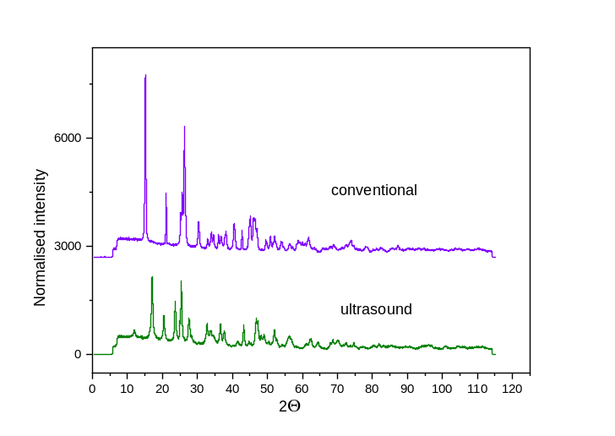

Fig 2: XRD profile of uranium peroxide

Keywords: Precipitation, Uranium peroxide, Morphology, Ultrasound, Cavitation

Recent publications:

- A novel approach of precipitation of Ammonium Di -Uranate (ADU) by sonochemical route, Shrishma Paik,SK Satpati, DK singh.January 2022, Progress in Nuclear Energy 143(6):104034

- Intensified gaseous phase precipitation of Ammonium Di-Uranate through ultrasonic assisted route, Shrishma Paik, SK Satpati, DK singh, Journal of Radioanalytical and Nuclear chemistry (Published on 6th Sept 2022)

- Study on the effects of Sonication on reactive precipitation of Ammonium Uranyl Carbonate from pure uranyl nitrate solution” Shrishma Paik,SK Satpati,SK Gupta,ML Sahu,DK Singh, Journal of Nuclear Materials, Volume 557, 15 December 2021, 153222

- Potential application of the by-product Ammonium Nitrate from Uranium Purification Facility as a Nutrient Enriched Fertilizer, Mehetre ST, Paik Shrishma, Satpati SK, Sahu ML, Suprasanna P and Venugopalan VP, Int Journal of Env. and Waste Management (Accepted for publication)

- Comparative studies on Neutralization of Aqueous Raffinate of Solvent
Extraction Process of Uranium by using Different Chemical Reagents:Shrishma Paik, SK Gupta,ART2,NUFUC 2022, MAY20-21,Tarapur

Biography

Author Shrishma Paik is currently working in the field of nuclear technology on separation and recovery of uranium from different sources. Her development area involves intensification of process of uranium by precipitation as well as solvent extraction by novel techniques and minimization of waste volume during uranium refining process.

