Assessment of Platelet indices as predictor of in-hospital mortality in patients with Acute Kidney Injury requiring Renal Replacement therapy at a Local Tertiary Hospital in Cebu CIty
Melvy June Balasa, MD, Chong Hua Hospital, Philippines

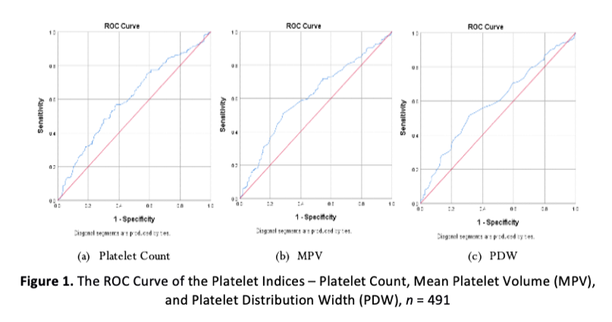
Abstract

Platelet indices can independently predict in-hospital mortality. This study aimed to investigate whether these biomarkers are good predictors of adverse outcomes in patients with acute kidney injury (AKI) who received initiation renal replacement therapy. This retrospective, single-center study was done in a local private tertiary hospital in Cebu. Four hundred ninety-one patients with AKI who underwent initiation renal replacement therapy (RRT) between January 2018 and December 2021 were enrolled. Based on the outcome at discharge, the patients were divided into survival and non-survival group. The study used the receiver operating characteristic (ROC) curve for platelet indices to predict mortality. To determine the optimal cut-off values for in-hospital mortality. Mortality-related factors were identified using univariate and multivariate logistic regression analysis. This study showed that the all-cause mortality of patients was 58.45%, with a mean age of 68.6 years among non-survivors. Platelet count and PDW were better predictors of in-hospital mortality in patients who received initiation renal replacement therapy. The optimal cut-off value of platelet count was 173 x 103/uL, with the area under the ROC curve of 0.604. The optimal cut-off value of PDW was 16.45%, with the area under the ROC curve of 0.611. Multivariate regression analysis demonstrated that age, cancer, serum urea, hospital stay, number of vasopressors, and ventilator use were independent risk factors for in-hospital mortality in patients who underwent initiation renal replacement therapy. In conclusion, low platelet counts, high MPV values, and high PDW values are associated with poorer outcomes and higher mortality risk.
Image

Recent Publications (minimum 5)
None

Biography

Melvy June Balasa is a Third Year Resident of Internal Medicine at Chong Hua Hospital and an aspiring Nephrologist. Her drive is to bridge the knowledge gap, especially in the dynamic field of medicine. Several kinds of research have established the increasing mortality of patients who develop acute kidney injury. Yet, cost-effective predictors of adverse clinical outcomes still need to be elucidated. This research could prompt clinicians' awareness regarding their management and help in anticipating prognosis.
Email: hemerythrin29@gmail.com

Notes/Comments:

Presenting author details
Full name: MelvyJune Balasa
Contact number: +(639)-17-307-5350
Twitter account: melvyjune
Linked In account: N/A
Session name/ number:
Category: (Oral presentation/ Poster presentation)

