Efficacy and safety of sucroferric oxyhydroxide vs sevelamer carbonate in Chinese dialysis patients with hyperphosphataemia

Jun Liu, Nanfang Hospital of Southern Medical University, Guangzhou City, Guangdong Province, China
Li Zuo, Peking University People’s Hospital, Beijing, China
Sebastian Walpen, Laurence Bernard, Matthieu Marty, and Milica Enoiu, CSL Vifor, Glattbrugg, Switzerland

Abstract

Background: Sucroferric oxyhydroxide (SFOH) is a non-calcium-based, oral iron-containing phosphate binder that has been demonstrated to be efficacious and generally well tolerated for the control of serum phosphorus (sP) in patients with chronic kidney disease undergoing dialysis.^{1–5} This study aimed to investigate the efficacy and safety of SFOH vs sevelamer carbonate in controlling sP in adult Chinese dialysis patients with hyperphosphataemia.

Methods: An open-label, randomised (1:1), active-controlled, parallel group, multicentre, phase III study of SFOH and sevelamer at starting doses of 1,500 mg/day and 2.4 g/day, respectively, was carried out in adult Chinese dialysis patients with hyperphosphataemia
(sP >1.78 mmol/L) (NCT03644264). The primary efficacy endpoint was a non-inferiority analysis of change from baseline in sP at
Week 12 (last observation carried forward [LOCF]) with SFOH vs sevelamer.

Results: 415 patients screened, 286 enrolled and randomised (142 to SFOH and 144 to sevelamer). Mean (standard deviation [SD]) baseline sP was 2.38 (0.57) and 2.38 (0.52) mmol/L, respectively. Mean (SD) change from baseline in sP at Week 12 (LOCF) was –0.71 (0.60) vs
–0.63 (0.52) mmol/L, respectively (Figure), and difference (sevelamer minus SFOH) in least squares means (95% confidence interval [CI]) was 0.08 mmol/L (–0.02; 0.18) with the lower limit of the 95% CI above the non-inferiority margin of –0.34 mmol/L. SFOH reduced sP from baseline earlier (mean [SD] change from baseline –0.69 [0.55] vs
–0.37 [0.47] mmol/L at Week 4, respectively) and with a lower pill burden (mean 3.2 vs 6.3 tablets/day over 12 weeks, respectively) than sevelamer. Safety and tolerability of SFOH were generally comparable to sevelamer and no new safety signals were observed for SFOH.

Conclusion: SFOH reduced sP from baseline and was non-inferior to sevelamer after 12 weeks of treatment in Chinese patients on dialysis with hyperphosphataemia. SFOH is an appropriate treatment option for these patients.

Figure
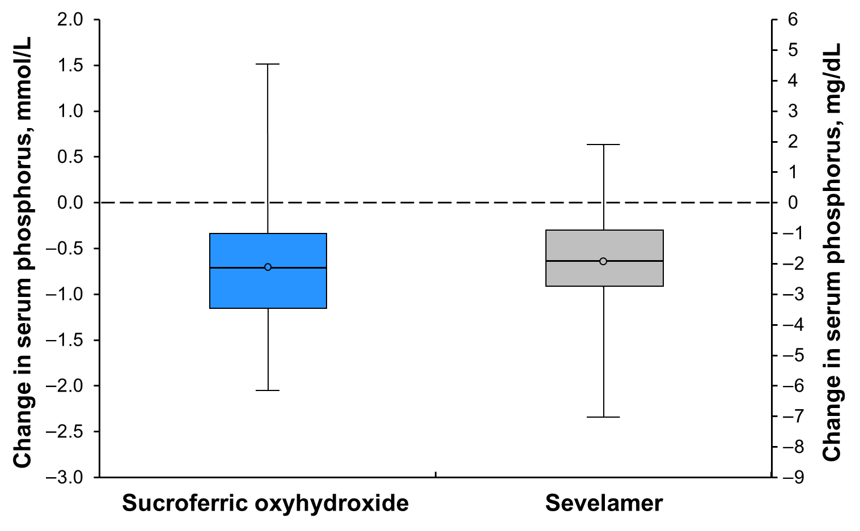Change from baseline in serum phosphorus at Week 12
(last observation carried forward).
The box is defined by Q1 (lower line) and Q3 (upper line), and the distance between these is the interquartile range (IQR). Inside the box, the line represents the median (Q2), and the dot represents the mean.
The whisker boundaries represent the minimum and maximum.
Recent Publications
- Wüthrich RP, et al. Clin J Am Soc Nephrol. 2013;8:280–9.
- Floege J, et al. Kidney Int. 2014;86:638–47.
- Floege J, et al. Nephrol Dial Transplant. 2015;30:1037–46.
- Koiwa F, et al. Nephrology (Carlton). 2017;22:293–300.
- Koiwa F, et al. J Ren Nutr. 2017;27:346–54.

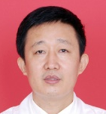 Professor Jun Liu, MD

Professor Liu is head of the Blood Purification Center in the Nephrology Department of the National Clinical Research Center for Kidney Disease, at NanFang Hospital. His research interests in kidney disease treatment include conservative management of acute and chronic renal failure, and blood purification therapy. He is member of the Chinese Hospital Association of Blood Purification, the Blood Purification Access Academic Group in China, the Guangdong Medical Doctor Association in Nephrology and the Blood Purification of Chinese Medical Association. He is Vice Chairman of the Guangdong Provincial Hospital Association of Blood Purification and the Guangdong Blood Purification Therapy Control Center, and is Head of the Blood Purification Access Academic Group in Guangdong. He has supervised seven nationally and provincially funded projects. He came third in the national new drug development award and first in the Guangdong technology progress award. He has authored over 60 articles and contributed to three treatises.
Email: liujun62nfyy@163.com

Notes/Comments:

Presenting author details
Full name: Milica Enoiu
Contact number: +41 58 851 82 64
Mail id: milica.enoiu@viforpharma.com
Category: (Oral presentation/ Poster presentation)

