Comparative Study of Performances Between Single and Double truncated Square Patch Antenna With Circular Polarization For S-Band Small Satellite Applications

M.A.MEBREK, M.BACHA, M.BENSAADA
Department of Space Instrumentation
Algerian Space Agency (ASAL), Center of Satellite Development
Oran, Algeria
mamebrek@cds.asal.dz

Abstract— In this paper, two designs of patch antennas are presented and a comparative study of the performances of both designs is done. The two designs presented in this paper are: square patch antenna with single corner cut and square patch antenna with double corner cut, both designs are suitable for S-Band small satellites applications. For the both patch antennas, the analyses were done using HFSS and a comparison was made between them. The simulated antennas operate in the s-band frequency (around 2.2 GHz) and based on the obtained results, it can be noticed that the square patch with a single cut shows about 3dB higher return loss than the square patch with double cut. Also, the antenna with single cut has improved the axial ratio value where the single cut antenna has an axial ratio of 0.1723 and the one with double cut has an axial ratio of 0.6439, the both antennas gain are nearly the same.
Keywords—Circularly polarized; S-band; square patch; single corner cut, double corner cut; high gain; coaxial probe; small satellites.

Introduction
In the present era, the small satellites play an important role into facilitating the human life with the numerous tasks and experiments achieved by those satellites in the space. The satellites built become smaller than before due to technology miniaturization. As the satellites become smaller, all of the satellite subsystems must be designed with respect to physical limitations and restrictions (1). The parabolic antennas are not suitable for small satellites even if they are small and also those antennas require deployment mechanism once reaching the space. For small satellites the patch antennas present an attractive alternative comparatively to the conventional antennas as these are:

- compact,
- light-weight,
- and require less power.

In small satellite, the antennas used for reception and transmission have generally a circular polarization. By using the circular polarization, there will be no need to have a good antennas orientation as the antennas circularly polarized have the capability of receiving equal power in the both plans (horizontal & vertical) -ideally AR =1, or 0 dB-.
But, in practice, antennas should present AR less than 3 dB (1.412) (2). The circular polarization of single-feed patch antenna is generally achieved by:

- truncating the patch corners,
- or cutting a diagonal slot in the patch [3].

Microstrip Patch Antenna
In the last few decencies in the communication area the most efforts have been observed in the patch antennas field. The patch’s which are frequently used are: square (4), rectangular (5), circular (6), triangular (7), and elliptical or some other common shape. The substrate material, dimension of substrate, feeding technique all those parameters will determines the performance of the antenna. As presented into the figure below, a patch antenna is composed by a dielectric substrate with a ground plane and radiating patch on each side. For our study case, a square shape was selected.
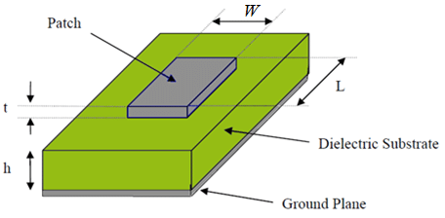
Figure 1. Patch antenna.
In general, the patch is made of copper, gold or other conducting material and can take different forms. Typically, the substrate dielectric constant ($ε_{r}$) is comprised between 2.2 and 12. A low dielectric constant along with thick dielectric substrate will provide good antenna performance such us:
- better radiation,
- better efficiency,
- and larger bandwidth (8).

Another important point in patch antenna conception is the feeding type. A variety of methods exists and which can be classified into two groups as contacting and non-contacting. The contacting methods are strip-line and coaxial probe, while non-contacting is aperture coupling and proximity coupling (9). In our work the coaxial probe feeding method is used.

Antenna Design
For patch antenna design, there are three parameters which are considered important. Those parameters are:

Frequency of operation ($f_{R}$):
The two antennas were designed to operates at the frequency of 2.233GHz (S-band frequency for small satellites in sun- synchronous orbit).

Dielectric constant of the substrate (εr):
Dielectric constant is one of the most sensitive parameters in patch antenna, and it is taken of substrate. In our case “Rogers RT/duroid 5880” with permittivity of $ε_{r}$ $ε_{r}$ = 2.2 was chosen (this substrate was chosen due to its high gain and also with using a low dielectric constant the dimensions of the antenna are reduced (8), (10)).

Height of dielectric substrate (h):
Antennas embedded onboard of satellites have to be light in weight and compact in size which sets a constraint to their height.

Using: C = 3×10e8 m/s, εr = 2.2 and $f_{R}$ = 2.233GHz, the values of antenna dimensions can easily be determined.
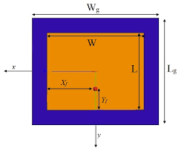
Figure 2. Geomtery and dimensions of patch antenna.
The equations used for designing the patch antennas (11) are listed below:

Calculation of the height (h):
$h= \frac{0.3*C}{2* π* f_{R}*\sqrt{ε_{r}}}$ (1)

Calculation of the width (W) of the patch:
$W= \frac{C}{2f_{r}}\sqrt{\frac{2}{ε_{r}+1}}$ (2)

Calculation of the effective dielectric constant ($ε_{eff}$):
$ε_{eff}= \frac{ε_{r}+1}{2}+\frac{ε_{r}-1}{2} {\left[1+12 \frac{h}{W}\right]}^{-1/2}$ (3)

Calculation of the effective length of the patch ($L_{eff}$):
$L_{eff}= \frac{C}{2* f_{r}*\sqrt{ε_{r}} }$ (4)

Calculation of the length extension ($∆L$):
$\frac{ ∆L}{h}=0.412 \frac{\left(ε_{eff}+0.3\right)*(\frac{W}{h}+0.264)}{\left(ε_{eff}-0.258\right)*(\frac{W}{h}+0.8)}$ (5)

Calculation of the actual length (L) of the patch:
$L= L_{eff}-2 ∆L$ (6)

In the present work, the shape selected to design the antenna is the square shape. So, the dimensions of the square patch (length L and width W) are taken to be equal.

Calculation of the ground plane dimensions:
$L_{g}= L+6h$ (7)
$W_{g}= W+6h$ (8)

As the coaxial probe feeding method was chosen for this design, so we need to calculate the feeding point position.

Feed point position:
$X_{f}= \frac{L}{2* \sqrt{ε_{eff}}}$ (9)
$Y_{f}= \frac{W}{2}$ (10)

For S-band small satellite applications, the polarization which is the most used is the circular polarization (RHCP or LHCP). So the antennas designed have to present this characteristic. There are many ways to get circular polarization for the patch antennas. They can be divided into two groups, dual feed and single feed patches (12). Among the single feed patch method we can found the method using truncated corner which is used in this work.

Corner Trunc size:
The circular polarization could be achieved by the truncation of one or two corners of the patch. Small triangular with right angle patches are removed from one corner or two (diagonally opposite) of the patch. The design equations for truncated length are given as (3):

$Q_{0}= \frac{C* \sqrt{ε_{r}}}{4* f_{r}*h }$ (11)

$\frac{∆S}{S}= \frac{1}{2* Q_{0}}$ (12)

$a=L \sqrt{\frac{∆S}{S}}$ (13)
Where:
$Q_{0}$: unloaded quality factor,
$\frac{∆S}{S}$ : trunction Ratio,
a: truncated length.

Antenna Dimensions
As a first step into the designing of the both antennas, we started by calculating the dimensions of a square patch antenna fed by coaxial probe using the theoretical design formulas listed in the section above.

The obtained results using εr=2.2 and $f_{R}$=2.233GHz are listed into the table below:

TABLE1. Theoretical Square Patch Antenna Dimensions
Description | Dimension (mm)
Height of Substrate | 4.3
Patch Dimensions | 42.7
Substrate Dimensions | 80
Feed Point “X” | 15
Feed Point “Y” | 26.5
Trunc Size | 8.99

Since the theoretical design is based on closed loop formulas and the software is based on open loop formulas, the resonant frequency of the patch designed with theoretical values shifted from 2.233GHz to 2.2GHz and also the parameters which are used for the patch antenna performances evaluation as: return losses (S11), gain (G), directivity (D), beam width (BW), axial ratio (AR), voltage standing wave ratio (VSWR)…….etc. was not optimized. So, the patch dimensions, the feeding point location and the corner cut size for both antennas was changed and an iterative simulation of the design was performed in order to get a better performance.

The following table show the both square antenna (One corner truncated and two corners truncated) dimensions after optimization.

TABLE1. Antennas parameters
Parameters | Antenna with single corner  cut | Antenna with double corner cut
Solution Frequency | 2.2 GHz | 2.2 GHz
Height of Substrate | 3.41mm | 3.09mm
Patch Dimensions | 21.5mm | 21.5mm
Substrate Dimensions | 40mm | 32mm
Feed Point “X” | 10mm | 8mm
Feed Point “Y” | 0 | 0
Trunc Size | 9mm | 5mm

The figures below show the two designed square patch antenna in 3D model under HFSS environment.

The first antenna designed (figure 3) is a square patch antenna with a single corner truncated and the second shown in figure 4 is a square patch antenna with a double corner truncated. We have to note that the both antennas are fed by a coaxial probe.

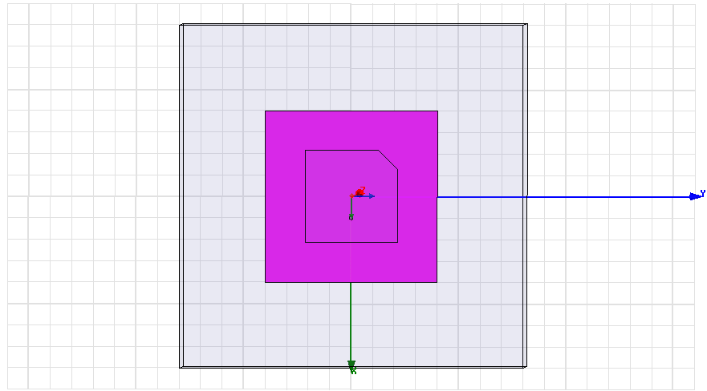
Figure 3. Square Patch Antenne with a Single Truncated corner.
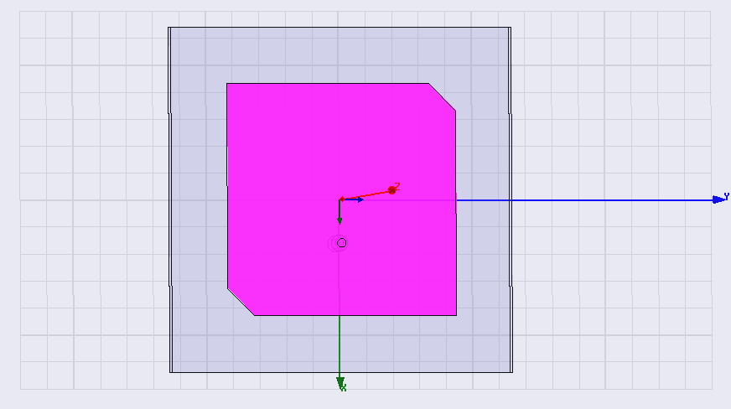
Figure 4. Square Patch Antenne with a Double Truncated corner.

Analysis and results
The parameters generally used to evaluate the performances of an antenna are: return losses (S11), gain (G), directivity (D), beam width (BW), axial ratio (AR) and voltage standing wave ratio (VSWR)…etc. All those performances are resumed in the table below for the two simulated antenna.

TABLE2. Antenna Performances
Parameter | Single corner  cut | Double corner cut
Resonance frequency (GHz) | 2,2 | 2,2
Return loss "S11" (dB) | -20.43 | -17.99
Bandwidth "BW" @ -10dB (MHz) | 134 | 112
Bandwidth "BW" @ -15dB (MHz) | 71 | 42
Bandwidth "BW" @ -18dB (MHz) | 32 | 0
Gain (dB) | 6,97 | 7.08
Directivity (dB) | 6,94 | 7.07
Axial Ratio "AR" | 0,17 | 0,64
3dB Axial Ratio beam width (°) | 110 | 110
AR @ Theta=-30° (phi=0°) | 0,037 | 0.59
AR @Theta=-30° (phi=90°) | 1,02 | 0.81
AR @ Theta=30°(phi=0°) | 0,65 | 1.45
AR @Theta=30°(phi=90°) | 0,71 | 0.38
Polarization | RHCP | RHCP
VSWR | 1,65 | 2.2

The figure 5 represents the variation of Return Loses with Frequency for both antennas. Plot shows that at resonant frequency the antenna with a single cut present a 3dB higher return loses than the antenna with double cut.

The antenna with single cut presents a minimum of -20.43 dB return losses available at resonant frequency and the antenna with double cut present a minimum of -17.99dB.
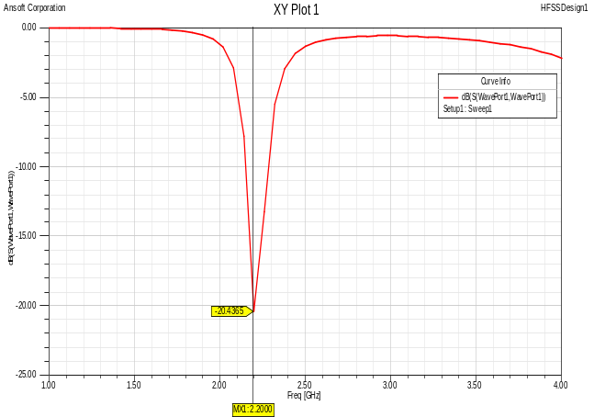
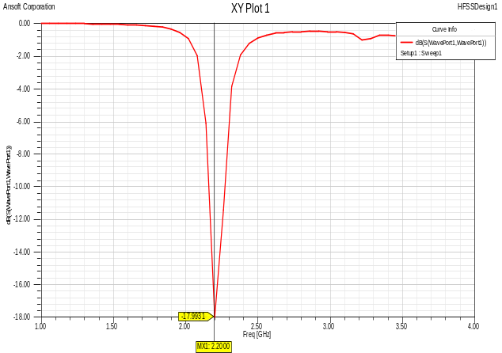
Figure 5. Variation of return loss with frequency.

The next two figures (Figure 6 & figure 7) represent the change of the antenna gain versus the frequency and the change of the antenna directivity versus the frequency.

The plots show that at the resonant frequency which is 2.2 GHz:

- The antenna gain is almost the same for both antennas: 6.97dB for the antenna with single cut and 7.08db for the antenna with double cut,

- For the directivity which is also almost the same for both antennas: 6.94dB for the antenna with single cut and 7.07dB for the antenna with double cut.

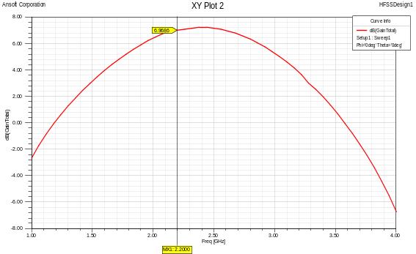
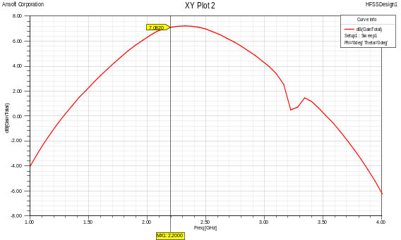
Figure 6. Gain of the simulated antennas.

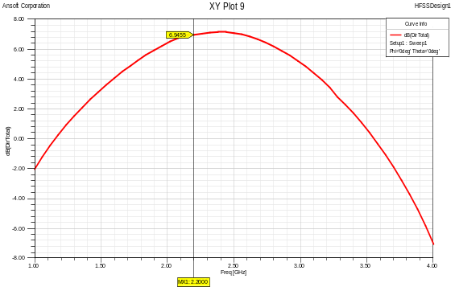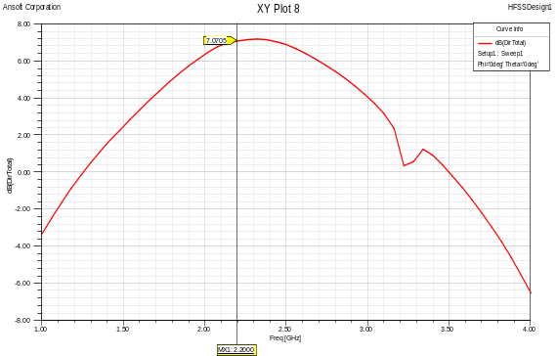
Figure 7. Directivity of the simulated antennas.

The axial ratio is a very important parameter for the quantification of the polarization of an antenna. The axial ratio of a wave which is elliptically polarized can take values among one to infinity (13) depending on major and minor axes of the ellipse:

- Linear polarized antenna: the axial ratio tends to infinity as one components of the electric field is zero,

- Circular polarized antenna: the axial ratio is 1 (or 0 dB) as the electric field components have the same magnitude,

- Elliptical polarization: the axial ratio is greater than 1.

Axial ratio versus frequency for square patch antennas designed is shown in figure 8. The value of axial ratio is 0.17db for the antenna with a single corner cut and 0.64dB for the antenna with double corner cut. This is mean that the antenna with single corner cut present a pure circular polarization than the antenna with double cut

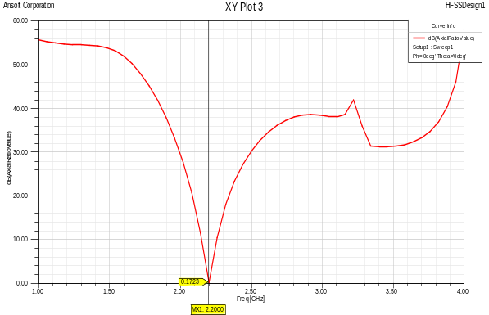
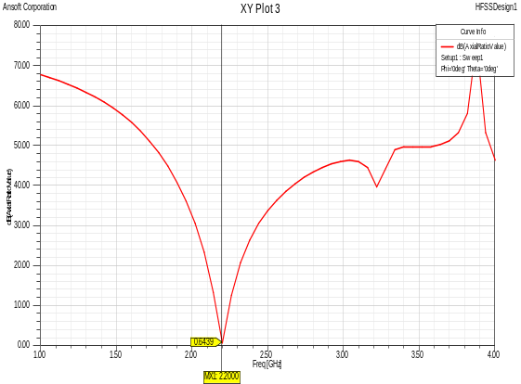

Figure 8. Axial ratio of the simulated antennas.

Next figure represent the axial ratio for two angles: “phi=0° and phi=90°” and this for the range of “-30°< theta <30° “, because the axial ratio tends to degrade away from the main beam of an antenna but for this simulated antenna with a single cut the axial ratio is still under the limit of 1dB in this range and for the antenna with double cut the AR is a little bit more than 1dB in theta=30° side for an angle of phi=0°.

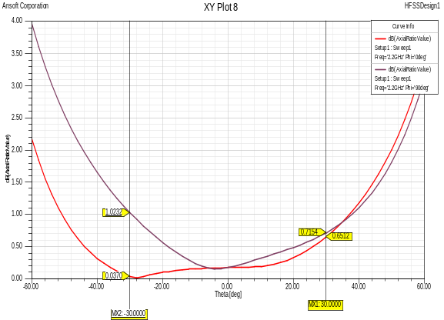
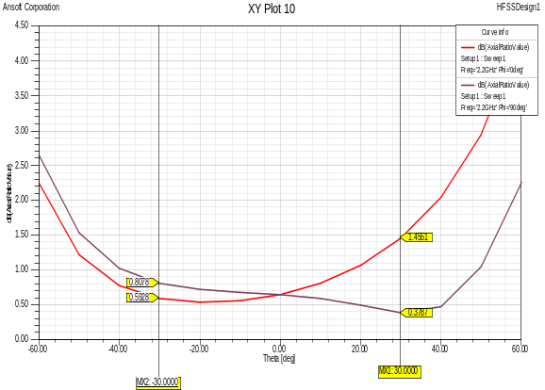
Figure 9. Axial ratio at Theta=-30° and Theta=30° for Phi=0° and Phi=90°.

The both simulated antennas presents a RHCP polarization and this is visible into the figures below where we can see that the difference between the RHCP gain and the LHCP gain is more than 30dB for both antennas and generally a difference of 10-15dB is sufficient to say that this is the antenna polarization.

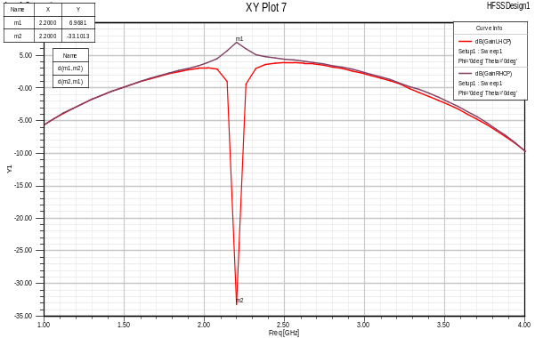
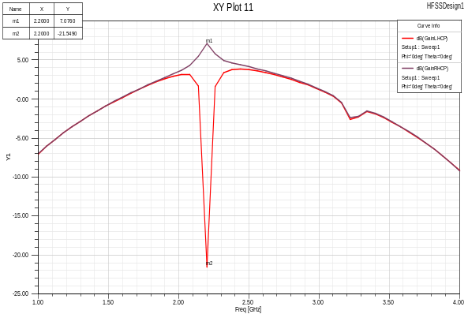
Figure 10. RHCP & LHCP gains.

We can find in some references in the literature like (14) where they consider into antenna performances anther parameter which is 3dB axial ratio beam width.

For this reason, in the figure 11, it can be noticed that the both simulated antennas present a 3dB axial ratio beam width of around 110°.
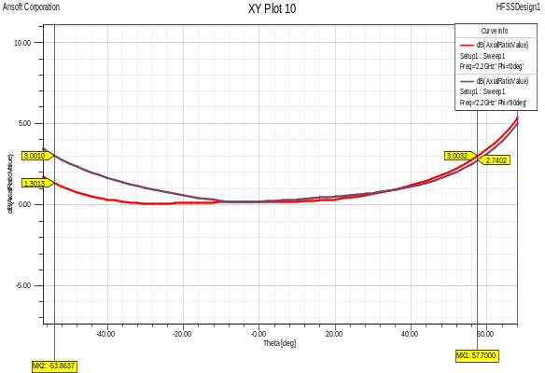
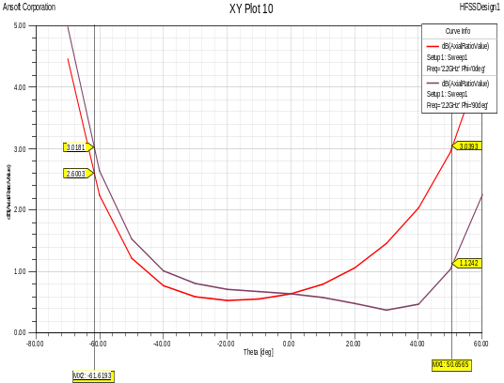
Figure 11. 3dB Axial Ratio beam width.

Finally, we took also into account the variation of VSWR with frequency. The VSWR observed for the antenna with single cut is around to be 1.65 which is better that the one for the antenna with double corner cut where the VSWR is around 2.2.
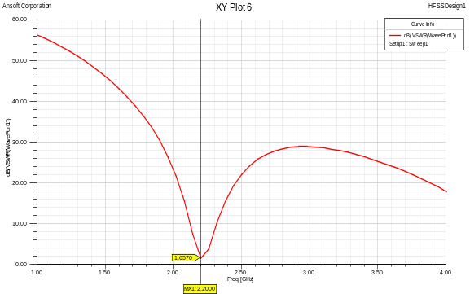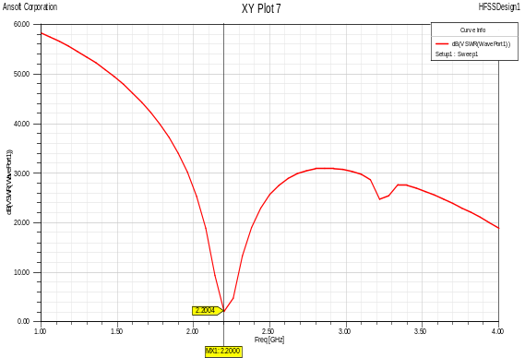
Figure 12. VSWR with frequency.

Conclusion
The design of square patch antenna with circular polarization and operating at the frequency of 2.2 GHz which is suitable for S-band small satellite applications using coaxial probe feeding technique has been completed using HFSS software. Two antennas were simulated one with a single truncated corner and the second with double truncated corner. The scope of this study was to compare the performances achieved by both designs. Based on the obtained results, the both designs present good performances compared to what is done practically and presented in several papers in the literature. However, the antenna with single cut present better performances than the antenna with double cut in term of S11, BW and especially in term of AR which means that the antenna with single cut has a better circular polarization than the antenna with double cut.

References

- M. Samsuzzaman, M. T. Islam, Haslina Arshad, J. S. Mandeep, and N.Misran, “Circularly Polarized S Band Dual Frequency Square Patch Antenna Using Glass Microfiber Reinforced PTFE Composite”, Hindawi Publishing Corporation, The Scientific World Journal, Volume 2014, Article ID 345190.
- Z. Yoon, W. Frese, A. Bukmaier and K. Brieb, “System Design of an S-Band Network of Distributed Nanosatellites”, CEAS Space J, vol. 6, pp 61-71, 2014.
- Prafull Ranjan, Saurabh Mishra, “Design of Circularly Polarized Rectangular Patch Antenna with single cut”, Conference on Advances in Communication and Control Systems 2013 (CAC2S 2013).
- Deepak Sood, Gurpal Sing, Chander Charu Tripati, Suresh Chander Sood & Pawan Joshi, “Design, fabrication and characterization of microstrip square patch arrey for X-band applications,” Indian Journal of Pure and Applied Physics, vol. 46, August 2008, pp. 593-597.
- Loran I. Basilio, Michael A. Khayat, Jeffery, T. Williams, Stuart A. Long “ The Dependence of the Input Impedance on Feed Position of Probe and Microstrip Line-Fed Patch Antennas,” IEEE Transactions on antenna and propagation, vol.49, No. 1, January 2001. pp. 45-47.
- Arun K. Bhattacharyya, “Analysis of circular patch antennas on electrically thick substrate,” Computer Physics Communication, vol. 68, 1991, pp.485-495.
- K Alameddine, S. Abou Chahine, M. Rammal, Z. Osman “Wideband patch antennas for mobile communication,” International. J. of Electron. Communication. (AEU) 60 (2006) pp.596-598.
- N.Mohamed, Sabidha Banu,Dr.M.Ramkumar Prabhu, U.T.Sasikala, “Design A Square Microstrip Patch Antenna for S-Band Application”, IOSR Journal of Electronics and Communication Engineering (IOSR-JECE), e-ISSN: 2278-2834,p-ISSN: 2278-8735.Volume 10, Issue 2, Ver. IV (Mar-Apr.2015), PP24-30.
- Sanjay R. Bhongale, Pramod N. Vasambekar, “Square Shaped Microstrip Patch Antenna at 2.45GHz”, International Journal of Science and Research (IJSR), ISSN (Online): 2319-7064, Volume 4 Issue 10, October 2015.
- [10] Kiran Jain, Keshav Gupta, “Different Substrates Use in Microstrip Patch Antenna-A Survey”, International Journal of Science and Research (IJSR), ISSN (Online): 2319-7064, Paper ID: 020132140.
- Adejoh Joshua, Okere B. I., Lanre Danian “Design of an S-Band Rectangular Microstrip Patch Antenna”, International Journal of Engineering and Applied Sciences (IJEAS) ISSN: 2394-3661, Volume-4, Issue-5, May 2017.
- Thomas Edling, “Design of circular polarized dual band patch antenna”, Master Programme in Electrical Engineering, UPPSALA university, May 2012.

- [Rosu, Julian,“Small Antennas for High Frequencies”, Yo3dac - Va3iul. Consulted October 2010.
- [14]researchgate.net/post/How_do_I_measure_axial_ratio_of_the_antenna

