Selective GSK3β inhibition mediates an Nrf2-independent anti- inflammatory microglial response
Mohamed H. Yousef¹, Mohamed Salama², Hassan A. N. El-Fawal², and Anwar Abdelnaser^{2*}
¹, ² The American University in Cairo, Egypt

Abstract:
Glycogen Synthase Kinase 3 (GSK3) is associated with the proinflammatory phenotype of microglia and has been shown to act in concert with nuclear factor kappa B (NF-κB). GSK3 is also a suppressor of nuclear factor erythroid 2-related factor 2 (Nrf2), the principal regulator of redox homeostasis. Agreeing with the oxidative paradigm of aging, Nrf2 is often deregulated in parainflammatory and neurodegenerative diseases. In this study, we aimed to explore a multimodal disease-modifying utility of GSK3 inhibition, beyond neuronal proteopathologies. Furthermore; we aimed to underscore the difference in therapeutic value between the two GSK3 paralogs by isoform-selective chemical inhibition.

The anti-inflammatory effects of paralog-selective GSK3 inhibitors were evaluated as a function of the reductive capacity of each to mitigate LPS-induced activation of SIM-A9 microglia. The Griess method was employed to detect the nitrate-lowering capacity of selective GSK3 inhibition. Real-time PCR was used to assess post-treatment expression levels of pro-inflammatory markers and antioxidant genes; pro- inflammatory cytokines were assayed by ELISA. Nuclear lysates of treated cells were examined for Nrf2 and NF-κB accumulation by immunoblotting. Finally, to infer whether the counter-inflammatory activity of GSK3 inhibition was Nrf2-dependent, DsiRNA-mediated knockdown of Nrf2 was attempted.

Results from our experiments reveal a superior anti-inflammatory and anti-oxidative efficacy for GSK3β- selective inhibition, compared to GSK3α-selective and non-selective pan-inhibition; hence use of selective GSK3β inhibitors is likely to be more propitious than non-selective dual inhibitors administered at comparable doses. Moreover, our results suggest that the anti-inflammatory effects of GSK3 inhibition is not Nrf2 dependent.

Keywords: GSK3; Paralog selectivity; Microglia; Neuroinflammation; Neurodegenerative diseases; Oxidative stress; Nrf2; NF-κB.

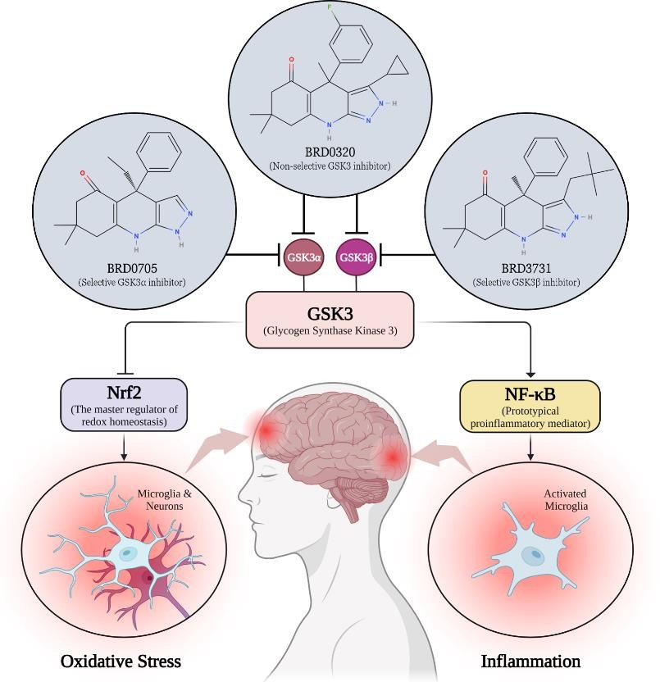

References:
1.Nagamoto-Combs K, Kulas J, Combs CK. A novel cell line from spontaneously immortalized murine microglia. J Neurosci Methods. 2014 Aug; 233:187–98.

2.Beurel E, Jope RS, E B, RS J, Beurel E, Jope RS, et al. Lipopolysaccharide-induced interleukin-6 production is controlled by glycogen synthase kinase-3 and STAT3 in the brain. J Neuroinflammation. 2009 Mar 1; 6(1):1–11.

3. Yuskaitis CJ, Jope RS, CJ Y, RS J, Yuskaitis CJ, Jope RS. Glycogen synthase kinase-3 regulates microglial migration, inflammation, and inflammation-induced neurotoxicity. Cell Signal. 2009 Feb; 21(2).

4.Guzman-Martinez L, Maccioni RB, Andrade V, Navarrete LP, Pastor MG, Ramos-Escobar N. Neuroinflammation as a common feature of neurodegenerative disorders. Front Pharmacol. 2019; 10(SEP).

