Paper title tunable optoelectronic properties of WS₂ by local strain engineering and folding

Ahmed Raza Khan
Australian National University, Australia

Abstract:
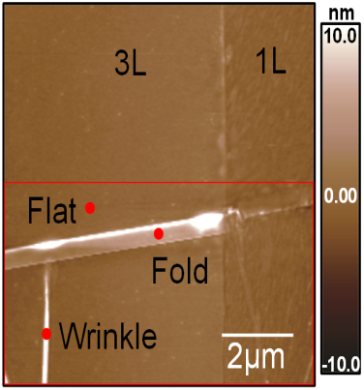
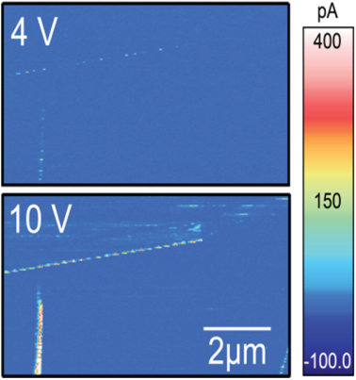
Local-strain engineering is an exciting approach to tune the optoelectronic properties of materials and enhance the performance of devices. Two dimensional (2D) materials such as 2D transition metal dichalcogenides (TMDCs) are particularly well-suited for this purpose because they have high flexibility and can withstand high deformations before rupture. Wrinkles on thick TMDC layers have been reported to show the interesting photoluminescence enhancement due to bandgap modulation and funneling effect. However, the wrinkles in ultrathin TMDCs have not been investigated, because the wrinkles can easily fall down to form folds in these ultrathin layers of TMDCs. Here, we have achieved both wrinkle and fold nano-structures simultaneously on 1-3L WS2 using a new fabrication technique. The comparable layer dependent reduction in surface potential is observed for both folded layers and corresponding perfect pack layers due to the dominant interlayer screening effect. The strains produced from the wrinkle nanostructures considerably vary semi conductive junction properties. Thermo-ionic modelling suggests that the strained (1.6%) wrinkles can lower the Schottky barrier height (SBH) by 20%. The photo-generated carriers would further significantly lower the SBH. These results present an important advance towards controlling the optoelectronic properties of atomically thin WS2 using strain engineering, with important implications for practical device applications.
a
b

Keywords: Strain engineering, Folding, WS2, Kelvin Probe Force Microscopy (KPFM), Surface Potential, Photo current, Layer dependence

References:

- Ahmed Raza Khan, Yuerui Lu, “Optical Harmonic Generation in 2D Materials”, Advanced Functional Materials, 2021.
- Ahmed Raza Khan, Boqing Liu, Wendi Ma, Linglong Zhang, Ankur Sharma, Yi Zhu, Tieyu Lü and Yuerui Lu, “Direct Measurement of Folding Angle and Strain Vector in Atomically thin WS2 using Second Harmonic Generation”, ACS Nano, 2020, 14(11).
- Ahmed Raza Khan, Teng Lu, Yun Liu, Yuerui Lu, “Tuneable Optoelectronic Properties of WS2 using Local Strain Engineering and Folding”, Advanced Electronics Materials, 2020, 6(4).

Biography:
Ahmed Raza Khan did his PhD from Australian National University. He is working as postdoctoral researcher in School of Engineering, Australian National University. His research interests include linear and nonlinear optics, strain-engineering of nano- materials and non-conventional machining process. He has published many papers, including in high impact journals like ACS Nano, Science Advances, Materials today, and Nano Letters, etc.

