Development of a vaccine against leishmaniasis
Derya T. Ata, M. Wiese and K. C. Carter
University of Strathclyde, UK

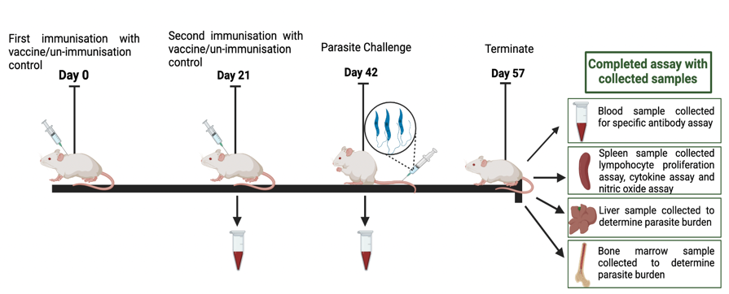
Abstract (300 word limit)
Statement of the Problem: Leishmaniasis is a serious neglected tropical disease and nearly 2 million people around the world are at risk of infection. Visceral leishmaniasis is fatal if untreated and most cases occur in Brazil, East Africa and in India. It remains one of the top parasitic diseases with outbreak and mortality potential. At present there is no clinical vaccine for leishmaniasis. Therefore, control is mainly managed by limiting transmission and treating active cases. The purpose of this study was to test a new vaccine candidate in a murine model of visceral leishmaniasis.
Methodology & Theoretical Orientation: BALB/c mice were immunised with two doses of the vaccine candidate on days 0 and 21. The mice were infected alone with unvaccinated controls with 2 x 10⁷ Leishmania donovani amastigote parasites and parasites burdens determined 14 days later. Specific IgG1 and IgG2a antibody responses were monitored over the course of the study and antigen-specific responses were determined by completing a lymphocyte proliferation assay using spleen cells harvested at the end of the study.
Conclusion & Significance: Vaccination induced significant protection against infection but did not induce sterile immunity. Immunity was associated with a mixed specific Th1 and Th2 immune response.

Figure 1 The immunisation protocol and completed assays during the vaccine study

Recent Publications (minimum 5)
- Kaye PM, Mohan S, Mantel C, Malhame M, Revill P, Le Rutte E, Parkash V, Layton AM, Lacey CJN, Malvolti S. Overcoming roadblocks in the development of vaccines for leishmaniasis. Expert Rev Vaccines. 2021, 20:1419
- Shaw CD, Carter KC. (2014) Drug delivery: lessons to be learnt from Leishmania studies. Nanomedicine (Lond). 9:1531
- Carter, K.C., Roberts, C., Doro, B. M., Alsaadi, M., Mullen, A., Campbell, S., Alawa, J., Alawa, C. & Nok, A. (2012) Comparative assessment of a DNA and protein Leishmania donovani gamma glutamyl cysteine synthetase vaccine to cross-protect against murine cutaneous leishmaniasis caused by L. major or L. mexicana infection. Vaccine. 30:1357
- F. L. Henriquez, S.A. Campbell, C.W. Roberts, A.B. Mullen, R. Burchmore and K. C. Carter (2010) Vaccination with recombinant L. donovani gamma-glutamylcysteine synthetase fusion protein protects against Leishmania donovani infection. J. Parasitol. 96: 929
- Carter KC, Henriquez FL, Campbell SA, Roberts CW, Nok A, Mullen AB, McFarlane E. (2007) DNA vaccination against the parasite enzyme gamma-glutamylcysteine synthetase confers protection against Leishmania donovani infection. Vaccine. 25: 4502

Biography

Derya Ata is a third year PhD student at University of Strathclyde, Pharmacy & Biomedical Sciences. She is working on project developing a vaccine against leishmaniasis. She studied motor neuron disease at Yildiz Technical University, Turkey in her master degree. She finds Immunology fascinating and would like to contribute to understanding how the immune system protects against infection.

