Challenges in computer guided mandibular resection and reconstruction
Ahmed A. Barakat, BDS, MDS, PhD, Cairo University, Egypt

Abstract (300 word limit)

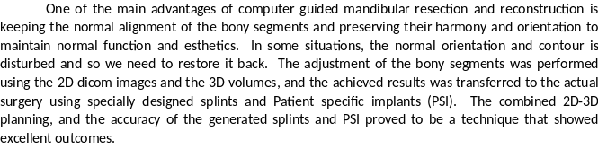
Image
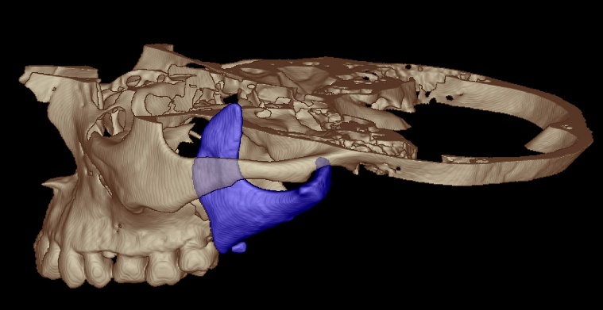
Fig showing the only remaining piece of the mandible (in blue)
Recent Publications (minimum 5)
Al Shazly A, Taha M, Barakat A and Zein el Abdien M: Evaluation of soft tissue changes in excessive gingival display cases after Le Fort I maxillary impaction surgery using 3D facial surface laser scanner. FDJ. 2021; 7.

EL Morsy O, Barakat A, Mekhemer S and Mounir M:Assessment of 3-dimensional bone augmentation of severely atrophied maxillary alveolar ridges using patient-specific poly ether-ether ketone (PEEK) sheets. Clin Implant Dent Relat Res. 2020;22:148–155

El Hadidy M, Mounir M, Abou-Elfetouh A and Barakat A: Assessment of vertical ridge augmentation and labial prominence using buccal versus palatal approaches for maxillary segmental sandwich osteotomy (inlay technique): A randomized clinical trial. Clin Implant Dent Relat Res. 2018 Oct;20(5):722-728.

Barakat A, Abou-ElFetouh A, Hakam M, El-Hawary H and Abdel-Ghany K: Clincal and radiographic evaluation of a computer-generated guiding device in bilateral sagittal split osteotomies. J Craniomaxillofac Surg. 2014; 42(5):195-203.

Shehab M, Barakat A, Abdel-Ghany K, Mostafa Y and Baur D: A novel design of a computer-generated splint for vertical repositioning of the maxilla after Le Fort I osteotomy. Oral Surg Oral Med Oral Pathol Oral Radiol. 2013 Feb;115(2):e16-25.

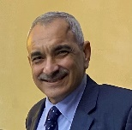Biography (150 word limit)
Paste your Logo here
Restoration of the facial contour and esthetics was my passion in Oral and Maxillofacial Surgery, I was quite concerned about that in orthognathic and tumor surgery. I started using computer assisted procedures in dental implantology, then I expanded to maxillofacial surgery and was fascinated with the potential and the results. I started to learn 3D modelling and planned my cases myself and designing my splints, prosthetic joints, and custom patient specific implants. I believe this is the best treatment I can give to my patients and encourage all the fellow practitioners to enter the field of modelling to add more and more innovative and creative ideas.
Email: ahmed@ahmedbarakat.com

Notes/Comments:

Presenting author details
Full name: Ahmed Abdel-Moniem Abdel-Aziz Barakat
Contact number: +201005566556
Mail id: ahmed@ahmedbarakat.com
Category: (Oral presentation/ Poster presentation) Oral presentation

