Upper arch dimensional changes with clear aligners in the early mixed dentition
Lione R, DDS, MS, PhD, Research Assistant UniCamillus-Saint Camillus International University of Health Sciences, Rome, Italy
Cozza P, Full Professor, UniCamillus-Saint Camillus International University of Health Sciences, Rome, Italy

Abstract

Background One goal of orthodontic treatment in mixed dentition is to expand the maxillary arch to allow proper tooth alignment and a correction of sagittal and vertical malocclusions. However, for most treatment protocols, expected outcome is not really clear to allow for a standardization of phase I orthodontic treatments. This lack of information makes it difficult for clinicians to predict tooth movements, including transverse expansion efficacy with Invisalign® (Align Technology, Santa Clara, CA, USA) in children. Therefore, the aim of the present study was to evaluate the transverse maxillary arch development with the Invisalign First System® in growing subjects.

Methods The study group included 23 subjects (9 females, 14 males, mean age 9.4±1.2 years). Patients were treated nonextraction with Invisalign First System® clear aligners with no auxiliaries other than Invisalign® attachments. Transverse interdental widths were measured only in the upper arch on each model at the start (T1) and at the end (T2) of treatment. A paired t-test was chosen to compare T2–T1 changes. The level of significance was set at 5%.

Results The greatest increase of maxillary width was detected at the level of the upper first deciduous molars (+3.7±1.4mm; P<0.001), followed by the level of the second deciduous molars (+3.4±1.6mm; P<0.001) and by the deciduous canine (+2.6 ± 2.0 mm; P < 0.001). Upper first molars showed a greater expansion in the intermolar mesial width (+3.2±1.2mm; P<0.001) than in the intermolar distal (+1.7±1.2mm; P<0.001) and transpalatal width (+1.2±1.2mm; P < 0.01).

Conclusions The Invisalign First System® can be considered effective in growing patients who require maxillary arch development. The greatest net increase was detected at the level of upper first deciduous molars, whereas the upper first molars showed a greater expansion in the intermolar mesial width due to a rotation that occurs around its palatal root.
Image
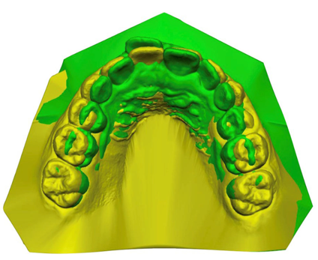

Fig. Superimposition of pretreatment (green) and posttreatment (yellow) digital models on palatal rugae
Recent Publications
- Blevins R (2019) Phase I orthodontic treatment using Invisalign first. J Clin Orthod 53:73–83
- Galan-Lopez L, Barcia-Gonzalez J, Plasencia E (2019) A system- atic review of the accuracy and efficiency of dental movements with Invisalign. Korean J Orthod 49:140–149
- Germane N, Lindauer SJ, Rubenstein LK, Revere JH Jr, Isaacson RJ (1991) Increase in arch perimeter due to orthodontic expansion. Am J Orthod Dentofacial Orthop 100:421–427
- Harris K, Ojima K, Dan C, Upadhyay M, Alshehri A, Kuo CL, Mu J, Uribe F, Nanda R (2020) Evaluation of open bite closure using clear aligners: a retrospective study. Prog Orthod 21:23
5. Khosravi R, Cohanim B, Hujoel P, Daher S, Neal M, Liu W et al (2017) Management of overbite with Invisalign appliance. Am J Orthod Dentofacial Orthop 151:691–699
.

Biography
I have a broad background in Orthodontics and biomechanical teeth movements, with specific training and expertise in cranio-facial growth and orthodontic treatment in growing patients. My research includes the behavior of the growth factors, the directionality of the growing facial structures and undergoing orthodontic treatment, the cellular and structural potential of response to orthodontic treatment in growing patients, the new approaches of maxillofacial surgery with three-dimensional visualization, modern conceptions the tooth movement in three- dimensional software, new protocols and new approaches to orthodontic treatment for the resolution of the most complex malocclusions. I laid the groundwork for the proposed research by developing my personal ability to handle well three-dimensional visualization software (as used by AlignTechnology), and having excellent knowledge of biomechanical orthodontic. This knowledge, which come from many years of clinical orthodontics with MBT technique, they are integrated with the latest knowledge of pure mechanical engineering and 3D design.
Email: robertalione@yahoo.it

Presenting author details
Full name: Roberta Lione
Contact number: +39 3494753583
Mail id: robertalione@yahoo.it
Category: Oral presentation

