Heavy oil enhanced recovery via Catalytic In-situ combustion: The effect of ligand nature on kinetics parameters and thermodynamic functions.
Mohammed Amine Khelkhal, PhD, Kazan Federal University, Russia

Abstract (300 word limit)
Statement of the Problem: The world is witnessing nowadays a serious geopolitical crisis due to the high demand of energy and the lack of resources. Heavy oil resources are of great interest in term of sustaining the market demand. However, their exploitation still represents the major challenge due to the high viscosity and low mobility of these oils in the reservoir. Enhanced oil recovery are promising technologies which allow at least some recovery of heavy oil. Much of the literature points toward the high efficiency of in-situ combustion in enhancing heavy oil recovery due to their economic and time effectiveness. Yet, this technique suffers from the early breakthrough of the created combustion front within the reservoir. This work shed light on stabilizing this front via bio-based catalysts in the presence of different metals. Methodology & Theoretical Orientation: We opted thermal analysis combined with the isoconversional and model-based methods to find out the kinetic parameters and thermodynamic function related to the process of heavy oil oxidation in the presence and absence of the obtained catalysts. Findings: The efficiency of the synthesized catalysts is mainly dependent on the ligand choice, the activation energy of the process of heavy oil oxidation decreased significantly in the presence of copper-based catalysts. Conclusion & Significance: The choice of the metal and ligand is crucial for its application in the process of in-situ combustion. Selecting sunflower based ligand and combining it with copper metals was found the most efficient method to improve the process of heavy oil in-situ combustion.

Image
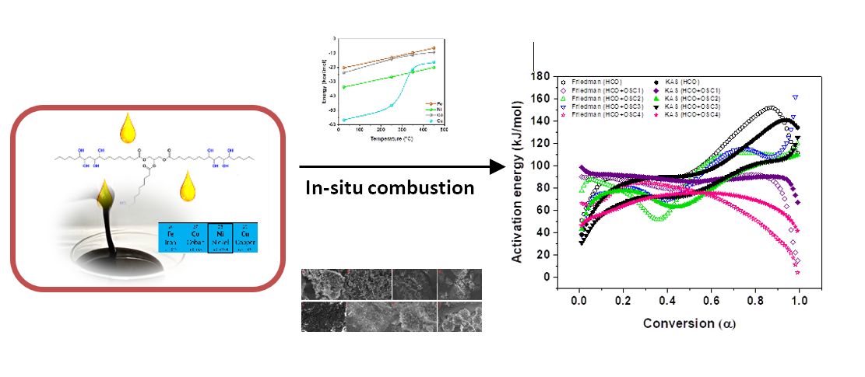
Recent Publications (minimum 5)
- SA Sitnov, MA Khelkhal, et al. (2022) Iron oxide nanoparticles impact on improving reservoir rock minerals catalytic effect on heavy oil aquathermolysis. Fuel 327, 124956.
- AS Ushakova, V Zatsepin, MA Khelkhal et al. (2022) In Situ Combustion of Heavy, Medium, and Light Crude Oils: Low-Temperature Oxidation in Terms of a Chain Reaction Approach. Energy & Fuels. 111:855-876.
- MA Khelkhal, SE Lapuk, AV Buzyurov et al. (2022) Thermogravimetric Study on Peat Catalytic Pyrolysis for Potential Hydrocarbon Generation. Processes 10 (5), 974.
- AV Vakhin, MA Khelkhal et al. (2022) Changes in Heavy Oil Saturates and Aromatics in the Presence of Microwave Radiation and Iron-Based Nanoparticles. Catalysts 12 (5), 514
5. MA Khelkhal et al (2022) Thermal Behavior of Heavy Oil Catalytic Pyrolysis and Aquathermolysis. Catalysts 12 (4), 449.

 Biography (150 word limit)
Paste your Logo here
Dr. Khelkhal Mohammed Amine is in expert in the field of catalysis application in enhanced oil recovery methods. After a decade of research and teaching experience he became able to recommend his innovation to different petroleum companies in Russia via project initiation and implementation for heavy oil reservoirs in the republic of Tatarstan. Currently, the author is leading different projects funded by the Russian science foundation in addition to forming future leader of the energy field in the Kazan Federal University.
Email: amine.khelkhal@gmail.com

Notes/Comments:

Presenting author details
Full name: Khelkhal Mohammed-Amine
Contact number: +79869163912
Session name/ number: Petroleum Engineering
Category: Oral presentation

