To decipher the function of signalling transducing adaptor protein 1 (STAP1) in immune cells
Chujun, DENG PhD, Department of Health Technology and Informatics, The Hong Kong Polytechnic University, Hong Kong

Chi-Ming WONG, Dr., Department of Health Technology and Informatics, The Hong Kong Polytechnic University, Hong Kong

Abstract
Background/Aims: Signal transducing adaptor family protein 1 (STAP1) is mainly expressed in immune cells. However, the function STAP1 protein in immune cell is still unclear. The aim of this study is to explore the function of STAP1 in immune cell by its interacting protein partners. Methods: HEK293 cells expressing TAP-tagged STAP1 were generated for tandem affinity purification, and its interacting partners were identified by Orbitrap mass analyzer. The STAP1 expression level in B cell cell-line and mouse primary lymphocytes were manipulated to explore the role of STAP1 in the immune cells. Results: Mass spectrometry identified a number of mitochondrial proteins as binding partners of STAP1 in HEK293 cells. We validated their interactions in immune cells by pull down assays and confocal analysis. Knockdown of STAP1 in B cells cell-line and knockout of mouse primary lymphocytes impaired the respiration rate as compared with their controls as determined by Seahorse XF extracellular flux analyzer. The phenotype could be complemented by overexpressing STAP1 in B cells. Conclusions: Our findings suggest that STAP1 regulates respiration via interaction with mitochondrion proteins. Further investigation on the connection between how immune cell expressed STAP1 modulates immune system by immune cells’ respiration is warrant.

Image

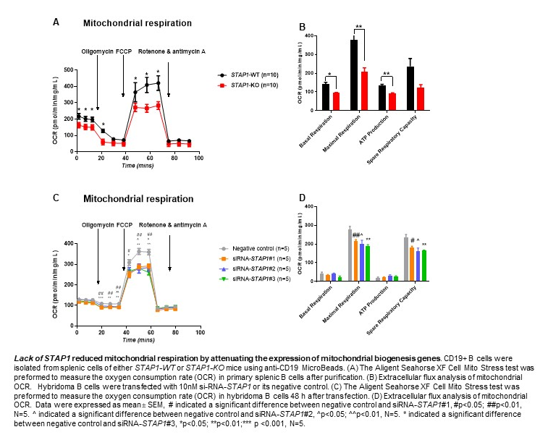

Recent Publications
- Tao W, Zhang Y, Ma L, Deng C, Duan H, Liang X, Liao R,Lin S, Nie T, Chen W, Wang C, Birchmeier C, Jia S.(2018) Haploinsufficiency of Insm1 Impairs Postnatal Baseline β-Cell Mass. Diabetes. 2018 Dec;67(12):2615-2625.
- Liao, R. Deng C(2019). Preparation of Adipose-derived stem cells (ASCs) in various sources of Human ASCs.
- Mengyao Wu, Deng, Chujun, Lo, Tak Ho, Chan, Ka-Ying, Li Xiang, Wong, Chi-ming. (2022). Peroxiredoxin, Senescence, and Cancer. Cells. 11. 1772. 10.3390/cells11111772.




Biography

DENG Chujun has her expertise in metabolism and immunology investigation. She was used to study metabolism for the past 6 years, and she opened her eyes on immunometabolism. Recently, she was focusing on immunometabolism research. She found the STAP1 gene which expressed in immune cells regulates the immune response in some mouse models, which may be caused by the metabolism function of this gene. And similar hypothesis have been proved, which can provide more ideas for her to study more details.
Email:chujun.deng@connect.polyu.hk

Notes/Comments:
Presenting author details
Full name: Chujun, DENG
Contact number: 852 5205 2033
Twitter account:
Linked In account:
Session name/ number:
Category: (Oral presentation/ Poster presentation)

