Modeling risk and disaster scenarios technologies by explosion of the condensate of natural gas, Alagoinhas/BA
Oliveira, Alarcon Matos de, PhD, DCET II UNEB, BRA. NASCIMENTO, Crislane Santos, DCET II UNEB, BRA

Introduction and importance

The transformations in the dynamics of society that occurred after the Industrial Revolution provided significant advances in the global economy, however, environmental impacts and the increase in the number of industrial accidents also intensified. The oil industry was one of the sectors that has grown the most since then, highlighting the increase in the use of natural gas as of the 1970s. The production of this fuel includes its humid part, the gas condensate. In the industrial scope, activities involving this substance can trigger risk scenarios and technological disasters of leakage and explosion of great magnitude, known as Boiling Liquid Expanding Vapor Explosion (BLEVE). Computer modeling and simulation is an important tool for the initial identification of the possible scope of these disasters, helping in emergency training and environmental management.

Case presentation:

Thus, this research aimed to simulate the explosion of natural gas condensate stored in a pressure vessel of an industrial plant in the city of Alagoinhas, a city located in the interior of the state of Bahia, Brazil. The study was developed deductively with exploratory research surveying geographic and climatic data and establishing the risk scenarios to be modeled in version 5.4.7 of the software Areal Locations of Hazardous Atmospheres (Aloha). With the results obtained, it was noticed that in all the panoramas analyzed, the explosion radii were greater than one kilometer and that the lethal zone encompasses the pressure vessel location facilities and the surrounding ecosystem.

Conclusion

The objective of the research was achieved, and it was possible to carry out a preliminary consequence analysis for disasters such as the BLEVE with Aloha, despite the limitations of the platform.
Image
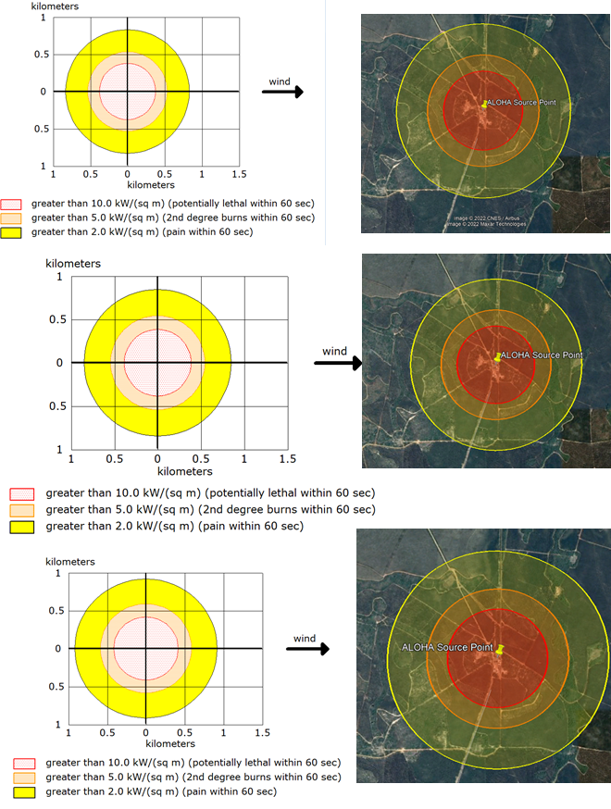
Recent Publications (minimum 5)
- Alarcon Matos de Oliveira, José Bueno Conti, Rosangela Leal Santos, Lusanira Nogueira Aragão de Oliveira, Carlos Alberto Oliveira Brito, Flavio Pietrobom Costa, Erivelton Nonato de Santana, Loss of life estimation and risk level classification due to a dam break, Heliyon, Volume 8, Issue 4, 2022, e09257, ISSN 2405-8440, https://doi.org/10.1016/j.heliyon.2022.e09257.
- OLIVEIRA, A. M.; CONTI, J. B. ; SANTOS, R. L. ; ARAGAO, L. N. . Processamento digital de imagens para mapeamento do coeficiente de manning em ambiente semiárido. INTERNATIONAL JOURNAL OF DEVELOPMENT RESEARCH, v. 11, p. 43921-43928, 2021.
- OLIVEIRA, A. M.; ARAGAO, L. N. ; SANTOS, R. L. ; SILVA, F. R. . Water Resources Management? Environmental and Legal Conceptions Applied to the Protection of Urban Ponds. International Journal of Current Science Research and Review, v. 03, p. 60-67, 2020.
- OLIVEIRA, A. M.; Fernandes, V. O. ; Alixandrini Jr, M. J. ; BRITO, P. L. . Análise da expansão urbana no entorno da Lagoa Grande e Lagoa da Tabua no município de Feira de Santana-BA a partir de série histórica de imagens Landsat MSS, TM e ETM. REVISTA BRASILEIRA DE GEOMÁTICA, v. 2, p. 49, 2014.
- OLIVEIRA, A. M.; SANTOS, R. L. ; ARAGAO, L. N. ; BRITO, C. A. O. . Classificação não supervisiona aplicada ao MDE para identificação de Lagoas. https://doi.org/10.34188/bjaerv3n4-074, v. 03, p. 3696-3714, 2020.

Biography
Paste your Logo here
He has a degree in Geography from the State University of Feira de Santana (2008) and a master's degree in Urban Environmental Engineering from the Federal University of Bahia (2012) PhD in Physical Geography from the University of São Paulo (2016). Substitute Professor at the State University of Bahia - UNEB Campos II - Alagoinhas DCET - Department of Exact and Earth Sciences. Collaborator/researcher at the State University of Feira de Santana. Has experience in Geosciences, with emphasis on Remote Sensing, acting mainly on the following themes: Geomorphology, Pedology, Climatology, Environmental Modeling, Environmental Risk, Environmental Analysis, Digital Image Processing, Remote Sensing, Cartography, Digital Cartography, Topography, Geographic Information System - GIS, Dam Breaking.

Notes/Comments:

Presenting author details
Full name: Alarcon Matos de Oliveira
Contact number: (75) 999792889
Twitter account:
Linked In account:
Session name/ number: Man-made and technological hazard
Category: (Oral presentation)

