Using MD simulation to study structure and dynamic properties of the 1-n-Alkyl-3-Methylimidazolium tris(perfluoroalkyl)trifluorophosphate ionic liquids

Gholizadeh Atani, Kazem, Mazandran, Babolsar, Iran

Abstract
In this study, we applied classical molecular dynamics (MD) simulations to understand the structure, dynamics and transport properties of the room-temperature 1-alkyl-3-methylimidazolium family with tris(perfluoroalkyl)trifluorophosphate ionic liquids, abbreviated as [Cnmim][eFAP]. Calculated densities of ionic liquids agree well with experimental data. Local structures were characterized by studying the center-of-mass (COM) and partial site-site RDFs, combined distribution functions (CDFs) and dihedral angles distribution of n-alkyl side chains in the imidazolium cations. The hydrogen bonding between Fluor atoms of anions and hydrogen atoms of imidazolium ring of cations were studied by contour maps of CDFs. Also, dynamical properties of these ILs such as mean-square displacement (MSDs) for center-of-mass of ions, ionic diffusion coefficients and the cationic transference numbers are calculated by simulation in the NVT ensemble. Results show that the length of alkyl-side chain of cation is the major factor to affect these properties. Calculated densities of ionic liquids agree well with experimental data. Calculated densities of four [Cnmim][eFAP] ionic liquids by isotherm – isobar (NPT) ensemble simulations at 298.15 K and 1 atm and shown in Table 1.
Table 1.Calculated densities of four [Cnmim][eFAP] ionic liquids at 298.15Kand 1atm.
Alkyl chain  length (n) | ρ(gr.cm-3)
Alkyl chain  length (n) | This work | Literature | % DEV
2 | 1.721 | 1.709[66] | 0.69
4 | 1.569 | 1.629[66] | 3.82
6 | 1.512 | 1.563[66] | 3.37
8 | 1.602 | NA | -

Radial Distribution Function (RDF) depicts the averaged local structure around a point or atom of interest where it characterizes the local microstructure of a liquid. We calculated the RDFs in this simualtion to better understand of hydrogen bonding in these ILs. Partial site-site RDFs between HR-F, HR-F2C and HR-F3C atoms were calculated and shown in Figure 1. It is evident that the F atoms are well organized around HR atoms, however F2C and F3C show smaller and broad peaks at larger distances. This observation can be explained in terms of the more negative charge of F atoms and also the steric hindrance around F2C and F3C atoms. The hydrogen bonding in different H atoms connected to the imidazolium ring was confirmed by many studies both theoretically and experimentally. Three types of fluorine atoms of anion can be grouped based on their partial charges and positions F, F2C and F3C.Atom labels are illustrated in Figure 2. The coordination number for the first solvation shell, N, can be calculated by integrating g(r) out to the location of the first minimum,
$$N=4π\int_{0}^{R_{min1}}{ρ_{nd}g(r)r^{2}}dr$$
where ρnd is the bulk number density and Rmin1 refers to the first minimum in g(r). The coordination numbers for PRDFs in Figure 1 are calculated and shown in Table 2. The coordination number of atom F around HR for all studied ILs is larger than the other fluorine-hydrogen Ns. This is not surprising in terms of the assigned charges to hydrogens of the imidazolium ring, where HR is the most positive among the other ring hydrogens.
Table 2. Calculated first maximum and minimum positions of different site-site Radial Distribution Functions
and the first shell coordination numbers (N) at 298.15 K and 1 atm.
[Cnim][eFAP] | type | First rmax position (Å) | First g(rmax) value | First rmin position | First g(rmin) value | Coordination number (N )
n=2 | F-HR | 2.65 | 3.082 | 4.45 | 0.518 | 0.665
n=2 | F-HM | 2.85 | 1.964 | 3.75 | 0.567 | 0.342
n=2 | F-HW | 2.85 | 1.964 | 3.45 | 0.192 | 0.224
n=2 | F2C-HR | 3.05 | 1.102 | 3.35 | 0.254 | 0.110
n=2 | F3C-HR | 2.65 | 1.568 | 3.25 | 0.647 | 0.179
n=4 | F-HR | 2.65 | 3.728 | 3.55 | 0.416 | 0.360
n=4 | F-HM | 2.65 | 2.051 | 3.75 | 0.466 | 0.326
n=4 | F-HW | 2.55 | 2.617 | 3.25 | 0.372 | 0.199
n=4 | F2C-HR | 3.15 | 0.989 | 3.35 | 0.350 | 0.115
n=4 | F3C-HR | 2.75 | 1.789 | 3.65 | 0.590 | 0.248
n=6 | F-HR | 2.55 | 4.402 | 3.35 | 0.638 | 0.370
n=6 | F-HM | 2.55 | 2.201 | 3.05 | 0.462 | 0.137
n=6 | F-HW | 2.65 | 2.650 | 3.55 | 0.568 | 0.231
n=6 | F2C-HR | 2.85 | 0.617 | 3.25 | 0.136 | 0.057
n=6 | F3C-HR | 2.95 | 1.700 | 3.95 | 0.489 | 0.304
n=8 | F-HR | 2.65 | 4.010 | 3.95 | 0.361 | 0.426
n=8 | F-HM | 2.65 | 2.606 | 3.65 | 0.528 | 0.249
n=8 | F-HW | 2.65 | 3.007 | 3.95 | 0.271 | 0.350
n=8 | F2C-HR | 3.15 | 0.993 | 3.55 | 0.447 | 0.128
n=8 | F3C-HR | 2.65 | 1.671 | 3.25 | 0.444 | 0.156

Image
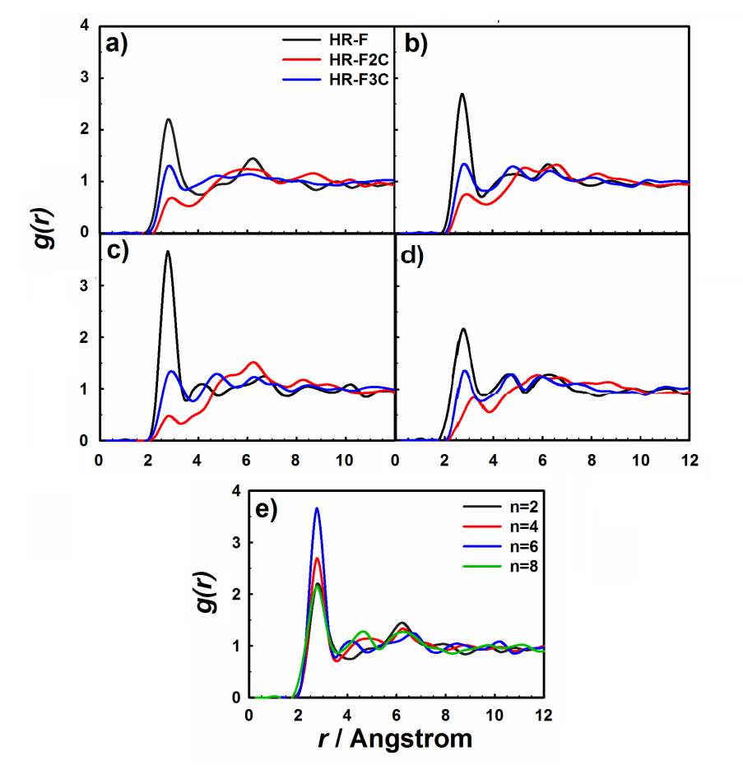
Figure 1. Calculated RDFs for the key atomic sites of the anion–cation (HR-F, HR-F2C and HR-F3C) for [Cnmim][eFAP] where n= a) 2, b) 4, c) 6, d) 8 and e) RDF for F-HR site in four studied ILs at 298.15K and 1atm.

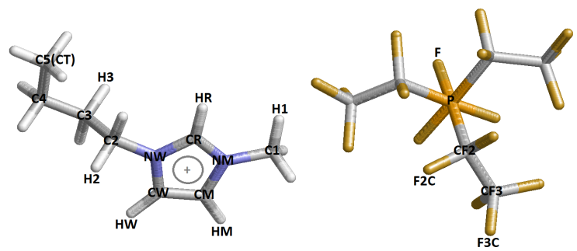
Figure 2. Labels applied to distinguish between the atoms applied in the studied ionic liquids.

Recent Publications
- Altschul SF, Gish W, Miller W, Myers EW, Lipman DJ (1990) Basic local alignment search tool J Mol Biol 215: 403-410.
- Bouvier F, Suire C, Mutterer J, Camara B (2003) Oxidative remodelling of chromoplast carotenoids: identifi cation of the carotenoid dioxygenase CsCCD and CsZCD genes involved in Crocus secondary metabolite biogenesis Plant Cell 15: 47-62.
- Chattopadhyay P, Chatterjee S, Sen SK (2008) Biotechnological potential of natural food grade biocolorants African Journal of Biotechnology 7: 2972-2985.
- Caspi R, Altman T, Dale JM, Dreher K, Fulcher CA, et al. (2010) The MetaCyc database of metabolic pathways and enzymes and the BioCyc collection of pathway/genome databases. Nucleic Acids Res 38: 473-479.
- Kloer DP, Ruch S, Al-Babili S,Beyer P,Schulz GE(2005) The structure of a retinal-forming carotenoid oxygenase. Science 308: 267.

 Biography
I have graduated with Ph.D. degree from univeristy of Mazandaran and currently teach the chemsitry in Tehran’ highschools and institutes. I already have professional and academic experience in the molecular dynamics simulation field of bulk and confined ionic liquids and their gas uptake. I worked on the structural and dynamic properties of mentioned systems. I have sufficient proficiency in many general and professional simulation softwares such as LAMMPS, DL_POLY and GAUSSIAN as well as different software and program to analyze the simulation results such as origin. Areas of expertise include MD simulation of bulk ILs, confined ILs in different nanotubes, gas uptake by bulk and confined ILs, Grand Canonical Monte Carlo (GCMC) simulations and quantum simulation by GAUSSIAN. In the MSc. and Ph.D. courses, with cooperation of our team and my professors, I have published 2 articles in the peer-reviewed journals and at present, we are ready to prepare the new article about the structural and dynamic properties of confined ILs. Also, I have a most motivation and interesting to study the mentioned systems, drug-polymer interaction and various models by quantum simulations.

Email: gholizadehatanikazem@gmail.com

Notes/Comments:
Presenting author details
Full name: Gholizadeh Atani, Kazem
Contact number:+989910125714
Mail id: gholizadehatanikazem@gmail.com
Category: Oral presentation
Linked In account: www.linkedin.com/in/kazem-atani-5171a4a8

