Antibodies with Functionality as a New Generation of Translational Tools designed to Monitor Multiple Sclerosis (MS) at Clinical and Subclinical Stages

Sergey Suchkov¹⁻³,
Noel Rose⁴, Aleks Gabibov⁵, Harry Schroeder⁶

¹I.M.Sechenov First Moscow State Medical University, Moscow, Russia

²A.I.Evdokimov Moscow State Medical & Dental University, Moscow, Russia

³EPMA (European Association for Prediction, Prevention and Personalized Medicine), Brussels, EU

⁴Johns Hopkins Center for Autoimmune Disease Research and PAHO/WHO Collaborating Center for
Autoimmune Disorders, Johns Hopkins Medical Institutions, Baltimore, MD, USA

⁵Institute for Bioorganic Chemistry, Russian Academy of Sciences, Moscow, Russia

⁶Division of Immunology & Rheumatology, Director UAB Program in Immunology,
UAB, Birmingham, ALA, USA

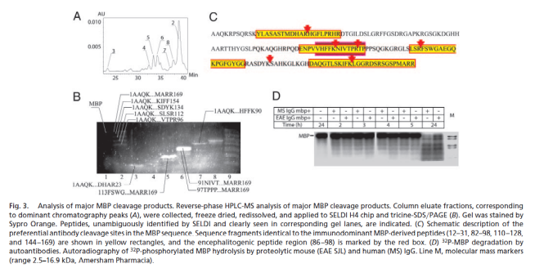
Catalytic Abs (catAbs) are multivalent immunoglobulins (Igs) with a capacity to hydrolyze the antigenic (Ag) substrate. In this sense, proteolytic Abs (Ab-proteases) represent Abs to provide proteolytic effects.
Abs against myelin basic protein/MBP with proteolytic activity exhibiting sequence-specific cleavage of MBP are of great value to monitor demyelination whilst in MS. The activity of Ab-proteases was first registered at the subclinical stages 1-2 years prior to the clinical illness. And the activity of the Ab-proteases revealed significant correlation with scales of demyelination and the disability of the patients as well. So, the activity of Ab-proteases and its dynamics tested would confirm a high subclinical and predictive (translational) value of the tools as applicable for personalized monitoring protocols.
Of tremendous value are Ab-proteases directly affecting remodeling of tissues with multilevel architectonics (for instance, myelin). By changing sequence specificity one may reach reduction of a density of the negative proteolytic effects within the myelin sheath and thus minimizing scales of demyelination. Ab-proteases can be programmed and re-programmed to suit the needs of the body metabolism or could be designed for the development of new catalysts with no natural counterparts. Further studies are needed to secure artificial or edited Ab-proteases as translational tools of the newest generation to diagnose, to monitor, to control and to treat and rehabilitate MS patients at clinical stages and to prevent the disorder at subclinical stages in persons-at-risks to secure the efficacy of regenerative manipulations.

Publications
- Mysikov V.K., Pronina O.A., Gnuchev N.V., Stepanenko R.N., Durova O.M., Gabibov A.G., Kotov S.V. (2002) Humoral immunity in patients with multiple sclerosis. European Journal of Neurology, 2002, V.9, Suppl. 2, N 2103, P. 136.
- Ponomarenko N.A., Durova O.M., Vorobiev I.I., Aleksandrova E.S., Telegin G.B., Chamborant O.G., Sidorik L.L., Suchkov S.V., Alekberova Z.S., Gnuchev N.V., Gabibov A.G. (2002) Catalytic antibodies in clinical and experimental pathology: human and mouse models. Journal of Immunological Methods, 2002, N 269, PP. 197-211
- Ponomarenko N.A., Durova O.M., Vorobiev I.I., Belogurov A.A., Telegin G.B., Suchkov S.V., A.G. Gabibov (2005) Catalytic activity of autoantibodies toward myelin basic protein correlates with the scores on the multiple sclerosis expanded disability status scale. Immunol. Lett., 2005, Vol. 103, N1, P. 45-50
- Gabibov A.G., Ponomarenko N.A., Tretyak E.B., Paltsev M.A., Suchkov S.V. (2006) Catalytic autoantibodies in clinical autoimmunity and modern medicine. Autoimmunity Reviews, 2006, N5, P. 324-330
- Gabibov A.A., Paltsev M.A., Suchkov S.V. (2011) Antibody-associated proteolysis in surveillance of autoimmune demyelination: clinical and preclinical issues Future Neurology, 2011, Vol. 6, N3, P. 303-305
- D. Kostyushev, I. Tsarev, D. Gnatenko, M. Paltsev, S. Suchkov (2011) Myelin-associated serological targets as applicable to diagnostic tools to be used at the preclinical and transient stages of multiple sclerosis progression. Open J Immunology, 2011, Vol. 1, №3, PP. 80-86


Biography Sergey Suchkov graduated from Astrakhan State Medical University and awarded with MD, then in 1985 maintained his PhD at the I.M. Sechenov Moscow Medical Academy and in 2001, maintained his Doctorship Degree at the Nat Inst of Immunology, Russia. From 1987 through 1989, he was a senior Researcher, Koltzov Inst of Developmental Biology. From 1989 through 1995, he was a Head of the Lab of Clinical Immunology, Helmholtz Eye Research Institute in Moscow. From 1995 through 2004, a Chair of the Dept for Clinical Immunology, Moscow Clinical Research Institute (MONIKI. Dr Suchkov has been trained at: NIH; Wills Eye Hospital, PA, USA; Univ of Florida in Gainesville; UCSF, S-F, CA, USA; Johns Hopkins University, Baltimore, MD, USA. He was an Exe Secretary-in-Chief of the Editorial Board, Biomedical Science, an international journal published jointly by the USSR Academy of Sciences and the Royal Society of Chemistry, UK. At present, Dr Sergey Suchkov is a Chair, Dept for Personalized and Translational Medicine, I.M.Sechenov First Moscow State Medical University. He is a member of the: New York Academy of Sciences, USA; American Chemical Society (ACS), USA; American Heart Association (AHA), USA; EPMA (European Association for Predictive, Preventive and Personalized Medicine), Brussels, EU; ARVO (American Association for Research in Vision and Ophthalmology); ISER (International Society for Eye Research); PMC (Personalized Medicine Coalition), Washington, USA.

Full name: Sergey Suchkov
E-mail: ssuchkov57@gmail.com
Contact number: 79857616567
Session name/number: Biomarkers and Personalized Medicine
Category: Oral presentation
Tel: xxx-xxx-xxxx
Session Name/Number
Category: (Oral presentation/Poster presentation)

