Simultaneous Characterization and Determination of Warfarin and Its Hydroxylation Metabolites in Rat Plasma by Chiral Liquid Chromatography-Tandem Mass Spectrometry
Shasha Jin, PhD student, Fudan University, China
Abstract:
Warfarin is extensively used for venous thromboembolism and other coagulopathies. In clinical settings, warfarin is administered as a mixture of S- and R-warfarin, and both enantiomers are metabolized by multiple cytochrome P450 enzymes into many hydroxylation metabolites. Due to the high degree of structural similarity of hydroxylation metabolites, their profile possesses significant challenges. The previous methods generally suffer from lacking baseline resolution and/or involving complex analysis processes. To overcome this limitation, a sensitive and specific chiral liquid chromatography-tandem mass spectrometry (LC-MS/MS) method was developed to simultaneously identify warfarin and hydroxywarfarins enantiomers. Chromatographic separation was achieved on a HYPERSIL CHIRAL-OT column. The mass spectrometric detection was carried out in negative ion MRM mode with electrospray ionization source. The optimized method exhibited satisfactory within-run and between-run accuracy and precision with lower limit of quantification (LLOQ) of 10.0 ng/mL and 1.0 ng/mL for warfarin and 7-, 10(R)-OH-warfarin enantiomers, respectively. Linear responses of warfarin enantiomers and 7-, and 10(R)-OH-warfarin enantiomers in rat plasma were observed over the range of 10.0–8000 ng/mL, and 1.00–800 ng/mL, respectively. The analytes were shown to be stable in various experimental conditions in rat plasma. Protein precipitation was used in sample preparation without a matrix effect. This method was successfully applied to pharmacokinetic study for quantitating the concentrations of S/R-warfarin, S/R-7-OH-warfarin, and S/R-10(R)-OH-warfarin and relatively quantitating 3’-, 4-, 6-, and 8-OH warfarin enantiomers in rat plasma.
Image:
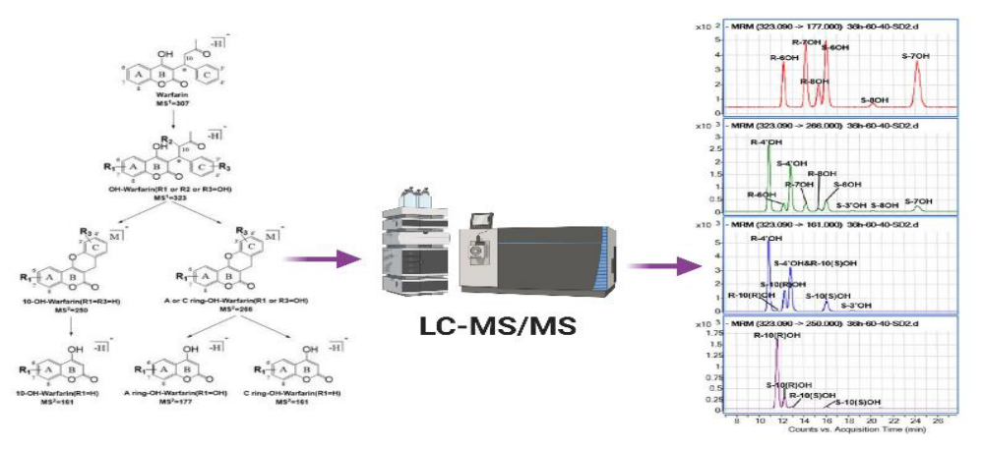

Biography:
Shasha Jin has her expertise in drug pharmacokinetics, drug-drug interactions and pharmacogenetics in promoting safe and rational drug use. Her present studies focus on drug-drug interactions between tyrosine kinase inhibitors and warfarin based on enzymes kinetic study, in vivo study in rats and PBPK modeling. She has recently developed a sensitive and specific chiral liquid chromatography-tandem mass spectrometry method to simultaneously identify warfarin enantiomers and its six warfarin hydroxylation metabolites in rat plasma, which was successfully applied to pharmacokinetic study. Before that, she made a lot of contributions on exploring the mechanism of methimazole induced liver injury using both pharmacogenetic and metabolomic method.

Email: 19111030080@fudan.edu.cn

Recent Publications:
1. Shasha J, Zhihong L, Qing Y, Boyu F, Xiaoqiang X, Chao P, Weimin C (2022) Simultaneous Characterization and Determination of Warfarin and Its Hydroxylation Metabolites in Rat Plasma by Chiral Liquid Chromatography-Tandem Mass Spectrometry. Pharmaceutics, 14(6), 1141.
2. Shasha J, Xuesong L, Yujuan F, Yu D, Haishu L, Weimin C, Jialin Y, Xiaoqiang X (2019) Association between genetic polymorphisms of SLCO1B1 and susceptibility to methimazole-induced liver injury. Basic & Clinical Pharmacology & Toxicology 125(6):508-517.
3. Xuesong L, Jialin Y, Shasha J, Yu D, Yujuan F, Xiaofang F, Zhigang L, Jianhua Y, Wai-Ping Y, Haishu L, Weimin C, Xiaoqiang X (2020) Mechanistic examination of methimazole-induced hepatotoxicity in patients with Grave’s disease: a metabolomic approach. Archives of Toxicology 94:231-244.
4. Wanjie N, Size L, Shasha J, Xiying L, Mengwan Z, Weimin C, Mingkang Z, Xiaoqiang X, Zheng J (2020) Investigation on the interaction between nifedipine and ritonavir containing antivirus regimens: a physiologically-based pharmacokinetic/pharmacodynamic analysis. British Journal of Clinical Pharmacology doi:10.1111/bcp.14684.
5. Xuesong L, Shasha J, Yujuan F, Xiaofang F, Zhijia T, Weimin C, Jialin Y, Xiaoqiang X (2019) Association of HLA-C*03:02 with methimazole-induced liver injury in Graves’ disease patients. Biomedicine & Pharmacotherapy 117: 109095.

6. Hongrui L, Fang C, Bing W, Hao W, Shasha J, Zhou Y, Yusheng C, Yingjun Q, Xiaoqiang X (2020) A Sensitive HPLC-MS/MS Method for the Quantification of Selegiline in Beagle Dog Plasma: Application to a Pharmacokinetic Study. Current Pharmaceutical Analysis 17(1):140-148.

Presenting author details Full name: Shasha Jin
Contact number: +86 19916927863
Twitter account:
Linked In account: 19111030080@fudan.edu.cn
Session name/ number:
Category: (Oral presentation/ Poster presentation)

