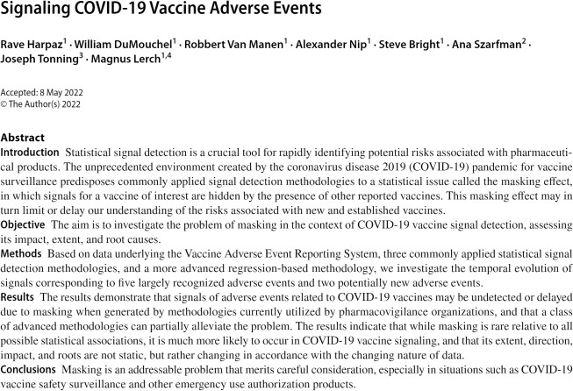

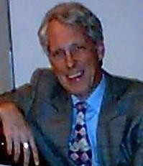

William DuMouchel is Chief Statistical Scientist at Oracle Health Sciences.
His current research focuses on statistical computing and Bayesian hierarchical models, including applications to meta- analysis and data mining. Dr. DuMouchel has developed data mining algorithms for drug adverse event associations in spontaneous reports and in clinical research data that have been used widely within regulatory agencies and industry. Dr. DuMouchel received the Ph.D. in Statistics from Yale University and has been a member of the faculties of the University of California at Berkeley, the University of Michigan, MIT, and Columbia University, as well as previous senior research positions at Bolt, Beranek, Newman, Inc., and AT&T Labs.

