FROM EDIBLE PRODUCTS TO DISINFECTING CURRENCY NOTES
Aniruddha Horea, Saptarshi Mitraa, Sandip Ghoshb, Sujoy Boseb, Avijit Ghosha
Heritage Institute of Technology, Chowbaga Road, Anandapur, Kolkata, West Bengal, India
Dr H L Roy Building, Jadavpur University Campus, 188 Raja Subodh Chandra Mullick Road, Kolkata, West Bengal, India
PRESENTING AUTHORS: ANIRUDDHA HORE, SAPTARSHI MITRA
\
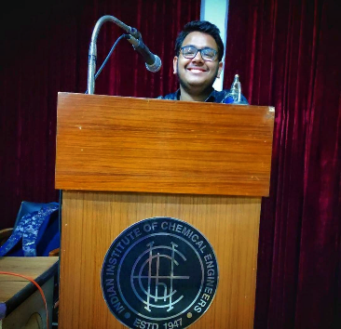

Abstract
The Indian rupee is the official currency of India. With time, science and technology got advanced and our society is slowly making its way to a cashless mode of transaction. But as India is still a developing country a large part of our society still depends on the transaction through cash. During the times of pandemics, we came to understand that everything that we touch is not safe from microbial contamination. The Indian currency is also not an exception. The Indian currency is the modern-day medium of harmful bacterial as well as other microbial contaminations resulting in diseases in human bodies. Therefore. the need came to make the currency disinfectant to give our people a healthier lifestyle.
The main focus of the study is to develop a solution that when applied to the currency notes will kill the persisting bacteria or microbes present in the notes. So various natural edible products were used in order to prepare the solution which is highly effective against the presence of harmful bacteria such as E. coli and S. aureus. The antibacterial activity of these natural ingredients is not unknown to us so extracts from those products were mixed together to form a solution which was made the Indian currency notes antibacterial for 20min approx. The solution was creating a layer on the surface of currency notes, therefore, making it antibacterial for a given duration of time i.e., no bacterial growth was seen during the time period of 20 minutes, therefore, making it safe for the usage of human hands.

BIOGRAPHY
Aniruddha Hore and Saptarshi Mitra, 3rd-year chemical engineering students of the Heritage institute of technology, Kolkata. Currently, we are also researchers at the Indian Institute of Chemical Engineers (IIChE) and we have 2 research papers in our name. We are currently working on 3 ongoing research and also are the research intern for IIT Kharagpur. Our field of research is Chemistry and Environment, and we want to keep working in this particular field to create healthier earth for people to live in.

Keywords: Indian currency; Antibacterial property of Indian currency; Surface coating on currency
References
(1) S. Sunil, G.S. Panchmal, R.P. Shenoy, V. Kumar, P.Jodalli, V. Somaraj, J Indian Assoc Public Health Dent. 18(2020) 179-182.
(2) G. Girma, J. Food Nutr. Sci. 2 (2) (2015) 49-54.
(3) J.Ali, B. Das, T. Saikia, Int. J. Curr. Pharm. Res. 9(2017) 79-82. 4) E.I. Oikeh, S. Ehimwenma, F. Omoregie, E. Oviasogie, K. Oriakhi. Food. Sci.Journal.
4(1) (2015) 103–109. 5) W.M.Otang, A.J.Afolayan. S.Afr. J. Bot. 102 (2016) 46-49. 6) M. Asker, S.-El Gengaihi, S.E. Hassan, Bull. Natl. Res. Cent. 194 (2020) 44-50.
5) S.P. Malu, G.O. Obochi, E.N. Tawo, B.E. Nyong,Glob. J. Pure Appl. 15 (3-4) (2009)

