The Elastic Properties of Postulated Solid Forms from First Principles
Reabetswe Zwane¹; Damien Thompson²; Anthony Reilly¹
reabetswe.zwane2@mail.dcu.ie
- Dublin City University; Synthesis and Solid-State Pharmaceutical Centre
- University of Limerick; Synthesis and Solid-State Pharmaceutical Centre

Understanding the nature of crystal energy landscapes, obtained from crystal structure prediction (CSP) calculations, can greatly aid drug development. Beyond crystal structure prediction, the analysis of a crystal energy landscape in a pharmaceutical setting can highlight the preferred crystal packing of an active pharmaceutical ingredient or structural motifs. Identifying these distinctive structural features can then be useful for establishing structure-property relationships for crystal engineering or drug design. For structure-mechanical response relationships (see figure below), the mechanical properties of a set of low putative solid forms from a CSP study can be predicted, and therefore potentially assist in identifying mechanical properties accessible to an API, within a specific energy range of interest. In this contribution, elastic properties of postulated solid forms of 2-((4-(3,4-Dichlorophenethyl)phenyl)amino)benzoic acid DPAB, utilized for the treatment of Alzheimer disease and the XXIIIth molecule in the sixth CSP blind test, are characterized using first-principles and first-principles based methods. The assessment of mechanical stability, elastic moduli and the anisotropy of the elastic moduli of DPAB will potentially enable the screening of putative solid forms for a polymorph(s) that exhibits improved compression properties.

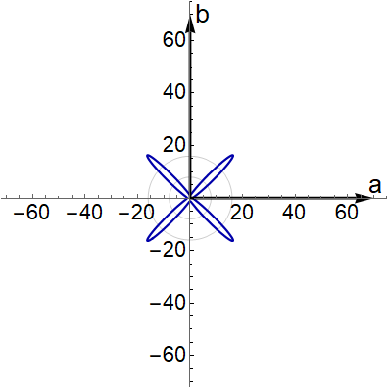

Figure 1 (left) The 2-dimensional spatial dependence of the Young’s modulus of urea in the ab crystallographic plane and (right) the N-H$⋯$O hydrogen bond arrangement in the ab crystallographic plane. The direction of the largest resistance of the Young’s modulus aligns with the N-H$⋯$O bonds.

