Effectiveness of the Herbal Decoction Varanadi Kashaya in Managing Obesity of an Individual with Metabolic Disorders (Observational Case Study)
W.K.A.A.T Perera^{*1}
N.D.N Jayawardhane¹
Institute of Indigenous Medicine, University of Colombo, Rajagiriya, Sri Lanka

Abstract
V
aranadi Kashaya (VK) is a polyherbal decoction which is prepared from the drugs of Varanadigana mentioned in Ayurveda classic Ashtanga Hrudaya. Several clinical studies have shown the potentiality of VK in suppressing adipogenesis and lipid accumulation favouring anti-obesity action. Moreover, hypocholestrolemic, anti-oxidant, free radical scavenging and anti-diabetic characteristics of the herbals which constitute VK make it a potential candidate to address metabolic disorders as well. However, the effectiveness of VK in managing obesity of individuals with metabolic disorders has not yet been evaluated in detail. Aim: The aim of the study was to determine the effectiveness of VK in an obese individual with metabolic disorders. Materials and method: VK was given over a period of 30 days to an obese individual with diabetes and hyperlipidemia. The effect of VK was determined by analyzing the changes in anthropometry, Ayurveda parameters and laboratory investigations such as FBS, HbA1C, SGOT, SGPT and lipid profile. Results: Reduction could be observed in weight/hip ratio from 0.95 to 0.84, shifting the high risk apple shape body into a ratio between apple and pear threshold which is of moderate risk to

health problems. Markedly reduction in LDL levels from 112.6 mg/dl to 106.2 mg/dl, total cholesterol levels from 180 mg/dl to 171 mg/dl, and Non-HDL levels from 132 mg/dl to 129 mg/dl were noticed in laboratory findings while FBS, HbA1C, SGOT and SGPT were constant throughout. Conclusion: The results demonstrate the potency of anti-obesity action of VK which addresses both subcutaneous and visceral fat. Hence, opens up the possibilities of controlling obesity related metabolic disorders.

Biography
W.K.A.A.T Perera (Corresponding author) is reading Bachelor of Ayurveda Medicine and Surgery in the Institute of Indigenous Medicine, University of Colombo, Sri Lanka, and is in the final year. As per the interest in carrying out research studies in Ayurveda, has participated in expert talks, webinars, and national and international training programs and has submitted abstracts and papers to international conferences, and is in the process of publishing in journals.
N.D.N Jayawardhane(Supervisor) is a senior lecturer for 13 years in the Institute of Indigenous Medicine, University of Colombo, Sri Lanka, and a consultant at the National Ayurveda Teaching Hospital. Has completed MD in the year of 2012 and has served on roughly fifteen conference and workshop programs nationally and internationally.
.

https://herbal.europeannualconferences.com Volume 84 , 2022
1

About the Institute/University

Institute of Indigenous Medicine (IIM), University of Colombo remains one of the country’s traditional health care systems in the field of Medical education by maintaining high standards and values. The Institute of Indigenous Medicine is the one and only institute which teaches indigenous medicine in Sri Lanka and produce Ayurveda Medical doctors and Unani Medical
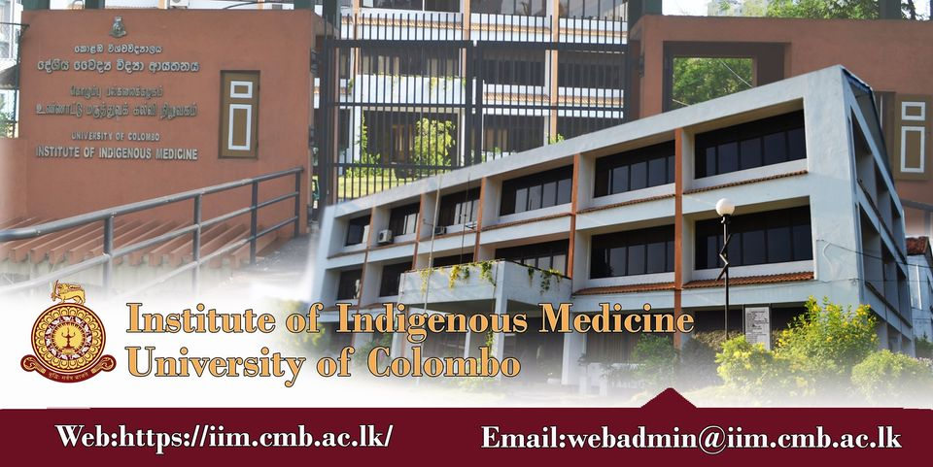
doctors. Hence, the IIM provides a brilliant opportunity for its undergraduate students to expand the knowledge and skills on indigenous medicine with hands on experience on Ayurveda system of medicine or Unani system of medicine with the exposure for a highly diverse and nourishing environment with clinically-based study programs as top-priority. The institute also actively conducts various diploma courses, certificate courses and postgraduate diploma courses related to different disciplines in Ayurveda and Unani systems of medicine. The Institute has a dynamic, vibrant and highly stimulating clinical based teaching and research environment which is achieved through a blend of high quality academic staff members who are committed to disseminate knowledge in all the areas of Ayurveda and Unani systems of Medicine. Ultimate goal of the institute is to produce knowledgeable skilled doctors in Ayurveda or Unani systems of Medicine.

References
[1] Samhita C. (2007) Ayurveda Dipika Commentary of Chakrapanidatta. Chaukhambha Surbharati Prakashan, Varanasi, Reprint, Sutra Sthana; 1 (68), 20.
[2] Srikanthamurthy, K. R. (1998). Bhāvaprakāśa of Bhāvamiśra: text, English translation, notes, appendences and index (Vol. 2). Krishnadas Academy.
[3] Mohamed, G. A., Ibrahim, S. R., Elkhayat, E. S., & El Dine, R. S. (2014). Natural anti-obesity agents. Bulletin of faculty of pharmacy, Cairo University, 52(2), 269-284.
[4] Chinchu, J. U., & Mohan, M. C. (2020). Downregulation of adipogenic genes in 3T3-L1 Pre adipocytes-a possible mechanism of anti-obesity activity of herbal decoction Varanadi Kashayam. Journal of herbal medicine, 19, 100309.
[5] Blundell, J. E., & Halford, J. C. (1995). Pharmacological aspects of obesity treatment: towards the 21st century. International journal of obesity and related metabolic disorders: journal of the International Association for the Study of Obesity, 19, S51-5.
[6] Parasuraman, S., Thing, G. S., & Dhanaraj, S.

A. (2014). Polyherbal formulation: Concept of Ayurveda. Pharmacognosy reviews, 8(16), 73.
[7] Chinchu, J. U., & Kumar, B. P. (2018). In-vitro anti-lipase and antioxidant activity of polyherbal ayurvedic medicine varanadi kashayam. International journal of pharmaceutical sciences and research, 9(12), 5373-5381.
[8] Labhade, S. D., Sharma, S., Paliwal, S., & Desai, S. (2021). An Overview of Some Plant Based Products With Hepatoprotective Activity.

Iraqi Journal of Pharmaceutical Sciences (P-ISSN: 1683-

3597, E-ISSN: 2521-3512), 30(2), 1-15.
[9] Talukdar, S. N., Rahman, M. B., & Paul, S. (2015). A Review on Barleria prionitis: its pharmacognosy, phytochemicals and traditional use. Journal of the Academy of Marketing Science, 4(4), 1-13.
[10] Banerjee, S., Banerjee, S., Jha, G. K., & Bose, S. (2021). Barleria prionitis L.: An Illustrative Traditional, Phytochemical and Pharmacological Review. The Natural Products Journal, 11(3), 258-274.
[11] Wishnofsky, M. (1964). Use of Diuretics in the Treatment of Obesity. JAMA, 187(5), 377-377.
[12] Dhale, D. A., & Markandeya, S. K. (2011). Antimicrobial and phytochemical screening of Plumbago zeylanica Linn.(Plumbaginaceae) leaf. Journal of Experimental Sciences, 2(3).
[13] Nayak, A., & De, S. (2014). Phytopharmacognostic investigation of Marsdenia tenacissima (ROXB) moon. World J. Pharm. Res, 3, 891-904.
[14] Rahman, S., & Parvin, R. (2014). Therapeutic potential of Aegle marmelos (L.)-An overview. Asian Pacific journal of tropical disease, 4(1), 71-77.
[15] Srinivasan, K., & Kumaravel, S. (2016). Unraveling the potential phytochemical compounds of Gymnema sylvestre through GC-MS study. Int J Pharm Sci, 8(1), 1-4.
[16] Parmar, S., Gangwal, A., & Sheth, N. (2010). Solanum xanthocarpum (yellow berried night shade): a review. Der Pharm Lett, 2(4), 373-383.
[17] Sharma, V., Hem, K., Seth, A., & Maurya, S. K. (2017). Solanum indicum Linn.: An ethnopharmacological, phytochemical and pharmacological review. Curr. Res. J. Pharm. Allied Sci, 1, 1-9.
[18] Chopade, V. V., Tankar, A. N., Pande, V. V., Tekade, A. R., Gowekar, N. M., Bhandari, S. R., & Khandake, S. N. (2008). Pongamia pinnata: Phytochemical constituents, traditional uses and pharmacological properties: A review. International Journal of Green Pharmacy (IJGP), 2(2).
[19] Bhuvad Sushama, B., & Nishteswar, K. (2013). Ayurvedic and Ethnoâ€“botanical perspectives of chirabilva (Holoptelea Integrifolia Planch). Int Ayurvedic Med J, 1, 1-8.
[20] Mali, P. Y. (2015). Premna integrifolia L.: a review of its biodiversity, traditional uses and phytochemistry. Ancient Science of Life, 35(1), 4.
[21] Rathinamoorthy, R., & Thilagavathi, G. (2014). Terminalia chebula-review on pharmacological and biochemical studies. Int. J. Pharm. Tech. Res, 6, 97-116.
[22] Brilhante, R. S. N., Sales, J. A., Pereira, V. S., Castelo, D. D. S. C. M., de Aguiar Cordeiro, R., de Souza Sampaio, C. M., ... & Rocha, M. F. G. (2017). Research advances on the multiple uses of Moringa oleifera: A sustainable alternative for socially neglected population. Asian Pacific journal of tropical medicine, 10(7), 621-630.
[23] Al-Snafi, A. E. (2017). Pharmacological and therapeutic importance of Desmostachya bipinnata-A review. Indo American Journal of Pharmaceutical Sciences, 4(1), 60-66.
[24] Lima, A. L., Parial, R. A. M. E. N. D. U., Das, M. A. N. I. S. H. A., & Das, A. K. (2010). Phytochemical and pharmacological studies of ethanolic extract from the leaf of mangrove plant Phoenix paludosa Roxb. Malaysian Journal of Pharmaceutical Sciences, 8(2), 59-69.
[25] Vishnu, P. M., & Acharya, S. (2017). Varanadigana kashaya in the management of sthaulya (obesity)-A clinical trial. Ayurpharm Inte J Ayurveda Allied Sci, 6, 149-56.

https://herbal.europeannualconferences.com Volume 84 , 2022
2

