Depth Sensors and Volumetric Video Meet Deep Learning
Rafael Diniz, PhD, University of Brasília, Brazil

Abstract (300 word limit)
The new visual immersive media formats provide a 3D visual representation of real objects and scenes. In this new visual format, objects can be captured, compressed, transmitted and visualized in real-time not anymore as a flat 2D image, but as 3D content. This new dimension of image capture is easily possible given the introduction of affordable yet powerful depth (or range) sensors. One of the most popular formats for immersive media is Point Cloud (PC), which is composed by points with 3 geometry coordinates plus color information, and sometimes, other information like reflectance and transparency. The proposed work considers the introduction of novel PC feature extractors [1] which are obtained by using both color and geometry information of a given scene or selected volumetric element of a larger object or scene. Initially, these feature descriptors were design for the purpose of objective quality assessment of volumetric images, but they can also be used to provide valuable information of the volumetric content. The use of PCs as input for machine learning algorithms is showing potential in providing greater accuracy for many types of machine learning algorithms for computer vision. The proposed descriptors are based on local-neighborhood luminance and surface geometry distances among the volumetric elements (voxels). The joint use of features based on color texture and geometry information is also proposed, and present a better correlation to the human vision system (HVS) when such features are used as quality estimation.

Image
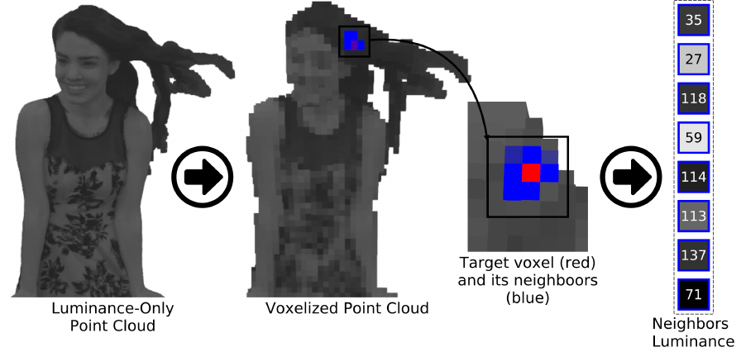
Figure 1: A luminance-based feature extractor for Point Cloud content.
Recent Publications (minimum 5)
- Diniz, Rafael, Pedro Garcia Freitas, and Mylene CQ Farias: Point cloud quality assessment based on geometry-aware texture descriptors. COMPUTERS & GRAPHICS-UK, v. 103, p. 31-44, 2022.
- Diniz, Rafael, Mylene Q Farias, and Pedro Garcia-Freitas: Color and geometry texture descriptors for point-cloud quality assessment. IEEE Signal Processing Letters, 2021.
- Diniz, Rafael, Pedro Garcia Freitas, and Mylène Farias: A novel point cloud quality assessment metric based on perceptual color distance patterns. Electronic Imaging, 2021(9):256–1, 2021.
- Diniz, Rafael, Pedro Garcia Freitas, and Mylene CQ Farias: Towards a point cloud quality assessment model using local binary patterns. In 2020 Twelfth International Conference on Quality of Multimedia Experience (QoMEX), pages 1–6. IEEE, 2020.
- Diniz, Rafael, Pedro Garcia Freitas, and Mylene CQ Farias: Multi-distance point cloud quality assessment. In 2020 IEEE International Conference on Image Processing (ICIP), pages 1–5. IEEE, 2020.
- Diniz, Rafael, Pedro Garcia Freitas, and Mylène CQ Farias: Local luminance patterns for point cloud quality assessment. In 2020 IEEE 22nd International Workshop on Multimedia Signal Processing (MMSP), pages 1–6. IEEE, 2020.

Biography (150 word limit)

Rafael Diniz is Computer Scientist (UNICAMP) and holds a masters in Informatics from PUC-Rio and PhD from University of Brasília. Has experience in the area of digital TV and radio (broadcasting), hypermedia and multimedia systems, computer vision, quality assessment of 2D and volumetric video and electromagnetic spectrum management. Member of the Telemídia Lab at PUC-Rio (since 2013) and the GPDS (Digital Signal Processing Group) at University of Brasília (since 2016).
Email: rafael@riseup.net

Notes/Comments: Track 18: Developing AI Technologies (Or at chair discretion)

Presenting author details
Full name: Rafael Diniz
Contact number: +55 11 998728111
Mail id: rafael@riseup.net
Category: (Oral presentation/ Poster presentation)

