Fabrication and characterization of cross-linked CMC/PVP-co-poly (AMPS) based hydrogel for the sustained release of model drug metoprolol tartrate
Akram Ashames*1,2, Fahad Pervaiz3, Moawia Al-Tabakha1,2, Kanza Khalid3, Nageeb Hassan1,2, Hina Shoukat3, Manal Buabeid1,2, Ghulam Murtaza*4

1College of Pharmacy and Health Sciences, Ajman University, Ajman 346, United Arab Emirates
2Medical and Bio-allied Health Sciences Research Centre, Ajman University, Ajman, United Arab Emirates
3Department of Pharmaceutics, Faculty of pharmacy, The Islamia University of Bahawalpur, Pakistan.
4Department of Pharmacy, COMSATS University Islamabad, Lahore Campus 54000, Pakistan.

Abstract (300 word limit)

This research aims to fabricate and characterize chemically cross-linked CMC/PVP-co-poly (AMPS) based hydrogel for the sustained release of model drug metoprolol tartrate through free radical polymerization technique. CMC/PVP-co-poly (AMPS) hydrogels were formulated by the free radical polymerization technique. Carboxymethyl cellulose crosslinked chemically with AMPS with a constant ratio of PVP by the ethylene glycol dimethacrylate as the cross-linker in the existence of sodium hydrogen sulfite/ammonium peroxodisulfate as initiators. CMC based hydrogels were fabricated by using different concentrations of polymer, monomer, and cross-linker. Dynamic swelling, sol-gal fraction, and percent drug release were performed along with some characterizations such as FTIR, XRD, TGA, DSC, and SEM. In-vitro drug release and swelling were performed at 1.2 and 6.8 pH to determine the sustained release pattern and pH-responsive behavior. These parameters are directly linked with the different ratios of cross-linker, polymer, and monomer. XRD, SEM, and FTIR show the successful grafting of constitutes and formation of a stable hydrogel. While the DSC and TGA confirm the thermodynamic stability of the hydrogel. The swelling of hydrogels increases as the ratio of monomer rises while decreases with a rise in the ratio of polymer and cross-linker. In-vitro gel fraction and drug release also depend on the ratios of polymer, monomer, and cross-linker. CMC/PVP-co-poly (AMPS) hydrogels can be considered as the potential system for the sustained delivery of model drug metoprolol tartrate for prolonged disease treatment with reduced dosing frequency and enhanced patient compliance. Box-Behnken Design was used to optimize CMC/PVP-co-poly (AMPS) hydrogel by varying the content of reactants such as; polymer (CMC), monomer (AMPS), and crosslinker (EGDMA).

Image
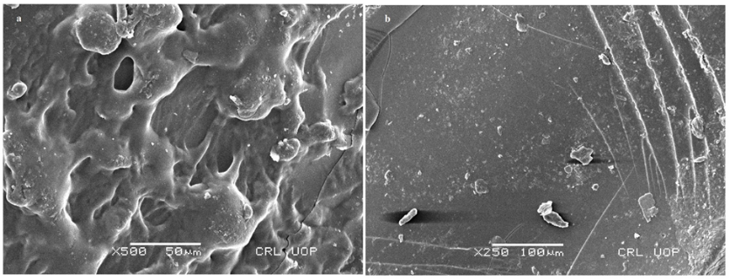
Figure 1: SEM image of loaded (a) and loaded (b) CMC/PVP-co-poly(AMPS) hydrogels
Recent Publications (minimum 5)
- BS Alotaibi, A Ashames, M Buabeid, M Masood, S Mir, G Murtaza. A new approach for the management of Escherichia coli and Klebsiella pneumonia by using cefixime-based bionanocomposite films (2022). Journal of Experimental Nanoscience 17 (1), 389-419.
- Z Patel, SA Gharat, MM Al-Tabakha, A Ashames, SHS Boddu, MM Momin. Recent Advancements in Electrospun Nanofibers for Wound Healing: Polymers, Clinical and Regulatory Perspective (2022). Critical Reviews™ in Therapeutic Drug Carrier Systems 39 (4).
- Khairi Mustafa Fahelelbom, Abdullah Saleh, Moawia M. A. Al-Tabakha, Akram Ashames. Recent applications of quantitative analytical FTIR spectroscopy in pharmaceutical, biomedical, and clinical fields: A brief review (2022). Reviews in Analytical Chemistry 41 (1), 21–33.
- 5. BS Alotaibi, F Pervaiz, M Buabeid, A Ashames, KM Fahelelbom, et al. Nanostructured lipid carriers based suppository for enhanced rectal absorption of ondansetron: In vitro and in vivo evaluations (2021). Arabian Journal of Chemistry 14 (12), 103426.
- S Noreen, F Pervaiz, A Ashames, M Buabeid, K Fahelelbom, H Shoukat, e al. Optimization of novel naproxen-loaded chitosan/carrageenan nanocarrier-based gel for topical delivery: ex vivo, histopathological, and in vivo evaluation (2021). Pharmaceuticals 14 (6), 557.

Biography (150 word limit)
Paste your Logo here
* 25+ years of proven experience in university teaching and research, pharmaceutical sciences, cancer research, and nano-biomaterials. * R&D accomplishments in drugs development and separation techniques of biological materials. * Hands-on experience in pharmaceutical quality control, quality assurance, and biomaterial separation and characterization. * Experienced in pharmaceutical analytical methods, pharmaceutical laboratories, and pharmacy-based policy development and management.
Email: a.ashames@ajman.ac.ae

Notes/Comments:
Presenting author details
Full name: Akram Ashames
Contact number: +97167056240
Mail id: a.ashames@ajman.ac.ae
Category: Poster presentation

