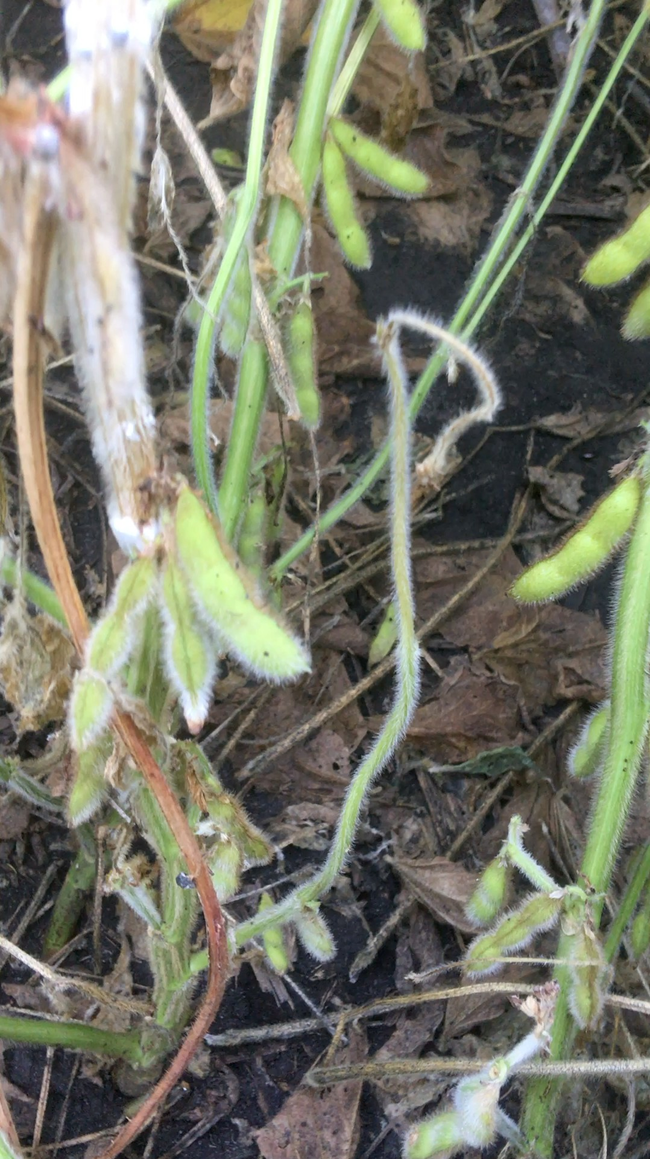
My Most Success In Plant Nutrition Always Began with A What If?
Brad Forkner, B.S. Agronomy and Animal Husbandry, University of Missouri 1976, Greater Chicago area

Abstract (300 word limit)
The challenge in crop nutrition has always been multi faceted. How do we get the nutrition inside the plant, economically and at the correct time. How to understand the intersection of plant growth stage, heat units, and current weather conditions. Beyond the 4 R’s Right time, Right product, Right rate, Right form, Right delivery system. As a Nutritionists, we must be able to assemble a plan based around the customers capabilities. Does he have a liquid delivery system?
Does he utilize strips? Does he have irrigation? Does he foliar? Does he make multiple in season adjustments? Does he tissue or SAP test? Does he Believe in my Nutritional approach system? Now begins the What if section. What if we could provide a Multi Mode of Nutritional Movement? What if we developed a plan that worked as a seed coat, or a planter box amendment, an in furrow, or an early foliar application. What if we could deliver micronutrients in a sulfate form instead of the less efficient EDTA forms?
What if , as a formulator you learn to build your own Starter Blends and PGR’s, or better yet have a plant build their own? What if we used Tissue, SAP, and N Watch procedures to make every application tailored to precisely what a plant needs in the next growth phase? What if you helped design a fully VRT prescription implement that could deliver, streams of liquid at the base of a plant, and also spray up or sideways. And include dry? Can we stop things like white mold and still produce a crop? Yes we can!

Recent Publications (Things I Study)
- The Chemistry of Essential Oils Made Simple
- The application of knowledge over multiple disciplines.
- Utilizing fulvic acid, amino acids, essential oils, and nanos to move nutrition into and through plants.
- Mixing orders, vortexes, water structure, and turning suspensions into stable solutions.
- Finding a way to deliver the nutrition I need with the machinery they currently have.
- How much of the new products are an improvement and allocating each dollar to the best ROI.
- Transferring knowledge to the next generation to keep the Best and Brightest in Agriculture.

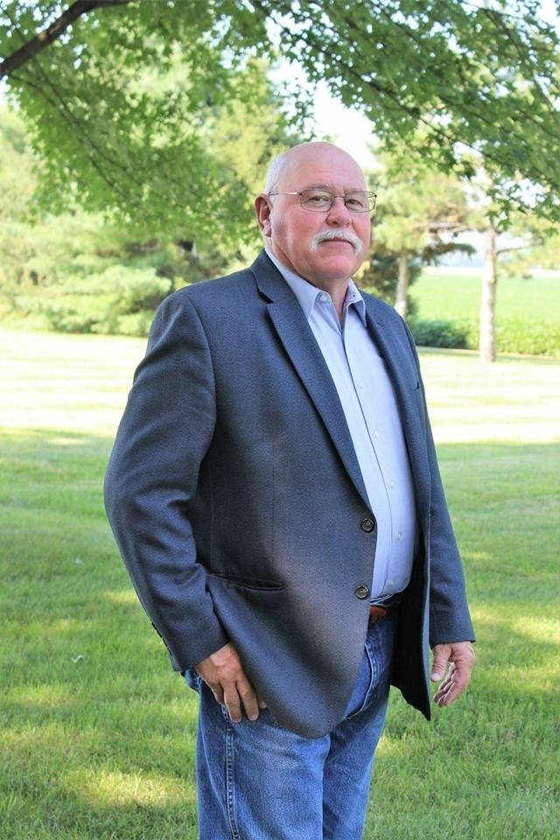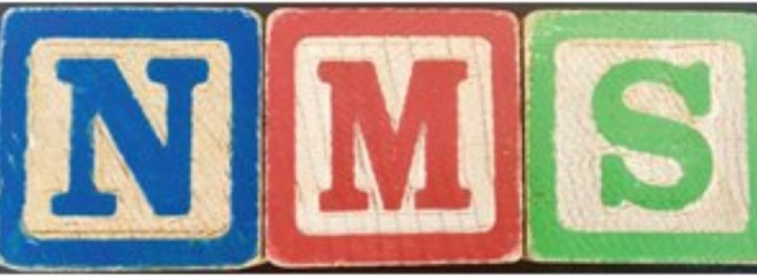
Biography
Since 2011, ADD, what my wife graciously refers to as, "Authority Defiant Disorder" sent me away from corporate Ag with its more rigid structure and definitions and restrictive boundaries of what my roles should be and how much value there could be if they allowed me leeway to actively resolve more questions from many years of traveling 10 states at that time. What if, begins some of the most delicious food I have tasted, what if brought about many of the unique machines I have seen in orchards, Melons, vegetables , and crops. What if this works in livestock or humans, could these thoughts, products and concepts solve a challenge in crops. Would a product be able to stop biofilm, sanitize, buildings, interior atmosphere, stop leaf diseases in progress? What if we were not so secretive and selfish with our gifts that we could become part of a network of scientists, nutritionists , engineers, chemists, organic, and fully GMO producers that shared observations? That belief started Nutrient Management Specialists, LLC. Over 11 years ago was the formal introduction of a lifetime of core moral beliefs instilled through generations of midwestern ancestors who were givers, sharing resources, knowledge, labor, insight into genetic combinations, nutritional nuances, and mentoring at every opportunity. Worth all it required!!
Email: Brad@nutrientmanagementspecialists.com

Notes/Comments: If some of my thoughts and experiences can challenge others, encourage them to never lose their imagination, and mentor their replacement candidates, I would love to opportunity to present.

Presenting author details
Full name: Bradford Alan Forkner Contact number: (815) 257-8463
Mail id: Brad@nutrientmanagementspecialists.com Category: (Oral presentation)

