Peripheral analgesic mechanism and effective parts of Stauntonia Chinensis
Su Chen, College of Biomedical Engineering, South-Central Minzu University, China

Abstract (300 word limit)
Pain is one of main problems endangering human health. The research and development of new analgesic drugs with high efficiency, small side effects and no addiction has always been a hot research direction. Stauntonia chinensis is a traditional Chinese medicine and has been made into a variety of preparations. Acupoint injection of Stauntonia chinensis injection can produce a good clinical analgesic effect. Studies have shown that the saponins of Stauntonia chinensis may be the analgesic effective part. In our studies, the triterpenoid saponins from Stauntonia chinensis (TSS) were successfully extracted by a flash extraction way and the basic skeleton structures were identified. Through in vivo animal experiments and acute pain model, we found that TSS had short-term analgesic effect. In the formalin test, the time spent in licking the injected paw in phase II could be significantly decreased by TSS. In the capsaicin test, TSS also could decrease the time spent in licking the injected paw caused by capsaicin. Using the rat model of inflammatory pain induced by complete Freund's adjuvant (CFA), we also found that TSS had long-term analgesic effect. With the patch clamp technique and Western blot technique, we further observed the interaction between TSS and TRPV1 receptor, which is closely related to pain production and conduction. We found that TSS could inhibit the capsaicin-induced TRPV1 current. Compared with the control group, the expression of TRPV1 in DRG neurons of CFA-induced inflammatory pain rats could be increased and TSS could reduce the increased protein expression of TRPV1. The above results showed that the analgesic effect of TSS may be related to blocking TRPV1 receptor and interfering with its protein expression, which will provide an important pharmacological reference for the development of new analgesic drugs from Stauntonia chinensis.

Image
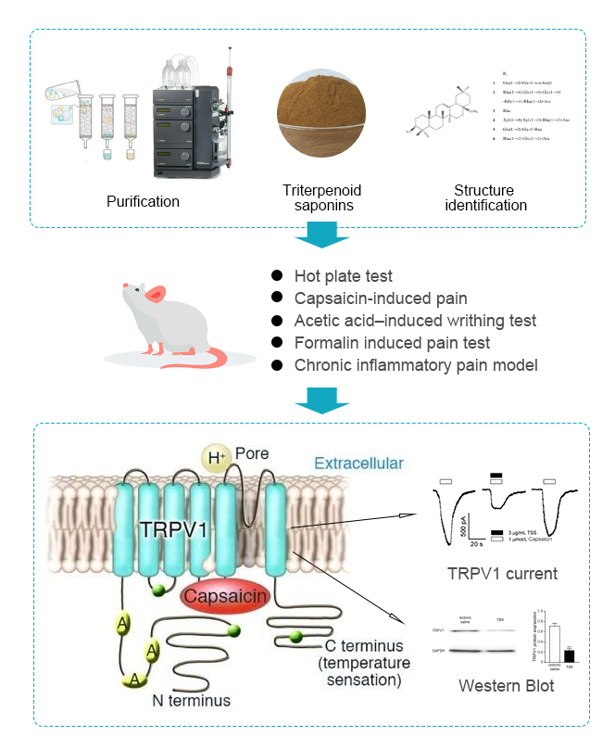
Recent Publications (minimum 5)
- Chen S, Rong Y, Liu M (2018). Analgesic Effects of Triterpenoid Saponins From Stauntonia chinensis via Selective Increase in Inhibitory Synaptic Response in Mouse Cortical Neurons. Front Pharmacol. 9:1302.
- Ying C, Ning W, Ying L (2014) Anti-nociceptive and anti-inflammatory activities of the extracts of Stauntonia chinensis. Pak J Pharm Sci. 27(5):1317-25.
- Gao H, Zhao F, Chen GD (2009) Bidesmoside triterpenoid glycosides from Stauntonia chinensis and relationship to anti-inflammation. Phytochemistry. 70(6):795-806.
- Gao H, Zhang X, Wang NL (2007) Triterpenoid saponins from Stauntonia chinensis. J Asian Nat Prod Res. 9(2):175-82.
- Zhang TX, Fu HZ, Yang YS (2016) Chemical Constituents from Stauntonia chinensis. Zhong Yao Cai. 39(7):1554-8.

Biography (150 word limit)
Major courses include neurobiology, principles of neuroscience, molecular cell biology and cell electrophysiology experimental technology. During this period, She was mainly engaged in calcium imaging experiment, electrophysiological patch clamp experiment, molecular biology experiment, cell culture and rat behavior experiment, mouse nerve ligation operation, etc. Master electrophysiological patch clamp technique and record Na + channel current, TRPV1, ASIC3 receptor channel current. Master cell calcium imaging technology, immunofluorescence technology, ELISA experiment, Western blot, etc. Master rat and rat pain model, cooperative sleep model and related animal behavior experiments, mouse nerve ligation, etc. Master SPSS, Graph pad, PS, Image J and other software, and have good statistical analysis ability of experimental data. She participated in the research on the "analgesic mechanism of total saponins and their components regulating substance P and its receptor (NK-1)" of the graduate academic innovation fund project. At present, She is participating in the research of "sedative hypnotic mechanism of Sabina vulgaris".

