Waste-Derived Fuels and Renewable Chemicals for promotion of Bioeconomy: A sustainable Approach
Vivek Narisetty M.Sc. Ph.D.
Moolec Science, UK

Abstract (300 word limit)
Food waste is a global problem, causing significant environmental harm and resulting in substantial economic losses globally. Bread is the commonly wasted food in the developed world and presents a severe problem for majority of the European nations. It is the second most wasted food in the UK after potatoes, with the equivalent of 20 million slices of bread thrown away daily. Bread is a starchy material and rich and clean source of easily extractable fermentable sugars – this is in direct contrast to lignocellulosic feedstocks where harsh physical, chemical and/or enzymatic pretreatment processes are required for release of fermentable sugars. Most food wastes and by-products in the UK including bakery waste are treated through AD processes that fail to harness the full potential of these wastes. The presence of clean and high-quality fermentable sugars, proteins and other nutrients in bread make it an ideal substrate for generating chemicals, fuels, bioplastics, pharmaceuticals, and other renewable products through microbial fermentations. We suggest potential applications for recycling bread waste into its chemical building blocks through a fermentative route where a circular biorefining approach could maximize the resource recovery and environmental savings and eliminate waste to as close to zero as possible. Acidic and enzymatic saccharification of BW was carried out resulting in the highest glucose release of 75 and 97.9 g/L which is 73.5 and 95.9% of theoretical yield, respectively. The obtained sugars were fermented into ethanol initially in shake flask followed by scale up in bioreactor in batch and fed-batch mode. In the fed-batch mode of cultivation, the maximum ethanol titers of 111.3, 106.9, and 114.9 g/L with conversion yield and productivity of 0.48, 0.47, and 0.49 g/g, and 3.1, 3.0, and 3.2 g/L. h was achieved from pure glucose, glucose-rich acidic and enzymatic hydrolysates, respectively. Further to improve the process economics, the solid residues after acidic and enzymatic hydrolysis of BW along with respective fermentation residues obtained after the ethanol production were pooled and subjected to anaerobic digestion. The solid residue from ABW+FR, and EBW+FR yielded a biochemical methanation potential of 345 and 379 mL CH₄/g VS, respectively.
.

Image
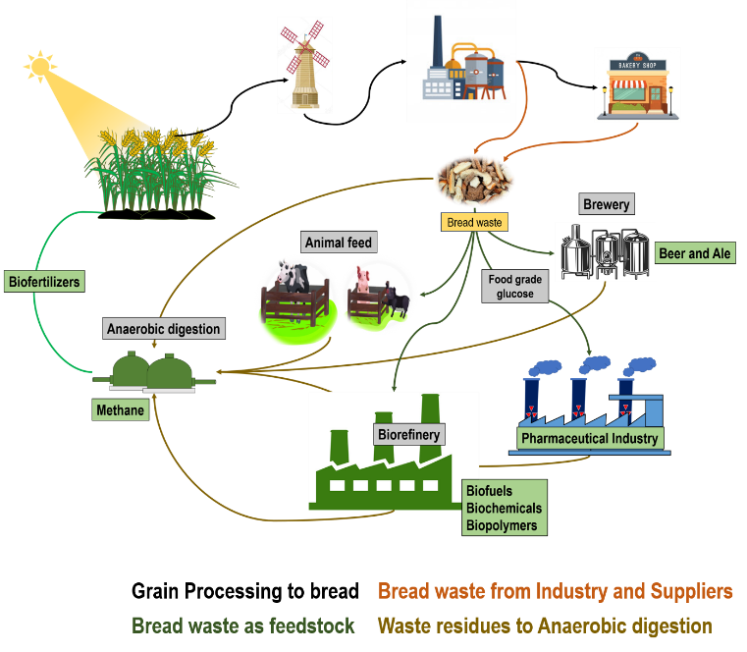
Recent Publications (minimum 5)
- Narisetty V, Zhang L, Zhang J, Lin CS, Tong YW, Show PL, Bhatia SK, Misra A, Kumar V. Fermentative Production of 2, 3-Butanediol using Bread Waste–A Green Approach for Sustainable Management of Food Waste. Bioresource Technology. 2022 May 26:127381.
- Narisetty V, Maitra S, Tarafdar A, Alphy MP, Kumar AN, Madhavan A, Sirohi R, Awasthi MK, Sindhu R, Varjani S, Binod P. Waste-Derived Fuels and Renewable Chemicals for Bioeconomy Promotion: A Sustainable Approach. BioEnergy Research. 2022 Mar 25:1-7.
- Narisetty V, Prabhu AA, Al-Jaradah K, Gopaliya D, Hossain AH, Khare SK, Punt PJ, Kumar V. Microbial itaconic acid production from starchy food waste by newly isolated thermotolerant Aspergillus terreus strain. Bioresource technology. 2021 Oct 1;337:125426.
- Narisetty V, Cox R, Willoughby N, Aktas E, Tiwari B, Matharu AS, Salonitis K, Kumar V. Recycling bread waste into chemical building blocks using a circular biorefining approach. Sustainable Energy & Fuels. 2021;5(19):4842-9..
- Narisetty V, Nagarajan S, Gadkari S, Ranade VV, Zhang J, Pandey A, Kumar V. Process optimization for recycling of bread waste into bioethanol and biomethane: A circular economy approach. Energy Conversion and Management. 2022; 115784.

Biography (150-word limit)
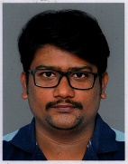
Dr. Vivek Narisetty is currently working as a senior scientist (Molecular biology) at Moolec Science, UK. In his 8 years of research, he has earned expertise in Process development (Upstream and Downstream processing) for functional proteins, value-added chemicals, and fuels. Currently, he is involved in industrial R&D tackling on one of the world leading concerns, i.e., Food for the future, by developing sustainable alternative proteins through fermentation platforms. He is adept in leading research personnel and managing multiple interdisciplinary projects and in dissipating knowledge for scientific and non-scientific communities. He has around 45 publications including original research papers, review articles, perspectives, and book chapters with more than 600 citations, h-index of 12 and i10 index of 16. Dr. Vivek is keen and interested in developing novel biorefinery processes with the concept of Net-zero emissions, to establish a Circular Bioeconomy.
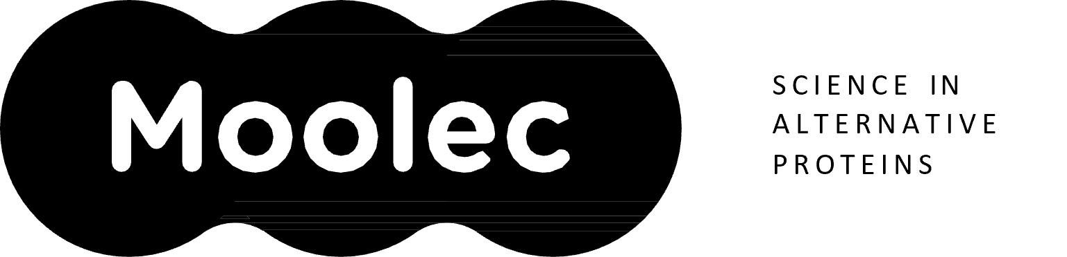
Email: viveknarisetty@gmail.com; vivek@moolecscience.com

Notes/Comments:

Presenting author details
Full name: Vivek Narisetty
Contact number: +4407769011742
Twitter account:
Linked In account:
Session name/ number: Biofuels
Category: (Oral presentation)

