Mechanical and Chemical Recycling of marine litter
Cristina Peña-Rodriguez, Gurutz Mondragon, Amaia Mendoza, Eider Mendiburu, Arantxa Eceiza, Galder Kortaberria
Materials+Technologies' Research Group. Faculty of Engineering, Gipuzkoa. University of the Basque Country (UPV/EHU)

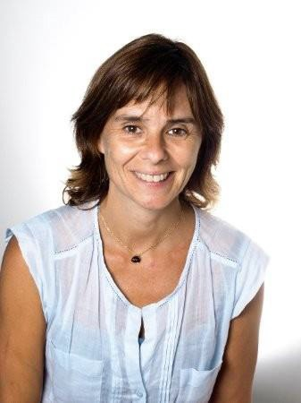Biography
Cristina Peña-Rodriguez, Bachelor degree on Petrochemical / Macromolecular Chemistry and Ph.D. in Materials Engineering (UPV/ EHU). Researcher in the ‘Materials+Technologies’ Group from 2000. Associate Professor at the Chemical and Environmental Engineering Department in the UPV/EHU. From 2020 Director of the Circular Economy University-Company Classroom of the Faculty of Engineering Gipuzkoa (University of the Basque Country - Provincial Council of Gipuzkoa).
Her research is focussed in the development of new materials based on partially or totally renewable materials for several applications and the mechanical and chemical recycling processes of polymeric materials.

Abstract

he circular economy relates to
the efficiency of material comsumption. This research analyses polyamide and poly(ethylene terephtalate) (PET) polymeric materials recovered from the seas and oceans to identify recycling possibilities. Their use as a source of raw materials should be analysed to exploit the fossil resources they contain. Marine litter is defined as any persistent solid material, manufactured or processed, that is discarded or abandoned in the marine environment directly or indirectly, intentionally or unintentionally. Annually between
1.15 and 2.41 million tonnes of plastic enters the ocean from rivers. As more than half of the plastic is less dense than water, it will not sink once it is in the sea.
Once marine litter has been located and identified, it must be treated for reuse, for recycling or for other uses such as energy recovery.

The treatment techniques for marine plastic waste are similar to those used for land-based plastic waste. However, it should be noted that the marine origin usually involves degradation of the materials by the presence of UV radiation, marine organisms or sand and the effect of mechanical forces (wind, currents, etc.).
One of the most abundant types of waste found in the sea is that related to fishing activities. An estimated 640,000 tonnes of abandoned, lost and discarded fishing gear reaches the ocean annually, which constitutes around 10-11% of marine litter. Mechanical recycling appears to be a suitable method for the manufacture of new nylon 6 products. The process includes several stages: fishing net waste is washed, cut, shredded and dried before the extrusion process, carried out at 255-270 °C. The filaments or pellets obtained by extrusion can then be used for the
manufacture of new products.
PET materials account for 7% of global plastics production, with approximately 18.8 million tonnes produced per year. However, more than 40% of consumed PET bottles and containers are not collected, and many of them end up in the sea. PET marine litter shows different degradation mechanisms depending on the marine compartments in which it is found. Indeed, PET degradation mechanisms may be different if the bottle is in the upper compartments of the sea, where hydrolysis and photodegradation occurs under the effect of UV radiation, or on the seabed, where it appears to be stable for approximately fifteen years.
This degradation takes place mainly at the ester bonds of PET, generating carboxyl (- COO) and and hydroxyl (- OH) groups (Dubelley et al. 2017). However, the best option for recycling degraded PET samples, such as marine PET, appears to be chemical recycling.

Conclusions
The degradation of the residues limit the recycling possibilities. In the case of marine litter, polyamide fishing nets can be recycled by thermo-mechanical processing while chemical recycling is most suitable for PET bottles.

Importance of Research
The circular economy is committed to efficiency in the use of materials. Recycling of plastic products is necessary to reduce the consumption of fossil resources. The physical and chemical state of marine waste must be identified in order to adapt the recycling process.
Yet, they not only have a high esteem for tradition, but are also remarkably foward-looking and have stablished a highly regarded industrial sector.
The region's sucess and scientific and technological progress are underpinned by the University of the Basque Country, a vibrant 30- year-old institution with 45,000 students, 5,000 world-class accademic staff and state-of-the-art facilities.
Following our motto 'Give and spread knowledge', the University of the Basque Country is an integrating institution willing to produce knowledge, experience and research in order to forward them to the general public. Our mission is to nurture a enlightened population by providing quality education and training based on

References

- Lebreton, L.C.M.; van der Zwet, J.; Damsteeg, J.W.; Slat, B.; Andrady, A.; Reiser, J. River plastic emissions to the world’s oceans. Nat. Commun. 2017, 8:15611–15621.
- PlasticsEurope (2019) Plastics
—the facts 2018.
PlasticsEurope, Brussels.
- Mondragon, G.; Kortaberria, G.; Mendiburu, E.; González, N.; Arbelaiz, A.; Peña- Rodriguez, C.
Thermomechanical recycling of PA6 from fishing nets waste. J. Appl. Polym. Sci. 019, 137:4844-4850.
- Mendiburu-Valor, E.; Mondragon, G.; González, N.; Kortaberria, G.; Martin, L.; Eceiza, A. Valorization of urban and marine PET waste

knowledge, innovation and equity.
Corresponding Author:
Cristina Peña-Rodriguez
PhD Materials Engineering University of the Basque Country E: cristina.pr@ehu.eus
by optimized
chemical

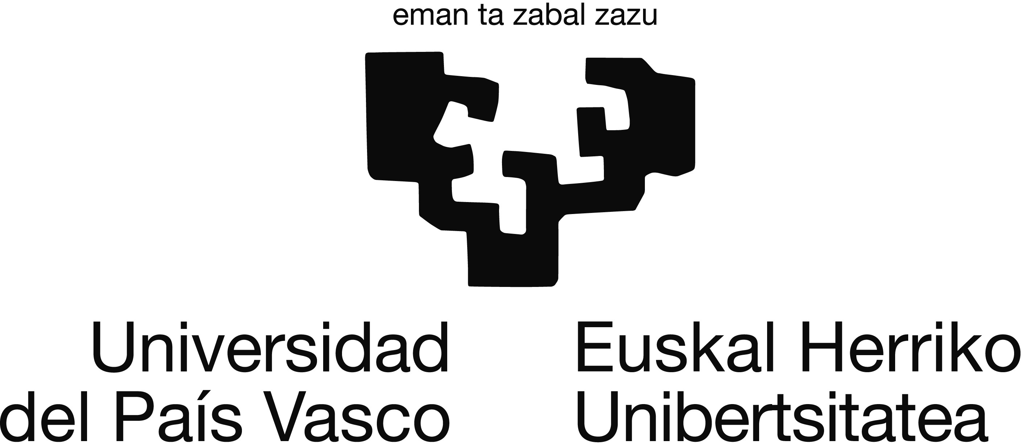About University
As public institution we are community-funded and both fees and services rely only to a small extent on students: our university is owped by all open to all.
recycling. Resources, Conservation and Recycling 2022, 184,106413-106420
- Mendiburu-Valor, E.; Mondragon, G.; González, N.; Kortaberria, G.; Eceiza, A.; Peña-Rodriguez, C. Improving the efficiency for the

Acknowledgements
production of
bis-(2-

University of the Basque Country (UPV/EHU)
In a prosperous region stretching along the Atlantic coast of northern Spain, the people of the Basque Country are the custodians of one of Europe's most ancient languages and cultures.
This work was supported by the Provincial Council of Gipuzkoa (Itsas-Mikro 2019-2022). The authors would like to thank the University of the Basque Country (GIU18/216)
hydroxyethyl) terephtalate (BHET) from the glycolysis reaction of poly(ethylene terephtalate) (PET) in a Pressure Reactor. Polymers 2021, 13, 1461-1474

NOTE: This is a sample proceedings abs4tr.act template. The content will be changed while publishing respective abstract in supporting journal website.

