Influence of a novel drying technique on the mechanical performance of recycled pet
Alejandra Costantino, Dra, Materials Science and Technology Research Institute (INTEMA), University of Mar del Plata, CONICET, Av. Juan B. Justo 4302, B7608FDQ Mar del Plata, Argentina
Gabriela Campos, RN PhD, Materials Science and Technology Research Institute (INTEMA), University of Mar del Plata, CONICET, Av. Juan B. Justo 4302, B7608FDQ Mar del Plata, Argentina
Joaquin Cruces, Materials Science and Technology Research Institute (INTEMA), University of Mar del Plata, CONICET, Av. Juan B. Justo 4302, B7608FDQ Mar del Plata, Argentina
Federico Morales Materials Science and Technology Research Institute (INTEMA), University of Mar del Plata, CONICET, Av. Juan B. Justo 4302, B7608FDQ Mar del Plata, Argentina
Valeria Pettarin Materials Science and Technology Research Institute (INTEMA), University of Mar del Plata, CONICET, Av. Juan B. Justo 4302, B7608FDQ Mar del Plata, Argentina

Abstract

Plastic materials are essential in modern societies; they come mainly from fossil resources. That is why recycling is a very important step in the transition towards a circular economy, to avoid continuing to use fossil resources and thus close the cycle of production. PET is currently considered one of the plastics with the greatest potential for be recycled due to its good properties and ability to be processed by industrial processing. However, those processes may deteriorate its properties, such as tensile strength or thermal stability, since they involve high temperatures and shear stresses that together with the presence of moisture (due to the strong hydrophilic nature of PET) can accelerate the thermal oxidation of the polymer with a corresponding loss in molecular weight. When working with recycled PET the excess moisture contained in the material may be higher. Despite the importance that represents the drying stage for this resin, it has not yet been studied how different techniques of drying can influence the final mechanical properties of the processed parts and the cycle total (time/costs). In the present work, two drying techniques were applied, one conventional through an oven widely used in the industry and another novel one through infrared rays (which involved the construction of an infrared oven) to study its influence on the cycle of recycled and mainly in the final mechanical properties of PET parts obtained from of waste soda bottles and virgin material used for comparison. It was found that drying by infrared technology reduces drying time by 80% which implies a Drastic reduction in total recycling time for all materials (recycled and virgin). In addition, no significant differences were found in the conventional and non-conventional mechanical properties, which indicates that drying by infrared technology does not degrade or affect negatively the performance of the materials used in the present work.
Image
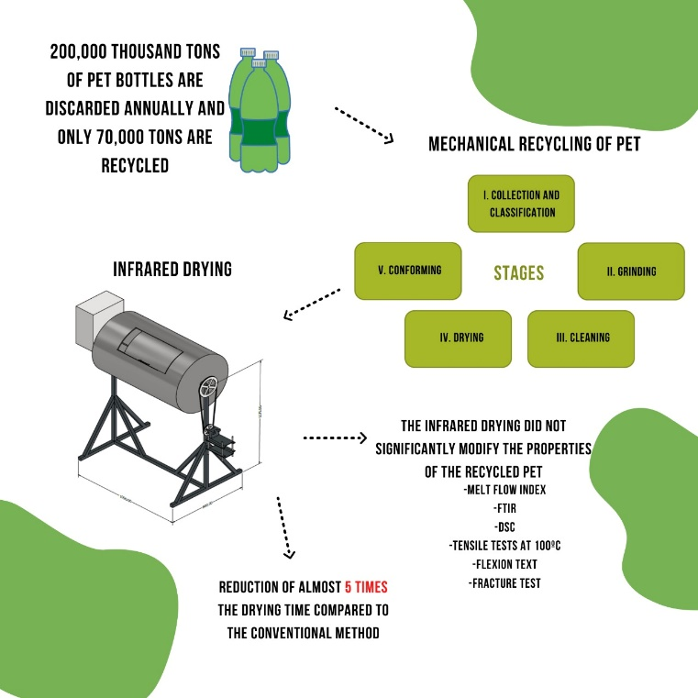
Recent Publications (minimum 5)
- Costantino A, Pettarin V, Viana J, Pontes A, Pouzada A, Frontini P (2013) Morphology-performance relationship of PP-nanoclay composites processed by shear controlled injection moulding, Polymer International 62:1589–1599
- Costantino A, Rueda F, Pettarin V, Frontini PM, Pontes AJ, Viana JC (2017) Characterization of PP/TPV/MMT ternary nanocomposites produced by injection molding , Macromolecular Symposia 373:1600153
- Rosales C, Costantino A, Palazzo G, Bernal C, Defacio Dutra R, V. Pettarin Influence of different copolymer based compatibilizers on performance of pristine and recycled PP/PE blends, , Advanced Materials Letters, Vol. 11, Issue: 11, 20111572 (2020) https://doi.org/10.5185/amlett.2020.111572Room R, BaborT, Rehm J (2005) Alcohol and public health. Lancet
365: 519-530.
- Costantino A, Rosales C, Pettarin V, Polypropylene blends and composites: processing-morphology-performance relationship of injected pieces, , In: W. Wang, Y. Zeng (Eds.), Polypropylene: Polymerization and Characterization of Mechanical and Thermal Properties. (DOI: 10.5772/intechopen.73995) Intech-Open, ISBN: 978-1-83880-416-9, pp. 1-14 (2019) http://dx.doi.org/10.5772/intechopen.85634
- Costantino MA., Ramajo L, Viana JC, Rosales C, Pontes A, Pettarin V (2021) Overall performance of PP complex injected pieces modified with MWCNT as a painting aide, , Advanced Materials Letters 12,4:21041618


Biography
My experience spans the spectrum of virgin and recycled polymers technology from mixing, extrusion, and basic molding processes to nanoscale structure, and
numerical modeling. I've worked with multicomponent systems, different processing operations and I've performed mechanical behavior under different stress conditions..
Email: alejandra-costantino@hotmail.com

Notes/Comments:

Presenting author details
Full name: Maria Alejandra Costantino
Contact number: +542235927360
Mail id: alejandra-costantino@hotmail.com
Category: Oral presentation

